­­ ­MINISTRY OF EDUCATION AND TRAINING

­

­

**FPT UNIVERSITY**

Capstone Project Document

**Interior Furniture Augmented Reality System for Online Shopping**

|  |  |
| --- | --- |
| **Group 3** | |
| **Group members** | Nguyễn Phước Anh Khoa – SE61742  Phan Hồng Đức - SE61835  Bùi Thanh Thiên- SE61813 |
| **Supervisor** | Kiều Trọng Khánh |
| **Ext. Supervisor** | N/A |
| **Capstone Project code** | ifAR |

-Ho Chi Minh City, ***08/01/2018*-**

# Table of Contents

Contents

[MINISTRY OF EDUCATION AND TRAINING - 1 -](#_Toc512210853)

[Table of Contents - 2 -](#_Toc512210854)

[List of Tables - 55 -](#_Toc512210855)

[List of Figures - 55 -](#_Toc512210856)

[Definitions, Acronyms, and Abbreviations - 57 -](#_Toc512210857)

[A. Report No. 1 Introduction - 58 -](#_Toc512210858)

[1. Project Information - 58 -](#_Toc512210859)

[2. Introduction………………………………………………………………………..- 58 -](#_Toc512210860)

[3. Current Situation - 58 -](#_Toc512210861)

[4. Problem Definition - 60 -](#_Toc512210862)

[5. Proposed Solution - 60 -](#_Toc512210863)

[5.1 Feature functions - 60 -](#_Toc512210864)

[5.2 Values and Challenges - 61 -](#_Toc512210865)

[6. Functional Requirements - 62 -](#_Toc512210866)

[7. Role and Responsibility - 62 -](#_Toc512210867)

[B. Report No.2 Software Project Management Plan - 62 -](#_Toc512210868)

[1. Problem Definition - 62 -](#_Toc512210869)

[1.1 Name of this Capstone Project - 62 -](#_Toc512210870)

[1.2 Problem Abstract - 62 -](#_Toc512210871)

[1.3 Project Overview - 63 -](#_Toc512210872)

[1.3.1 Current Situation - 63 -](#_Toc512210873)

[1.3.2 The Proposed System - 64 -](#_Toc512210874)

[1.3.2.1 Website - 64 -](#_Toc512210875)

[1.3.2.2 Mobile Application - 64 -](#_Toc512210876)

[1.3.2.3 Scheduler - 65 -](#_Toc512210877)

[1.3.3 Boundaries of the System - 65 -](#_Toc512210878)

[1.3.4 Future Plans - 66 -](#_Toc512210879)

[1.3.5 Development Environment - 66 -](#_Toc512210880)

[1.3.5.1 Hardware requirements - 66 -](#_Toc512210881)

[1.3.5.2 Software requirements - 66 -](#_Toc512210882)

[2. Project organization - 67 -](#_Toc512210883)

[2.1 Software Process Model - 67 -](#_Toc512210884)

[2.2 Roles and responsibilities - 68 -](#_Toc512210885)

[2.3 Tools and Techniques - 68 -](#_Toc512210886)

[3. Project Management Plan 69](#_Toc512210887)

[3.1 Product Backlog 69](#_Toc512210888)

[3.2 Sprint Backlog 72](#_Toc512210889)

[3.2.1 Sprint 1 (08.01.2018 – 21.01.2018): Project initiation 72](#_Toc512210890)

[3.2.1.1: Goal 72](#_Toc512210891)

[1.1 Project Information 72](#_Toc512210892)

[1.2 Current Situation 72](#_Toc512210893)

[1.3 Problem Definition 72](#_Toc512210894)

[1.4 Proposed Solution 72](#_Toc512210895)

[1.5 Role and Responsibility 72](#_Toc512210896)

[1.6 Functional Requirements 72](#_Toc512210897)

[2.1 Create Product Backlog 72](#_Toc512210898)

[3.1 Problem Definition 72](#_Toc512210899)

[3.2 Project Organization 72](#_Toc512210900)

[3.3 Project management plan 72](#_Toc512210901)

[3.4 Coding Convention 72](#_Toc512210902)

[4.1 User Requirement Specification 72](#_Toc512210903)

[4.2 Software Requirement Specification 72](#_Toc512210904)

[4.3 Software System Attributes 72](#_Toc512210905)

[4.4 Conceptual Diagram 72](#_Toc512210906)

[3.2.1.2: Development 72](#_Toc512210907)

[3.2.2 Sprint 2 (22.01.2018 – 11.02.2018): Software document description and basic features 73](#_Toc512210908)

[3.2.2.1: Goal 73](#_Toc512210909)

[5.1 Design Overview 73](#_Toc512210910)

[5.2 System Architectural Design 73](#_Toc512210911)

[5.3 Component Diagram 73](#_Toc512210912)

[5.4 Detailed Description 73](#_Toc512210913)

[5.5 Interface 73](#_Toc512210914)

[5.6 Database Design 73](#_Toc512210915)

[5.7 Algorithms 73](#_Toc512210916)

[8.1 Guest\_Register 73](#_Toc512210917)

[9.1 Guest\_Login 73](#_Toc512210918)

[9.2 Authenticated User\_Log out 73](#_Toc512210919)

[16.1 Authenticated user \_Change password 73](#_Toc512210920)

[3.2.2.2: Development 73](#_Toc512210921)

[3.2.3 Sprint 3 (26.02.2018 – 11.03.2018): Core flow 74](#_Toc512210922)

[3.2.3.1: Goal 74](#_Toc512210923)

[6.1 AR problem definition 74](#_Toc512210924)

[6.2 AR Algorithm document 74](#_Toc512210925)

[6.3 Implement Algorithm 74](#_Toc512210926)

[7.1 RC problem definition 74](#_Toc512210927)

[7.2 RC Algorithm document 74](#_Toc512210928)

[7.3 Implement Algorithm 74](#_Toc512210929)

[10.1 Customer\_Edit profile 74](#_Toc512210930)

[10.2 Customer\_Request to upgrade role 74](#_Toc512210931)

[10.3 Staff\_Approve upgrade role request 74](#_Toc512210932)

[11.1 Seller\_Request to sell product. 74](#_Toc512210933)

[11.2 Staff\_Approve product with pricing 74](#_Toc512210934)

[11.3 Seller\_Approve the pricing 74](#_Toc512210935)

[11.4 Scheduler\_Generate 3D model 74](#_Toc512210936)

[3.2.3.2: Development 74](#_Toc512210937)

[3.2.4 Sprint 4 (12.03.2018 – 25.03.2018): Core flow 75](#_Toc512210938)

[3.2.4.1: Goal 75](#_Toc512210939)

[11.5 Staff\_Update 3D model’s quality 75](#_Toc512210940)

[11.6 Staff\_Re-Upload edited model 75](#_Toc512210941)

[11.7 Seller\_Get product’s information 75](#_Toc512210942)

[11.8 Seller\_Get 3D model 75](#_Toc512210943)

[11.9 Seller\_Simulate product via smartphone’s camera 75](#_Toc512210944)

[11.10 Seller\_Update product’s information 75](#_Toc512210945)

[11.11 Seller\_Remove product 75](#_Toc512210946)

[11.12 Seller\_Contemplate products via 3D models. 75](#_Toc512210947)

[12.1 Customer\_Search product 75](#_Toc512210948)

[12.2 Customer\_Simulate products through smartphone’s camera 75](#_Toc512210949)

[12.3 Customer\_Add product to cart 75](#_Toc512210950)

[12.4 Customer\_Get cart 75](#_Toc512210951)

[12.5 Customer\_Execute payment 75](#_Toc512210952)

[12.6 Customer\_Contemplate products via 3D models. 75](#_Toc512210953)

[13.1 Customer\_Get order 75](#_Toc512210954)

[13.2 Customer\_Get order detail 75](#_Toc512210955)

[14.1 Staff\_Search product 75](#_Toc512210956)

[14.2 Staff\_Filter products following category 75](#_Toc512210957)

[14.3 Staff\_Get product’s details 75](#_Toc512210958)

[14.4 Staff\_Reject product 75](#_Toc512210959)

[3.2.4.2: Development 75](#_Toc512210960)

[3.2.5 Sprint 5 (26.03.2018 – 08.04.2018): Complete coding and software testing 76](#_Toc512210961)

[3.2.5.1: Goal 76](#_Toc512210962)

[15.1 Staff\_Search user 76](#_Toc512210963)

[15.2 Staff\_Get user’s information 76](#_Toc512210964)

[15.3 Staff\_Reject customer’s upgrade role request. 76](#_Toc512210965)

[17.1 Scheduler\_Send notification 76](#_Toc512210966)

[17.2 User\_Get notification 76](#_Toc512210967)

[17.3 User\_Confirm notification 76](#_Toc512210968)

[17.4 User\_Remove notification 76](#_Toc512210969)

[18.1 Create test plan 76](#_Toc512210970)

[18.2 Run test cases 76](#_Toc512210971)

[18.3 Fix bug 76](#_Toc512210972)

[18.4 Test document 76](#_Toc512210973)

[19.1 Quality document for system 76](#_Toc512210974)

[3.2.5.2: Development 76](#_Toc512210975)

[3.2.6 Sprint 6 (09.04.2018 – 22.04.2018): Complete document and paper 77](#_Toc512210976)

[3.2.6.1: Goal 77](#_Toc512210977)

[20.1 Installation guide 77](#_Toc512210978)

[20.2 User manual 77](#_Toc512210979)

[21.1 Paper document 77](#_Toc512210980)

[3.2.6.2: Development 77](#_Toc512210981)

[3.3 All Meeting Minutes 77](#_Toc512210982)

[4. Coding Convention 77](#_Toc512210983)

[C. Report No. 3 Software Requirement Specification 78](#_Toc512210984)

[1. User Requirement Specification 78](#_Toc512210985)

[1.1 Customer Requirement 78](#_Toc512210986)

[1.2 Seller Requirement 79](#_Toc512210987)

[1.3 Staff Requirement 79](#_Toc512210988)

[1.4 Administrator Requirement 79](#_Toc512210989)

[1.5 Authorized User Requirement 79](#_Toc512210990)

[1.5 Scheduler Requirement 79](#_Toc512210991)

[2. System Requirement Specification 80](#_Toc512210992)

[2.1 External Interface Requirement 80](#_Toc512210993)

[2.1.1 User Interface 80](#_Toc512210994)

[2.1.2 Hardware Interface 80](#_Toc512210995)

[2.1.3 Software Interface 80](#_Toc512210996)

[2.1.4 Communication Protocol 80](#_Toc512210997)

[2.2 System Overview Usecase 81](#_Toc512210998)

[2.3 List of Usecase 82](#_Toc512210999)

[2.3.1 < Administrator > Overview Usecase 82](#_Toc512211000)

[2.3.1.1 < Administrator > Create account Usecase 82](#_Toc512211001)

[2.3.1.2 < Administrator > Edit account Usecase 84](#_Toc512211002)

[2.3.2 < Authenticated User > Overview Usecase 86](#_Toc512211003)

[2.3.2.1 < Authenticated User > Log out Usecase 86](#_Toc512211004)

[2.3.2.2 < Authenticated User > Get Profile Usecase 88](#_Toc512211005)

[2.3.2.3 < Authenticated User > Edit Profile Usecase 90](#_Toc512211006)

[2.3.2.3 < Authenticated User > Reset password Usecase 93](#_Toc512211007)

[2.3.3 < Guest > Overview Usecase 95](#_Toc512211008)

[2.3.3.1 < Guest > Login Usecase 95](#_Toc512211009)

[2.3.3.2 < Guest > Register Usecase 97](#_Toc512211010)

[2.3.3.3 < Guest > Search product Usecase 101](#_Toc512211011)

[2.3.3.4 < Guest > Add to cart Usecase 102](#_Toc512211012)

[2.3.3.5 < Guest > Get cart Usecase 103](#_Toc512211013)

[2.3.3.6 < Guest > Simulate product through camera Usecase 105](#_Toc512211014)

[2.3.3.7 < Guest > Get product’s detail. 107](#_Toc512211015)

[2.3.3.8 < Guest > View product in 3D. 108](#_Toc512211016)

[2.3.4 < Customer > Overview Usecase 110](#_Toc512211017)

[2.3.4.1 < Customer > Search Product Usecase 111](#_Toc512211018)

[2.3.4.2 < Customer > Add to cart Usecase 112](#_Toc512211019)

[2.3.4.3 < Customer > Get cart Usecase 113](#_Toc512211020)

[2.3.4.4 < Customer > Checkout Usecase 115](#_Toc512211021)

[2.3.4.5 < Customer > Simulate product through camera Usecase 116](#_Toc512211022)

[2.3.4.6 < Customer > Get product’s detail Usecase 118](#_Toc512211023)

[2.3.4.7 < Customer > View product in 3D Usecase 120](#_Toc512211024)

[2.3.4.8 < Customer > Get order Usecase 121](#_Toc512211025)

[2.3.4.9 < Customer > Get order detail Usecase 123](#_Toc512211026)

[2.3.5.0 < Customer > Get notification Usecase 124](#_Toc512211027)

[2.3.5.1 < Customer > Confirm notification Usecase 126](#_Toc512211028)

[2.3.5.2 < Customer > Remove notification Usecase 127](#_Toc512211029)

[2.3.5 < Seller > Overview Usecase 128](#_Toc512211030)

[2.3.5.1 < Seller > Request to sale product Usecase 129](#_Toc512211031)

[2.3.5.2 < Seller > Remove product Usecase 131](#_Toc512211032)

[2.3.5.3 < Seller > Edit product’s information Usecase 133](#_Toc512211033)

[2.3.5.4 < Seller > Stop selling product Usecase 135](#_Toc512211034)

[2.3.5.5 < Seller > Get order Usecase 137](#_Toc512211035)

[2.3.5.6 < Seller > Cancel Order Usecase 139](#_Toc512211036)

[2.3.6 < Staff > Overview Usecase 141](#_Toc512211037)

[2.3.6.1 < Staff > Get product’s detail 141](#_Toc512211038)

[2.3.6.2 < Staff > Approve sale Product 143](#_Toc512211039)

[2.3.6.3 < Staff > Get seller’s profile 145](#_Toc512211040)

[2.3.6.4 < Staff > Approve upgrade role request 147](#_Toc512211041)

[2.3.6 < Scheduler > Overview Usecase 149](#_Toc512211042)

[2.3.6.1 < Scheduler > Generate 3D model of product Usecase 149](#_Toc512211043)

[2.3.6.2 < Scheduler > Notify Usecase 151](#_Toc512211044)

[2.3.7 < Designer > Overview Usecase 152](#_Toc512211045)

[2.3.7.1 < Designer > Edit product’s 3D model Usecase 153](#_Toc512211046)

[2.3.8 < Payment System > Overview Usecase 155](#_Toc512211047)

[2.3.8.1 < Payment System > Pay Usecase 155](#_Toc512211048)

[3. Software System Attribute 157](#_Toc512211049)

[3.1 Usability 157](#_Toc512211050)

[3.2 Reliability 157](#_Toc512211051)

[3.3 Availability 157](#_Toc512211052)

[3.4 Security 157](#_Toc512211053)

[3.5 Maintainability 158](#_Toc512211054)

[3.6 Portability 158](#_Toc512211055)

[3.7 Performance 158](#_Toc512211056)

[4. Conceptual Diagram 158](#_Toc512211057)

[D. Report No. 4 Software Design Description 159](#_Toc512211058)

[1. Design Overview 159](#_Toc512211059)

[2. System Architectural Design 159](#_Toc512211060)

[2.1 Web Server Architecture Description 159](#_Toc512211061)

[2.2 iOS Application Architecture Description 161](#_Toc512211062)

[2.3 Web Application Architecture Description 162](#_Toc512211063)

[3. Component Diagram 162](#_Toc512211064)

[4. Detailed Description 165](#_Toc512211065)

[4.1 Class Diagram 165](#_Toc512211066)

[4.2 Class Diagram Explanation 167](#_Toc512211067)

[4.2.1 role 167](#_Toc512211068)

[4.2.2 order 167](#_Toc512211069)

[4.2.3 order\_detail 167](#_Toc512211070)

[4.2.4 transaction 168](#_Toc512211071)

[4.2.5 notification 168](#_Toc512211072)

[4.2.6 notification\_type 168](#_Toc512211073)

[4.2.7 user\_account 169](#_Toc512211074)

[4.2.8 user\_profile 169](#_Toc512211075)

[4.2.9 seller\_store 170](#_Toc512211076)

[4.2.10 seller\_store\_status 170](#_Toc512211077)

[4.2.11 product 171](#_Toc512211078)

[4.2.12 product\_status 171](#_Toc512211079)

[4.2.13 category 172](#_Toc512211080)

[4.2.14 model 172](#_Toc512211081)

[4.3 Interaction Diagram 173](#_Toc512211082)

[4.3.1 Sequence Diagram 173](#_Toc512211083)

[4.3.1.1 Search product 173](#_Toc512211084)

[4.3.1.2 Approve upgrade role request 174](#_Toc512211085)

[4.3.1.3 Reject upgrade role request 175](#_Toc512211086)

[4.3.1.4 Re-upload 3D model 176](#_Toc512211087)

[4.3.2 Activity Diagram 177](#_Toc512211088)

[4.3.2.1 Checkout 177](#_Toc512211089)

[4.3.2.2 View product in AR view 178](#_Toc512211090)

[4.3.2.3 Seller request to sell product 179](#_Toc512211091)

[5.Interface……………………………………………………………………………..180](#_Toc512211092)

[5.1 Staff & Designer 180](#_Toc512211093)

[5.1.1 Display role request 180](#_Toc512211094)

[5.1.2 Display role request’s detail 181](#_Toc512211095)

[5.1.3 Reject role request 181](#_Toc512211096)

[5.1.4 Display sale product 182](#_Toc512211097)

[5.1.5 Display sale product detail 183](#_Toc512211098)

[5.1.6 Approve sale product request 184](#_Toc512211099)

[5.1.7 Reject sale product request 185](#_Toc512211101)

[5.2 Customer 186](#_Toc512211102)

[5.2.1 Select product 186](#_Toc512211103)

[5.2.2 Product detail 187](#_Toc512211104)

[5.2.3 Simulate products in AR view 188](#_Toc512211105)

[5.2.4 Check out 188](#_Toc512211106)

[5.3 Seller 189](#_Toc512211107)

[5.3.1 Request to sell product 189](#_Toc512211108)

[5.3.2 Notification 191](#_Toc512211109)

[6. Database Design 192](#_Toc512211111)

[6.1 Entity relationship diagram (ERD) 192](#_Toc512211112)

[6.2 Data Dictionary 193](#_Toc512211113)

[7.Algorithms…………………………………………………………………………..193](#_Toc512211114)

[7.1 Augmented Reality – Plane Detection 193](#_Toc512211115)

[7.1.1 Definition 193](#_Toc512211116)

[7.1.2 Define Problem 193](#_Toc512211117)

[7.1.3 Solution 193](#_Toc512211118)

[7.1.4 Work flow 194](#_Toc512211119)

[7.1.5 Reference 194](#_Toc512211121)

[7.2 Augmented Reality – Placing Object 194](#_Toc512211123)

[7.2.1 Definition 194](#_Toc512211124)

[7.2.2 Define Problem 194](#_Toc512211125)

[7.2.3 Solution 194](#_Toc512211126)

[7.2.4 Work flow 195](#_Toc512211127)

[7.2.6 References 195](#_Toc512211128)

[7.2.7 Example 195](#_Toc512211129)

[7.2 Reality Capture 196](#_Toc512211130)

[7.2.1 Definition 196](#_Toc512211131)

[7.2.2 Define Problem 196](#_Toc512211132)

[7.2.3 Solution 196](#_Toc512211133)

[7.2.4 Work flow 197](#_Toc512211134)

[7.2.5 References 197](#_Toc512211135)

[7.2.7 Example 198](#_Toc512211136)

[E. System Implementation & Test 198](#_Toc512211137)

[1.Introduction…………………………………………………………………………198](#_Toc512211138)

[1.1 Overview 198](#_Toc512211139)

[1.2 Test Approach 198](#_Toc512211140)

[2. Database Relationship Diagram 199](#_Toc512211141)

[2.1 Physical Diagram 199](#_Toc512211142)

[2.2 Data Dictionary 199](#_Toc512211143)

[3. Performance Measures 202](#_Toc512211144)

[3.1 Training NLP Performance 202](#_Toc512211145)

[3.2 Detecting NLP Performance 202](#_Toc512211146)

[3.3 Detect person face Performance 203](#_Toc512211147)

[3.4 Face recognize Performance 203](#_Toc512211148)

[3.5 Speech recognize Performance 203](#_Toc512211149)

[4.Test Plan……………………………………………………………………………..203](#_Toc512211150)

[4.1 Features to be tested 203](#_Toc512211151)

[4.1.1 Web application 203](#_Toc512211152)

[4.1.2 Mobile application 203](#_Toc512211155)

[4.2 Features not to be tested 203](#_Toc512211156)

[5. System Testing Test Case 204](#_Toc512211157)

[5.1 Communication Diagram 204](#_Toc512211158)

[5.1.1 Manipulate sale product request 204](#_Toc512211159)

[5.1.2 Simulate product via AR view 205](#_Toc512211160)

[5.1.3 Checkout via Paypal 205](#_Toc512211161)

[5.1.4 Seller requests to sell product 205](#_Toc512211162)

[5.1 Web Application Test case 206](#_Toc512211163)

[5.1.1 Approve sale product request 206](#_Toc512211164)

[5.1.2 Reject sale product request 206](#_Toc512211165)

[5.2 Mobile Application Test case 206](#_Toc512211166)

[5.2.1 Simulate product via AR view 206](#_Toc512211167)

[5.2.2 Request sale product 207](#_Toc512211168)

[5.2.3 Checkout via Paypal 207](#_Toc512211169)

[F. Software User’s Manual 208](#_Toc512211170)

[1. Installation Guide 208](#_Toc512211171)

[1.1 Setting up environment 208](#_Toc512211172)

[1.1.1 Hardware requirements 208](#_Toc512211173)

[1.1.2 Software requirements 208](#_Toc512211174)

[1.3 Web Server Deployment Process 209](#_Toc512211175)

[1.5 Web Application Deployment Process 210](#_Toc512211176)

[1.7 Mobile Application Deployment Process 211](#_Toc512211177)

[2. User Guide…………...……………………………………………………………..216](#_Toc512211178)

[2.1 Web Application 216](#_Toc512211179)

[2.1.1 Staff & Designer 216](#_Toc512211180)

[2.1.1.1 Manipulate Seller 216](#_Toc512211181)

[2.1.1.2 Manipulate Sale Request 219](#_Toc512211188)

[2.2 Mobile Application 222](#_Toc512211197)

[2.2.1 Customer 222](#_Toc512211198)

[2.2.1.1 Simulate Product in AR view and 3D view 222](#_Toc512211199)

[2.2.1.2 Go Online Shopping 230](#_Toc512211217)

[2.2.1.3 Track Orders 236](#_Toc512211230)

[2.2.2 Seller 239](#_Toc512211236)

[2.2.2.1 Request to sell product 239](#_Toc512211237)

[2.2.2.2 Manipulate products 248](#_Toc512211254)

[2.2.2.3 Manipulate orders 251](#_Toc512211261)

[G. Appendix 254](#_Toc512211268)

# List of Tables

[Table 1 Roles and Responsibilities 19](#_Toc512216767)

[Table 2: Hardware Requirement for Server 23](#_Toc512216768)

[Table 3: Hardware Requirement for Client 23](#_Toc512216769)

[Table 4: Software requirements 24](#_Toc512216770)

[Table 5: Roles and Responsibilities Details 26](#_Toc512216771)

[Table 6: Technique 27](#_Toc512216772)

[Table 7: Class dictionary 124](#_Toc512216773)

# List of Figures

[Figure 1 Scrum framework 67](#_Toc512215863)

[Figure 2: System Overview Usecase 81](#_Toc512215864)

[Figure 3: <Administrator> Overview UseCase 82](#_Toc512215865)

[Figure 4: <Administrator> Create account Usecase 82](#_Toc512215866)

[Figure 5: <Administrator> Edit account Usecase 84](#_Toc512215867)

[Figure 6: <Authenticated User> Overview Usecase 86](#_Toc512215868)

[Figure 7: <Authenticated User> Log out Usecase 86](#_Toc512215869)

[Figure 8: <Authenticated User> Get profile Usecase 88](#_Toc512215870)

[Figure 9: <Authenticated User> Edit profile Usecase 90](#_Toc512215871)

[Figure 10: <Administrator> Reset passwrd Usecase 93](#_Toc512215872)

[Figure 11: <Guest> Overview Usecase 95](#_Toc512215873)

[Figure 12:<Guest> Log in Usecase 95](#_Toc512215874)

[Figure 13: <Guest> Register Usecase 97](#_Toc512215875)

[Figure 14: < Guest > Search product Usecase 101](#_Toc512215876)

[Figure 15: < Guest > Add to cart Usecase 102](#_Toc512215877)

[Figure 16: < Guest > Get cart Usecase 103](#_Toc512215878)

[Figure 17: <Guest> Simulate product through camera Usecase 105](#_Toc512215879)

[Figure 18: <Guest> Get product’s detail. 107](#_Toc512215880)

[Figure 19: < Guest > View product in 3D 108](#_Toc512215881)

[Figure 20: < Customer > Overview Usecase 110](#_Toc512215882)

[Figure 21:<Customer> Search product Usecase 111](#_Toc512215883)

[Figure 22: <Customer> Add to cart Usecase 112](#_Toc512215884)

[Figure 23: <Customer> Get cart Usecase 113](#_Toc512215885)

[Figure 24: < Customer > Checkout Usecase 115](#_Toc512215886)

[Figure 25: < Customer > Simulate product through camera Usecase 117](#_Toc512215887)

[Figure 26: < Customer > Get product’s detail Usecase 119](#_Toc512215888)

[Figure 27: < Customer > View product in 3D Usecase 120](#_Toc512215889)

[Figure 28: < Seller > Get order Usecase 121](#_Toc512215890)

[Figure 29: < Seller > Get order detail Usecase 123](#_Toc512215891)

[Figure 30: <Customer> Get notification Usecase 125](#_Toc512215892)

[Figure 31: <Customer> Confirm notification Usecase 126](#_Toc512215893)

[Figure 32: <Customer> Remove notification Usecase 127](#_Toc512215894)

[Figure 33: <Seller> Overview UseCase 128](#_Toc512215895)

[Figure 34: < Seller > Request to sale product Usecase 129](#_Toc512215896)

[Figure 35: < Seller > Remove product Usecase 131](#_Toc512215897)

[Figure 36: < Seller > Edit product’s information Usecase 133](#_Toc512215898)

[Figure 37: < Seller > Stop selling product Usecase 135](#_Toc512215899)

[Figure 38: < Seller > Get order Usecase 137](#_Toc512215900)

[Figure 39: < Seller > Cancel Order Usecase 139](#_Toc512215901)

[Figure 40: < Staff > Overview Usecase 141](#_Toc512215902)

[Figure 41: < Staff > Get product’s detail Usecase 141](#_Toc512215903)

[Figure 42: < Staff > Approve sale Product Usecase 143](#_Toc512215904)

[Figure 43: < Staff > Get product’s detail Usecase 145](#_Toc512215905)

[Figure 44: < Staff > Approve upgrade role request Usecase 147](#_Toc512215906)

[Figure 45: < Scheduler > Overview Usecase 149](#_Toc512215907)

[Figure 46: < Scheduler > Generate 3D model of product Usecase 149](#_Toc512215908)

[Figure 47: < Scheduler > Notify Usecase 151](#_Toc512215909)

[Figure 48: < Designer > Overview Usecase 152](#_Toc512215910)

[Figure 49: < Designer > Edit product’s 3D model Usecase 153](#_Toc512215911)

[Figure 50: < Payment System > Overview Usecase 155](#_Toc512215912)

[Figure 51: <Payment System > Pay Usecase 155](#_Toc512215913)

[Figure 52: Conceptual diagram 158](#_Toc512215914)

[Figure 53 System overview architecture 159](#_Toc512215915)

[Figure 54 Web server architecture 160](#_Toc512215916)

[Figure 55 iOS MVC architecture 161](#_Toc512215917)

[Figure 56 Web applicaiton architecture 162](#_Toc512215918)

[Figure 57 Component diagram 164](#_Toc512215919)

[Figure 58 Class diagram 165](#_Toc512215920)

[Figure 59 Entity relationship diagram 192](#_Toc512215921)

[Figure 60 Augmented Reality - Plance detection work flow 194](#_Toc512215922)

[Figure 61: Augmented Reality – Placing Object work flow 195](#_Toc512215923)

[Figure 62: Augmented Reality – Placing Object example 195](#_Toc512215924)

[Figure 63: Reality Capture work flow 197](#_Toc512215925)

[Figure 64: Reality Capture example 198](#_Toc512215926)

[Figure 65: Extend Entity Relation Diagram 199](#_Toc512215927)

[Figure 66: Manipulate sale product request test flow 204](#_Toc512215928)

[Figure 67: Simulate product via AR view test flow 205](#_Toc512215929)

[Figure 68: Checkout via Paypal test flow 205](#_Toc512215930)

[Figure 69: Seller requests to sell product test flow 205](#_Toc512215931)

Definitions, Acronyms, and Abbreviations

|  |  |
| --- | --- |
| **Name** | **Definition** |
| ifAR | Interior Furniture Augmented Reality System for Online Shopping |
| AR | Augmented Reality |
| RC | Reality Capture |
| Model | Model is a three-dimensional (3D) object which is used to represent a real-world object in our system. The model is created from seller’s series of pictures by system using Semi-auto processing\*. |
| Product | Product is an interior furniture which is sold by retailer on our marketplace. |
| Semi-auto processing | Semi-auto processing: combines system automatic processes and designer manual processes. Model is generated automatically by system using RC, the model will include two files: a 3D image file (.obj format) and a texture image file (.jpg format). After that, designer is about to upgrade model’s quality using 3D editors: Autodesk 3DS MAX or Blender and change format of 3D image file from .obj to.scn to conform mobile application’s requirement using Apple Xcode manually. Goal model is included a 3D image file (.scn format) and a texture image file (.jpg format). |

A. Report No. 1 Introduction

## 1. Project Information

* Project name: **Interior Furniture Augmented Reality System for Online Shopping**
* Project Code: **ifAR**
* Product Type: **Web Application, Mobile Application.**
* Start Date: **January 8th, 2018**
* End Date: **April 28th, 2018**

## 2. Introduction

We would like to introduce the augmented reality project, which is an integral part of the mobile technology in the future. Nowadays, it is difficult to choose the Interior Furniture at shop or expo that conform customers’ space in their house. The customers also want to visualizate interior decoration before purchasing furniture. The furniture retailers always need large showroom to demonstrade their products. These are the big problems with both customers and retailers.

Build an application that allows users to superimpose virtual real-world objects into human vision in real-world environment via smartphones. It will help the users contemplate virtual real-world interior furniture anywhere in real world coexisted on the same view through a smartphone screen. Users have ability to scan, upload and contemplate interior furniture using smartphone. We also establish an Interior Furniture Augmented Reality Marketplace for Online Shopping, so that everyone can trade products online, contemplate products in real-world environment through smartphone.

We hope this application will affect positively on the quality of shopping life as well as. In future, we intend to extend the system to several other product types, not only interior furniture. The system will become online marketplace provides diversity products, converting pictures to 3D models semi-automatically.

## 3. Current Situation

In the last few years, Virtual Reality is becoming increasingly popular, as computer graphics have progressed to a point where the images are often indistinguishable from the real world. However, the computer-generated images presented in games, movies, and other media are detached from our physical surroundings. This is both a virtue—everything becomes possible—and a limitation.

The limitation comes from the main interest we have in our daily life, which is not directed toward some virtual worlds, but rather toward the real world surrounding us. Smartphones and other mobile devices provide access to a vast amount of information, anytime and anywhere. However, this information is generally disconnected from the real world. Consumers with an interest in retrieving online information from and about the real world, or linking up online information with the real world, must do so individually and indirectly, which, in turn, requires constant cognitive effort.

In many ways, enhancing mobile computing so that the association with the real world happens automatically seems an attractive proposition. A few examples readily illustrate this idea’s appeal. Location-based services can provide personal navigation based on the Global Positioning System (GPS), while barcode scanners can help identify books in a library or products in a supermarket. These approaches require explicit actions by the user. however, they are rather coarse grained. Barcodes are useful for identifying books, but not for naming mountain peaks during a hiking trip; likewise, they cannot help in identifying tiny parts of a watch being repaired, let alone anatomic structures during surgery.

Augmented reality holds the promise of creating direct, automation and actionable links between the physical world and electronic information. It provides a simple and immediate user interface to an electronically enhanced physical world. The immense potential of augmented reality as a paradigm-shifting user interface metaphor becomes apparent when we review the most recent few milestones in human–computer interaction: the emergence of the World Wide Web, the social web, and the mobile device revolution.

iOS is the world’s largest augmented reality platform. After Apple announces their iOS version 11.0 with batch new features and Augmented Reality (AR) is the most interesting feature that both users and developers want to experience. Games and apps now offer fantastically immersive and fluid experiences that go far beyond the screen. By taking advantage of the latest in AR technology, you can digitally redecorate your home, explore a city you’ve never visited, or even walk with dinosaurs. The possibilities are endless.

ARKit, Apple's augmented reality (AR) technology for building AR apps on iOS, delivers immersive, engaging experiences that seamlessly blend virtual objects with the real world. In AR apps, the device's camera presents a live, onscreen view of the physical world. Three-dimensional virtual objects are superimposed over this view, creating the illusion that they actually existed. The user can reorient their device to explore the objects from different angles and, if appropriate for the experience, interact with objects using gestures and movement.

The basic requirement for any AR experience—and the defining feature of ARKit—is the ability to create and track a correspondence between the real-world space the user inhabits and a virtual space where you can model visual content. When your app displays that content together with a live camera image, the user experiences augmented reality: the illusion that your virtual content is part of the real world.

(Reference: <https://developer.apple.com/ios/human-interface-guidelines/technologies/augmented-reality>,

<https://developer.apple.com/documentation/arkit/about_augmented_reality_and_arkit>)

ARCore is a platform for building augmented reality apps on Android. ARCore uses three key technologies to integrate virtual content with the real world as seen through your smartphone's camera:

* Motion tracking allows the phone to understand and track its position relative to the world.
* Environmental understanding allows the phone to detect the size and location of flat horizontal surfaces like the ground or a coffee table.
* Light estimation allows the phone to estimate the environment's current lighting conditions.

Fundamentally, ARCore is doing two things: tracking the position of the mobile device as it moves and building its own understanding of the real world.

ARCore's motion tracking technology uses the phone's camera to identify interesting points, called features, and tracks how those points move over time. With a combination of the movement of these points and readings from the phone's inertial sensors, ARCore determines both the position and orientation of the phone as it moves through space.

In addition to identifying key points, ARCore can detect flat surfaces, like a table or the floor, and can also estimate the average lighting in the area around it. These capabilities combine to enable ARCore to build its own understanding of the world around it.

ARCore's understanding of the real world lets you place objects, annotations, or other information in a way that integrates seamlessly with the real world. You can place a napping kitten on the corner of your coffee table, or annotate a painting with biographical information

about the artist. Motion tracking means that you can move around and view these objects from any angle, and even if you turn around and leave the room, when you come back, the kitten or annotation will be right where you left it.

(Reference: <https://developers.google.com/ar/discover>)

Until now, Google has not officially announced the technology Arcore so no third-party applications using arcore officially released.

We can see that a complete AR system requires at least three components: a tracking component, a registration component, and a visualization component. A fourth component—a spatial model (i.e., a database)—stores information about the real world and about the virtual world. The real-world model is required to serve as a reference for the tracking component, which must determine the user’s location in the real world. The virtual-world model consists of the content used for the augmentation. Both parts of the spatial model must be registered in the same coordinate system.

IKEA Place, the app lets you browse through a wide selection of IKEA products, all of which can be placed right in your home using the new augmented reality functionality built into iOS 11. Chairs, tables, sofas, storage solutions, and more are available. IKEA has added more than 2,000 items from its catalog. From there, you can browse through the furniture collection and see how items fit into a room. Items can be rotated and moved around in a room so you can get an idea of the size of a piece of furniture relative to what's already in the room. Multiple pieces of furniture can be added to the app at the same time, and there's an option to take a photograph that can be saved to the camera roll or shared.

## 4. Problem Definition

**Advantage of current system:**

* People can see, interact, feel the real material of interior furniture.
* Customer can directly evaluate the real material of the interior furniture.

**Below are disadvantages of current situation:**

* The furniture retailer always need large showroom to demonstrate their products.
* Renting space in expo is difficult and expensive.
* Difficult to choose the interior furniture at shop or expo that conforms users space in their house.
* Cost of imparting, preservation is expensive.

## 5. Proposed Solution

### 5.1 Feature functions

Our proposed solution is to build an e-commercial system for interior furniture integrating AR technology named "ifAR" which provides users ability to place virtual real-world furniture to the real world via smartphone. Sellers can also create 3D models from scan real-world furniture using their smartphone via ifAR mobile application then selling this furniture with 3D sample on our online marketplace.

ifAR includes a mobile application and web application with following features:

1. **ifAR mobile application:**

* **Customer:**
  + Place virtual real-world products to real world via smartphone’s camera.
  + Contemplate products via 3D models.
  + Go shopping online
  + Upgrade role to Seller.
* **Seller:**
* Place virtual real-world objects to real world via smartphone’s camera.
* Contemplate products via 3D models.
* Go shopping online
* Sell products.
* Create 3D model from real-world object overlap images.
* Manipulate products.
* Manipulate orders.

1. **ifAR web application:**

* **Staff:**
  + Manipulate seller’s sale requests.
  + Manipulate customer’s upgrade role request.
* **Admin:**
  + Including all features of Staff.
  + Manipulate Staff’s account.

### 5.2 Values and Challenges

**Values:**

* Applying AR & RC technology helps increase convience and save cost, time of trading interior furniture at home for both customers and sellers.
* Experience and trading products are convenient with online marketplace using AR technology.
* User can self create 3D virtual real-world furniture using smartphone.

**Challenges:**

* Device must be iPhone 6S or later with iOS version 11.3 or later.
* There’re some strong competitors such as: Amazon, IKEA…
* AR & RC technologies are existed some shortcomings:
* Surface detection of AR is low quality with low light level or on too flat surfaces.
* 3D models which are generated from RC have redundant textures, so that designer have to upgrade 3D models’ quality manually.

## 6. Functional Requirements

Functional requirements of the system are listed as below:

* **Customer’s components:**
  + Go shopping online
  + Simulate products through AR view
* **Seller’s components:**
  + Go shopping online
  + Simulate products through AR view
  + Request to sell products.
  + Manipulte orders.
  + Manipulate products.
* **Staff’s component:** 
  + Manipulate seller requests.
  + Manipulate customer’s role upgrading requests.
* **Desginer’s component:**
  + Include Staff’s components.
  + Edit product’s 3D model.
* **Administrator’s component:** 
  + Including all components of Designers & Staff’s components.
  + Manipulate Staff’s & Designer’s account.

## 7. Role and Responsibility

|  |  |  |  |  |
| --- | --- | --- | --- | --- |
| **No** | **Full Name** | **Role** | **Position** | **Contact** |
| 1 | Kiều Trọng Khánh | Project Owner | Supervisor | khanhkt@fpt.edu.vn |
| 2 | Nguyễn Phước Anh Khoa | Scrum master | Leader | khoanpase61742@fpt.edu.vn |
| 3 | Phan Hồng Đức | Scrum team member | Member | ducphse61835@fpt.edu.vn |
| 4 | Bùi Thanh Thiên | Scrum team member | Member | thienbtse61813@fpt.edu.vn |

Table 1 Roles and Responsibilities

B. Report No.2 Software Project Management Plan

## 1. Problem Definition

### 1.1 Name of this Capstone Project

* + **Offical name:** Interior Furniture Augmented Reality System for Online Shopping
  + **Abbreviation:** ifAR

### 1.2 Problem Abstract

Selecting and purchasing interior furniture are complex and inconvinient because imparting, demonstration, trying out furniture are high cost, time consuming. Therefore, we proposed a system for furniture online shopping enhancing experience with AR technology. This technology will bring the most authentic experiencing products for user through a smartphone.

Therefore, we need to develop a system provides online marketplace and uses AR technology to bring virtual real-world objects to real-world environment. There’re some strong competitors have implement this concept, but the cost is expensive and services aren’t provided in Vietnam.

Using AR technology to bring real experience for user means we are building a mobile application providing semi-automatic 3D furniture models creation from series of pictures and placing those ones to real world via smartphone camera. And we also provide online marketplace that user can trade products with each other, like Lazada, Tiki… This technology requires us about iOS development, computer vision, 3D design knowledge. We also provide a web application for administrator to Manipulate marketplace and 3D model creating process.

There are some company have provided this concept in the world such as Amazon, IKEA… but in Vietnam, there’s no company providing this concept yet (at the time this document was written).

After trying AR, 3D creation technology from variety companies, we decide to use AR technology of ARKit from Apple Swift and 3D creation technology of Reality Capture API from Autodesk. 3D creation process is a semi-auto processing, because creating 3D model from series of pictures is automatic by vision technology. However, the model will be contained redundant background and texture, so that we need to use 3D editor such as Autodesk Maya to filter and upgrade model’s quality manually.

### 1.3 Project Overview

1.3.1 Current Situation

By research other systems, we found some problem current situation below:

* Swift (Programming Language for iOS Application): Our team hasn’t experienced in this platform before.
* Augmented Reality: This is not a new technology but it has just become popular recently.
* ARKit: This is a new framework of Swift, it was released recently by Apple in WWDC2017.
* ARCore: This is a platform for building augmented reality apps on Android which similars to ARKit. ARCore uses three key technologies to integrate virtual content with the real world as seen through your phone’s camera.
* Vuforia Object Scanner: The Vuforia Object Scanner is an Android application that is used to scan a physical 3D object but its pricing is expensive.
* Autodesk Reality Capture API: The Reality Capture API provides a set of endpoints for the Photo to 3D capability. These endpoints allow you to manipulate the process of generating a 3D mesh from overlapping photos.
* 3D model semi-auto processing: It combines not only computer vision algorithm but also manually 3D editing by people.
* E-Commercial: difficulty to compete with other systems such as Lazada, Amazon, IKEA…

1.3.2 The Proposed System

Because Augmented Reality technology is going to become popular so we decided to research about it. There are many providers for AR solution, such as: Vuforia, Oculus, Apple, Google... with varied pricing. But there are two free, powerful AR platforms from two popular companies: ARKit of Apple and ARCore of Google. ARKit has been realease by apple at WWDC 2017. Besides, ARCore is preview version, it doesn’t advoid errors while implementing. ARKit is also used by large number of developer win world. So, we decided to choose ARKit instead of ARCore.

There are some APIs and SDKs that help to create 3D model, such as: Insight3d (open-source image based 3D modeling software), Unity Vuforia, Autodesk Forge Reality Capture API. However, Autodesk Forge Reality Capture API service is free for 1 years and is also cheaper than others. This API can generate 3D model simply and quickly with acceptable quality. Finally, we decided to use 3rd party API services from Autodesk Forge to resolve problem instead of using graphic designer software.

To create 3D model, we build a web application for create 3D model from 2D pictures. First, we use graphic designer software to create 3D models but this solution costs a lot of money and time, so we choose semi-automatic solution. Semi-auto processing is that we use 3rd API to convert 2D pictures to 3D model automatically with acceptable quality. After this step, designers edit 3D model to filter background and upgrade model’s quality manually using 3D Editor.

1.3.2.1 Website

Website is main portal for staff and administrator. Website application provide following features:

* + **Staff’s feature:** 
    - Manipulate seller requests.
    - Manipulate customer’s role upgrading requests.
  + **Desginer’s feature:**
    - Include Staff’s feature.
    - Edit product’s 3D model.
  + **Administrator’s feature:** 
    - Including all components of Designers & Staff’s feature.
    - Manipulate Staff’s & Designer’s account.
  + **Seller’s feature:**
    - Manipulate products.
    - Manipulate orders.

1.3.2.2 Mobile Application

Mobile application for seller and customer. Mobile application provides following features:

* **For customer:**
* Login
* Simulate products through AR view.
* Contemplate products via 3D view.
* Go shopping online.
* Upgrade role to Seller.
* **For seller:**
* Login
* Simulate products through AR view.
* Contemplate products via 3D view.
* Go shopping online.
* Request to create 3D model for product.
* Manipulate products.
* Manipulate orders.

1.3.2.3 Scheduler

We develop a scheduler in web server application with following features:

* Generate 3D model.
* Create notifications.

1.3.3 Boundaries of the System

This section supposes that the government laws accept our e-commercial system and seller’s information. Our system provides e-commercial system for users to trading interior furniture and support AR & RC technologies to improve experience and convience.

The language of this system is English.

The complete product includes:

* Website application for seller, staff and administrator.
* Mobile application for guest, customer and seller.
* Web server.

**Our system supports:**

* User can simulate products through AR view on smartphone without any addition divice.
* User also contemplates product via 3D view.
* Customer can go shopping online.
* Seller can request to sell products with 3D model which will be generated from seller’s pictures.
* Seller is able to manipulate his/her products & orders.
* Staff and Degisner can manipulate seller information and sale requests.
* System supports create 3D model from seller’s pictures.
* Support language is English.
* Currency is US Dollar ($).

**Our system hasn’t supportted features below yet:**

* Manipulate staff
* Manipulate inventory.
* Manipulate product’s quality.
* Trade models between sellers.
* Use 3D model which provided by seller to represent product in AR view.
* Recommended system for searching product is not available.
* Multi-languages and currencies are not support yet.

(This is simulated system for e-commerce system)

1.3.4 Future Plans

The current system only support for iOS and staff has to approve seller’s pictures manually, so we recommend some features for future plans:

* Mobile application will be available on Android.
* Seller can use his/her own 3D model for product or trading model with other sellers.
* Apply color selection on 3D model.
* Support manipulate inventory & product’s quality.
* Apply multi-languages and currencies.
* Support rate quality for product.

1.3.5 Development Environment

1.3.5.1 Hardware requirements

**For server**

|  |  |  |
| --- | --- | --- |
| **Hardware** | **Minimum Requirements** | **Recommended** |
| Internet Connection | Cable, Wi-Fi (7 Mbps) | Cable, Wi-Fi (20 Mbps) |
| Computer Processor | Intel® Core ® i7 2.4GHz | Intel® Core ® i7 2.4GHz |
| Computer Memory | 8GB RAM | 12GB or more |

Table 2:

Table 2: Hardware Requirement for Server

**For smartphone**

|  |  |  |
| --- | --- | --- |
| **Hardware** | **Minimum Requirements** | **Recommended** |
| Internet Connection | Wi-Fi (7 Mbps) | Wi-Fi (14 Mbps) |
| Operating System | iOS 11.3 | iOS 11.3 or later |
| Device Version | iPhone 6S | iPhone 7 Plus or later |

Table 3: Hardware Requirement for Client

1.3.5.2 Software requirements

|  |  |  |
| --- | --- | --- |
| **Software** | **Name / Version** | **Description** |
| Environment | Java EE 7  Swift 4 | Specification for developing web application  Specification for developing mobile application |
| Modeling tool | Star UML | Used to design diagram |
| IDE | Eclipse Neon.3 Release (4.6.3)  Xcode 9.3  MySQL Workbench 6.3.9 | Programming tools |
| DBMS | MySQL 5.6.30 | Used to create & manage the database for system |
| Source control | GitKraken Pro (3.5.1) | Used for source control |
| Web browser | Chrome 42 or later | Testing browser |
| Mobile OS | iOS 11.3 or later | Testing mobile application |

Table 4: Software requirements

## 2. Project organization

### 2.1 Software Process Model

This project is developed under Scrum model. Below are the reasons why we choose this model:

* We have researched about Augmented Reality before. The risk of changing algorithm is high because proving accuracy of those algorithms is complicated. We need to use “try and test” method.
* The project contains a complicated system and the AR concept is very new for us, so we we need to try many design before the system run stability.



Figure 1 Scrum framework

Reference: <https://www.scrum.org/resources/what-is-scrum>

### 2.2 Roles and responsibilities

|  |  |  |  |
| --- | --- | --- | --- |
| **No** | **Full name** | **Role in Group** | **Responsibilities** |
| 1 | Kiều Trọng Khánh | Product Owner | * Specify scope and requirements * Control the development process * Give out technique and business analysis support * Product backlog management |
| 2 | Nguyễn Phước Anh Khoa | Scrum master | * Managing process * Designing database * Clarifying requirements * Prepare documents * Coding * Testing * Quality management * Risk management * Create test plan * Arrange meeting |
| 3 | Phan Hồng Đức | Scrum team member | * Designing database * Create test plan * Clarifying requirements * Prepare documents * Coding * Testing * GUI design |
| 4 | Bùi Thanh Thiên | Scrum team member | * Designing database * Create test plan * Clarifying requirements * Prepare documents * Coding * Testing * GUI design |

Table 5: Roles and Responsibilities Details

### 

### 2.3 Tools and Techniques

|  |  |
| --- | --- |
| **Tool** | **Name and version** |
| IDE | * Eclipse Neon.3 Release (4.6.3) * Xcode 9.3 |
| Source control | * GitKraken Pro (3.5.1) |
| Database Manager | * MySQL Workbench (6.3.9) |

Table 6: Tools

|  |  |
| --- | --- |
| **Technique** | **Name and version** |
| Front end | * HTML v5.0 * JQuery v3.2.1 * XML v1.0 * Bootstrap v3.3.7 |
| Back end | * Spring boot starter v4.1.6 RELEASE * Java v1.7 * Swift 4 * ARKit * Autodesk Forge Reality Capture v1 |
| Web server | * Apache Tomcat v8.5.11 |
| Database system | * MySQL 5.6.30 |

Table 6: Technique

## 3. Project Management Plan

### 3.1 Product Backlog

|  |  |  |  |
| --- | --- | --- | --- |
| **Story ID** | **Story** | **Task ID** | **Task** |
| 1 | Product Owner (PO) wants to have introduction document | 1.1 | Project Information |
|  |  | 1.2 | Current Situation |
|  |  | 1.3 | Problem Definition |
|  |  | 1.4 | Proposed Solution |
|  |  | 1.5 | Role and Responsibility |
|  |  | 1.6 | Functional Requirements |
| 2 | Scrum master wants to have Product Backlog | 2.1 | Create Product Backlog |
| 3 | PO wants to have project management plan | 3.1 | Problem Definition |
|  |  | 3.2 | Project Organization |
|  |  | 3.3 | Project management plan |
|  |  | 3.4 | Coding Convention |
| 4 | PO wants to have SRS | 4.1 | User Requirement Specification |
|  |  | 4.2 | Software Requirement Specification |
|  |  | 4.3 | Software System Attributes |
|  |  | 4.4 | Conceptual Diagram |
| 5 | PO wants to have SDD | 5.1 | Design Overview |
|  |  | 5.2 | System Architectural Design |
|  |  | 5.3 | Component Diagram |
|  |  | 5.4 | Detailed Description |
|  |  | 5.5 | Interface |
|  |  | 5.6 | Database Design |
|  |  | 5.7 | Algorithms |
| 6 | Scrum Team (ST) wants to know AR algorithm | 6.1 | AR problem definition |
|  |  | 6.2 | AR Algorithm document |
|  |  | 6.3 | Implement Algorithm |
| 7 | Scrum Team (ST) wants to know RC algorithm to generate 3D model | 7.1 | RC problem definition |
|  |  | 7.2 | RC Algorithm document |
|  |  | 7.3 | Implement Algorithm |
| 8 | Guest wants to register account | 8.1 | Guest\_Register |
| 9 | PO wants the system have authorization for 2 roles: staff, administrator, customer, seller | 9.1 | Guest\_Login |
|  |  | 9.2 | Authenticated User\_Log out |
| 10 | Customer wants to upgrade role to Seller | 10.1 | Customer\_Edit profile |
|  |  | 10.2 | Customer\_Request to upgrade role |
|  |  | 10.3 | Staff\_Approve upgrade role request |
| 11 | Seller wants to manipulate product | 11.1 | Seller\_Request to sell product. |
|  |  | 11.2 | Staff\_Approve product with pricing |
|  |  | 11.3 | Seller\_Approve the pricing |
|  |  | 11.4 | Scheduler\_Generate 3D model |
|  |  | 11.5 | Staff\_Update 3D model’s quality |
|  |  | 11.6 | Staff\_Re-Upload edited model |
|  |  | 11.7 | Seller\_Get product’s information |
|  |  | 11.8 | Seller\_Get 3D model |
|  |  | 11.9 | Seller\_Simulate product via smartphone’s camera |
|  |  | 11.10 | Seller\_Update product’s information |
|  |  | 11.11 | Seller\_Remove product |
|  |  | 11.12 | Seller\_Contemplate products via 3D models. |
| 12 | Customer wants to purchase product | 12.1 | Customer\_Search product |
|  |  | 12.2 | Customer\_Simulate products through smartphone’s camera |
|  |  | 12.3 | Customer\_Add product to cart |
|  |  | 12.4 | Customer\_Get cart |
|  |  | 12.5 | Customer\_Execute payment |
|  |  | 12.6 | Customer\_Contemplate products via 3D models. |
| 13 | Customer wants to track orders. | 13.1 | Customer\_Get order |
|  |  | 13.2 | Customer\_Get order detail |
| 14 | Staff wants to manipulate products | 14.1 | Staff\_Search product |
|  |  | 14.2 | Staff\_Filter products following category |
|  |  | 14.3 | Staff\_Get product’s details |
|  |  | 14.4 | Staff\_Reject product |
| 15 | Staff wants to manipulate user (seller and customer) | 15.1 | Staff\_Search user |
|  |  | 15.2 | Staff\_Get user’s information |
|  |  | 15.3 | Staff\_Reject customer’s upgrade role request. |
| 16 | PO wants authenticated user can modify profile | 16.1 | Authenticated user \_Change password |
| 17 | PO wants scheduler send notification | 17.1 | Scheduler\_Send notification |
|  |  | 17.2 | User\_Get notification |
|  |  | 17.3 | User\_Confirm notification |
|  |  | 17.4 | User\_Remove notification |
| 18 | Scrum master want to test the system | 18.1 | Create test plan |
|  |  | 18.2 | Run test cases |
|  |  | 18.3 | Fix bug |
|  |  | 18.4 | Test document |
| 19 | Scrum master want to verify quality of the system | 19.1 | Quality document for system |
| 20 | PO want to have software user’s manual | 20.1 | Installation guide |
|  |  | 20.2 | User manual |
| 21 | PO want to have document paper | 21.1 | Paper document |

Table 8: Sprint Backlog

### 3.2 Sprint Backlog

3.2.1 Sprint 1 (08.01.2018 – 21.01.2018): Project initiation

3.2.1.1: Goal

- Sprint 1 must complete the following tasks:

1.1 Project Information

1.2 Current Situation

1.3 Problem Definition

1.4 Proposed Solution

1.5 Role and Responsibility

1.6 Functional Requirements

2.1 Create Product Backlog

3.1 Problem Definition

3.2 Project Organization

3.3 Project management plan

3.4 Coding Convention

4.1 User Requirement Specification

4.2 Software Requirement Specification

4.3 Software System Attributes

4.4 Conceptual Diagram

3.2.1.2: Development

|  |  |  |  |
| --- | --- | --- | --- |
| **Task ID** | **Task** | **Responsible** | **Review** |
| 1.1 | Project Information | DucPH, KhoaNPA | ThienBT |
| 1.2 | Current Situation | DucPH, ThienBT | KhoaNPA |
| 1.3 | Problem Definition | KhoaNPA | DucPH, ThienBT |
| 1.4 | Proposed Solution | DucPH, ThienBT | KhoaNPA |
| 1.5 | Role and Responsibility | DucPH, ThienBT | KhoaNPA |
| 1.6 | Functional Requirements | KhoaNPA, DucPH | ThienBT |
| 2.1 | Create Product Backlog | KhoaNPA | DucPH, ThienBT |
| 3.1 | Problem Definition | KhoaNPA | DucPH, ThienBT |
| 3.2 | Project Organization | KhoaNPA | DucPH, ThienBT |
| 3.3 | Project management plan | KhoaNPA | DucPH, ThienBT |
| 3.4 | Coding Convention | KhoaNPA | DucPH, ThienBT |
| 4.1 | User Requirement Specification | KhoaNPA, DucPH, ThienBT | KhoaNPA, DucPH, ThienBT |
| 4.2 | Software Requirement Specification | KhoaNPA, DucPH | ThienBT |
| 4.3 | Software System Attributes | DucPH, ThienBT | KhoaNPA |
| 4.4 | Conceptual Diagram | KhoaNPA, DucPH | ThienBT |
| 4.1 | User Requirement Specification | KhoaNPA, DucPH, ThienBT | KhoaNPA, DucPH, ThienBT |
| 4.2 | Software Requirement Specification | KhoaNPA, DucPH, ThienBT | KhoaNPA, DucPH, ThienBT |

3.2.2 Sprint 2 (22.01.2018 – 11.02.2018): Software document description and basic features

3.2.2.1: Goal

- Sprint 2 must complete the following tasks:

5.1 Design Overview

5.2 System Architectural Design

5.3 Component Diagram

5.4 Detailed Description

5.5 Interface

5.6 Database Design

5.7 Algorithms

8.1 Guest\_Register

9.1 Guest\_Login

9.2 Authenticated User\_Log out

16.1 Authenticated user \_Change password

3.2.2.2: Development

|  |  |  |  |
| --- | --- | --- | --- |
| **Task ID** | **Task** | **Responsible** | **Review** |
| 5.1 | Design Overview | KhoaNPA | ThienBT, DucPH |
| 5.2 | System Architectural Design | KhoaNPA | DucPH, ThienBT |
| 5.3 | Component Diagram | KhoaNPA | DucPH, ThienBT |
| 5.4 | Detailed Description | DucPH, ThienBT | KhoaNPA |
| 5.5 | Interface | KhoaNPA | DucPH, ThienBT |
| 5.6 | Database Design | KhoaNPA | DucPH, ThienBT |
| 5.7 | Algorithms | KhoaNPA, DucPH, ThienBT | KhoaNPA, DucPH, ThienBT |
| 8.1 | Guest\_Register | KhoaNPA | ThienBT |
| 9.1 | Guest\_Login | KhoaNPA, ThienBT | DucPH |
| 9.2 | Authenticated User\_Log out | KhoaNPA, ThienBT | DucPH |
| 16.1 | Authenticated user \_Change password | KhoaNPA, ThienBT | DucPH |

3.2.3 Sprint 3 (26.02.2018 – 11.03.2018): Core flow

3.2.3.1: Goal

- Sprint 3 must complete the following tasks:

6.1 AR problem definition

6.2 AR Algorithm document

6.3 Implement Algorithm

7.1 RC problem definition

7.2 RC Algorithm document

7.3 Implement Algorithm

10.1 Customer\_Edit profile

10.2 Customer\_Request to upgrade role

10.3 Staff\_Approve upgrade role request

11.1 Seller\_Request to sell product.

11.2 Staff\_Approve product with pricing

11.3 Seller\_Approve the pricing

11.4 Scheduler\_Generate 3D model

3.2.3.2: Development

|  |  |  |  |
| --- | --- | --- | --- |
| **Task ID** | **Task** | **Responsible** | **Review** |
| 6.1 | AR problem definition | KhoaNPA, DucPH | ThienBT |
| 6.2 | AR Algorithm document | DucPH | KhoaNPA |
| 6.3 | Implement Algorithm | KhoaNPA, DucPH | ThienBT |
| 7.1 | RC problem definition | KhoaNPA, DucPH | ThienBT |
| 7.2 | RC Algorithm document | KhoaNPA | DucPH, ThienBT |
| 7.3 | Implement Algorithm | KhoaNPA, ThienBT | DucPH |
| 10.1 | Customer\_Edit profile | KhoaNPA | ThienBT, DucPH |
| 10.2 | Customer\_Request to upgrade role | KhoaNPA, ThienBT | DucPH |
| 10.3 | Staff\_Approve upgrade role request | KhoaNPA, ThienBT | DucPH |
| 11.1 | Seller\_Request to sell product. | KhoaNPA | ThienBT, DucPH |
| 11.2 | Staff\_Approve product with pricing | ThienBT | KhoaNPA, DucPH |
| 11.3 | Seller\_Approve the pricing | KhoaNPA | ThienBT, DucPH |
| 11.4 | Scheduler\_Generate 3D model | ThienBT, KhoaNPA | DucPH |

3.2.4 Sprint 4 (12.03.2018 – 25.03.2018): Core flow

3.2.4.1: Goal

- Sprint 4 must complete the following tasks:

11.5 Staff\_Update 3D model’s quality

11.6 Staff\_Re-Upload edited model

11.7 Seller\_Get product’s information

11.8 Seller\_Get 3D model

11.9 Seller\_Simulate product via smartphone’s camera

11.10 Seller\_Update product’s information

11.11 Seller\_Remove product

11.12 Seller\_Contemplate products via 3D models.

12.1 Customer\_Search product

12.2 Customer\_Simulate products through smartphone’s camera

12.3 Customer\_Add product to cart

12.4 Customer\_Get cart

12.5 Customer\_Execute payment

12.6 Customer\_Contemplate products via 3D models.

13.1 Customer\_Get order

13.2 Customer\_Get order detail

14.1 Staff\_Search product

14.2 Staff\_Filter products following category

14.3 Staff\_Get product’s details

14.4 Staff\_Reject product

3.2.4.2: Development

|  |  |  |  |
| --- | --- | --- | --- |
| **Task ID** | **Task** | **Responsible** | **Review** |
| 11.5 | Staff\_Update 3D model’s quality | DucPH, ThienBT | DucPH, ThienBT |
| 11.6 | Staff\_Re-Upload edited model | ThienBT | KhoaNPA |
| 11.7 | Seller\_Get product’s information | KhoaNPA | ThienBT, DucPH |
| 11.8 | Seller\_Get 3D model | KhoaNPA | ThienBT, DucPH |
| 11.9 | Seller\_Simulate product via smartphone’s camera | KhoaNPA, DucPH | ThienBT |
| 11.10 | Seller\_Update product’s information | KhoaNPA | ThienBT, DucPH |
| 11.11 | Seller\_Remove product | KhoaNPA | ThienBT, DucPH |
| 11.12 | Seller\_Contemplate products via 3D models. | KhoaNPA | ThienBT, DucPH |
| 12.1 | Customer\_Search product | DucPH | KhoaNPA, ThienBT |
| 12.2 | Customer\_Simulate products through smartphone’s camera | DucPH | KhoaNPA, ThienBT |
| 12.3 | Customer\_Add product to cart | DucPH | KhoaNPA, ThienBT |
| 12.4 | Customer\_Get cart | DucPH, ThienBT | KhoaNPA |
| 12.5 | Customer\_Execute payment | DucPH | KhoaNPA, ThienBT |
| 12.6 | Customer\_Contemplate products via 3D models. | KhoaNPA | ThienBT, DucPH |
| 13.1 | Customer\_Get order | KhoaNPA | ThienBT, DucPH |
| 13.2 | Customer\_Get order detail | KhoaNPA | ThienBT, DucPH |
| 14.1 | Staff\_Search product | ThienBT | KhoaNPA |
| 14.2 | Staff\_Filter products following category | ThienBT | KhoaNPA |
| 14.3 | Staff\_Get product’s details | ThienBT | KhoaNPA |
| 14.4 | Staff\_Reject product | ThienBT | KhoaNPA |

3.2.5 Sprint 5 (26.03.2018 – 08.04.2018): Complete coding and software testing

3.2.5.1: Goal

- Sprint 5 must complete the following tasks:

15.1 Staff\_Search user

15.2 Staff\_Get user’s information

15.3 Staff\_Reject customer’s upgrade role request.

17.1 Scheduler\_Send notification

17.2 User\_Get notification

17.3 User\_Confirm notification

17.4 User\_Remove notification

18.1 Create test plan

18.2 Run test cases

18.3 Fix bug

18.4 Test document

19.1 Quality document for system

3.2.5.2: Development

|  |  |  |  |
| --- | --- | --- | --- |
| **Task ID** | **Task** | **Responsible** | **Review** |
| 15.1 | Staff\_Search user | ThienBT | KhoaNPA |
| 15.2 | Staff\_Get user’s information | ThienBT | KhoaNPA |
| 15.3 | Staff\_Reject customer’s upgrade role request. | ThienBT | KhoaNPA |
| 17.1 | Scheduler\_Send notification | KhoaNPA, ThienBT | DucPH |
| 17.2 | User\_Get notification | KhoaNPA, ThienBT | DucPH |
| 17.3 | User\_Confirm notification | KhoaNPA, ThienBT | DucPH |
| 17.4 | User\_Remove notification | KhoaNPA, ThienBT | DucPH |
| 18.1 | Create test plan | KhoaNPA, ThienBT, DucPH | KhoaNPA, ThienBT, DucPH |
| 18.2 | Run test cases | KhoaNPA, ThienBT, DucPH | KhoaNPA, ThienBT, DucPH |
| 18.3 | Fix bug | KhoaNPA, ThienBT, DucPH | KhoaNPA, ThienBT, DucPH |
| 18.4 | Test document | KhoaNPA, ThienBT, DucPH | KhoaNPA, ThienBT, DucPH |
| 19.1 | Quality document for system | KhoaNPA, ThienBT, DucPH | KhoaNPA, ThienBT, DucPH |

3.2.6 Sprint 6 (09.04.2018 – 22.04.2018): Complete document and paper

3.2.6.1: Goal

- Sprint 6 must complete the following tasks:

20.1 Installation guide

20.2 User manual

21.1 Paper document

3.2.6.2: Development

|  |  |  |  |
| --- | --- | --- | --- |
| **Task ID** | **Task** | **Responsible** | **Review** |
| 20.1 | Installation guide | DucPH, ThienBT | KhoaNPA |
| 20.2 | User manual | DucPH, ThienBT | KhoaNPA |
| 21.1 | Paper document | KhoaNPA | ThienBT, DucPH |

### 3.3 All Meeting Minutes

All meeting minutes are saved at: <https://drive.google.com/drive/folders/1j4HTd58bhlBSbwdLoHMNTx-TY1EbrGu0?usp=sharing>

## 4. Coding Convention

Using Java and Swift to develop the application.

Summary:

* Code block Convention:
  + No line break before the opening brace.
  + Line break after the opening brace.
  + Line break before the closing brace.
  + Line break after the closing brace, *only if* that brace terminates a statement or terminates the body of a method, constructor, or *named* class.
* Naming Convention:
  + Package names are all lowercase, with consecutive words simply concatenated together (no underscores).
  + Class names are written in UpperCamelCase.
  + Constant names use CONSTANT\_CASE: all uppercase letters, with words separated by underscores.
  + Use camel-case style for variables and functions name
* Commenting Convention:
  + Place the comment on a separate line, not at the end of a line of code.
  + Begin comment text with an uppercase letter.
* Log data Convention:
  + Log URL on console before sending request.

Reference: [*https://google.github.io/styleguide/javaguide.html*](https://google.github.io/styleguide/javaguide.html)

# C. Report No. 3 Software Requirement Specification

## 1. User Requirement Specification

Our system is designed to solve the problem of helping customers choose interior furniture that they don’t know the interior furniture items fit the size of their home or not. Customers can also contemplate products with 360 degree view through their smartphone. We also provide online marketplace that sellers can demonstrate, sell their products with lower costs than the traditional way. This software consists of four user roles that are Customer, Seller, Staff, Admin with Staff and Admin are our employees.

1.1 Customer Requirement

Customer is a person who doesn’t have access to the system. Customer can only use shopping function and chooses and places virtual real-world objects to real world on mobile. For payment, customer must login. These are some functions customer can use*:*

* Register
* Login
* Upgrade role to Seller
* Search product
* Add product to cart
* Get cart
* Execute payment
* Place virtual real-world objects to real world on mobile.
* Contemplate products via 3D models.

1.2 Seller Requirement

Seller is a person who doesn’t have access to the system. Seller is a role that upgrade from Customer to have more features. There are some functions, Seller can use besiding Customer’s function:

* Login
* Search product
* Add product to cart
* Get cart
* Execute payment
* Place virtual real-world objects to real world on mobile.
* Contemplate products via 3D models.
* Request to sell product
* Manipulate products

1.3 Staff Requirement

Staff is an employee in the system who has responsible for technical work such as approving requests from customer to upgrade role to seller, 3D model generating, editing 3D model result. Staff can do the following functions:

* Approve Customer’s information to upgrade role from Customer to Seller
* Manipulate customer and seller
* Approve Seller’s product
* Update model’s quality
* Manipulate product

1.4 Administrator Requirement

Administrator is a person who has all functions of Staff and can also manipulate staffs’ account.

1.5 Authorized User Requirement

Authorized user is a person who already logined success into system. Authorized user can do the following task:

* Logout
* Edit profile.

1.5 Scheduler Requirement

Scheduler can run some functions in backend. Scheduler user can do the following task:

* Generate 3D model
* Send notifications

## ****2. System Requirement Specification****

### 2.1 External Interface Requirement

2.1.1 User Interface

The user interface uses language is English for all web application and mobile application.

* + 1. Hardware Interface
* **Server:**
* Ram: 2GB
* CPU: Intel Core i7-7700K CPU 4,20 GHz
* Disk storage:
* Database: 9322960 bytes ~ 9 MB
* Operational system: 20GB
* Environment: 128MB
* Total: ~21GB
* **Mobile smartphone:**
* Chipset: at least dual cores with 1.85 GHz
* Disk storage: at least 16 GB
* RAM: at least 2 GB
* Wifi connection: 802.11ac Wi‑Fi with MIMO
* LTE band: LTE (Bands 1, 2, 3, 4, 5, 7, 8, 12, 13, 17, 18, 19, 20, 25, 26, 27, 28, 29)

2.1.3 Software Interface

* Service 3rd party:
  + AWS S3
  + Autodesk Forge Reality Capture v1
* Driver library:
  + Mssql Jdbc (v4.0)

2.1.4 Communication Protocol

* Use HTTP protocol 1.1 for communication between:
* Web application and web server
* Mobile application and web server

2.2 System Overview Usecase

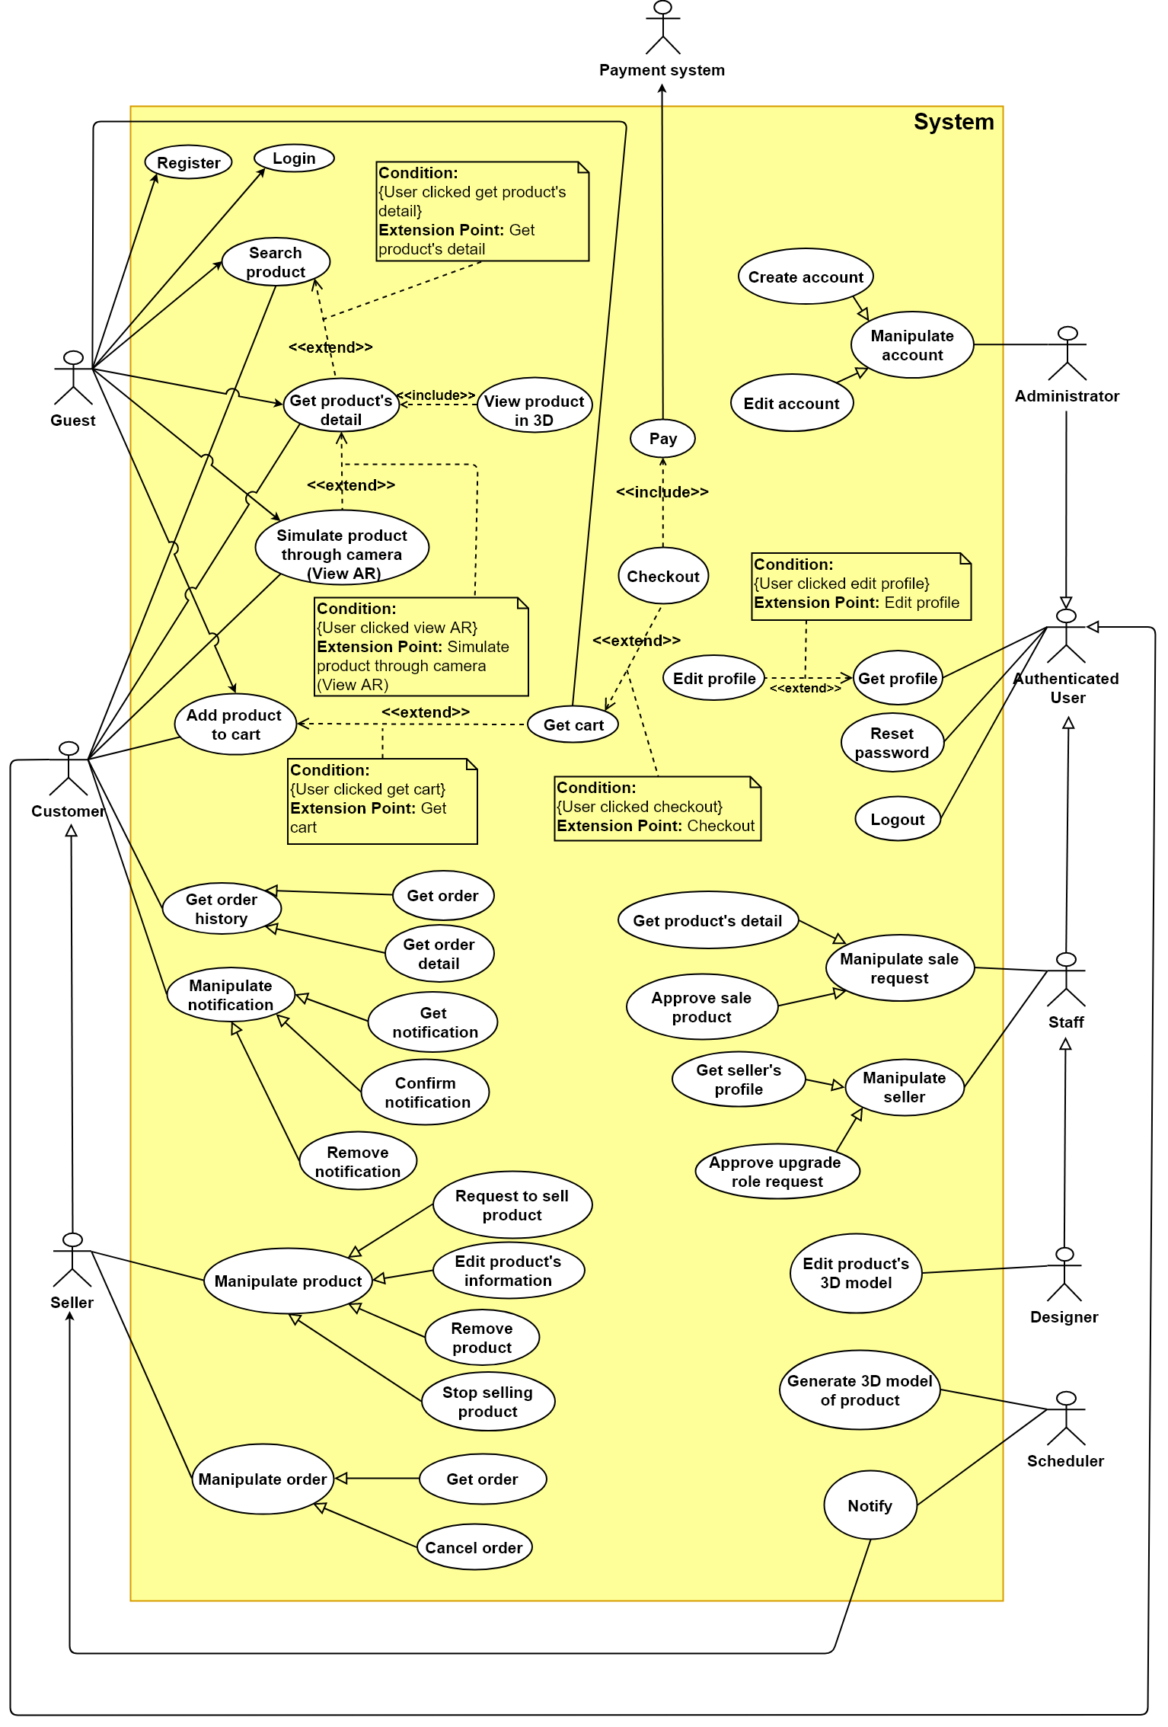

Figure 2: System Overview Usecase

### 2.3 List of Usecase

**2.3.1 < Administrator > Overview Usecase**

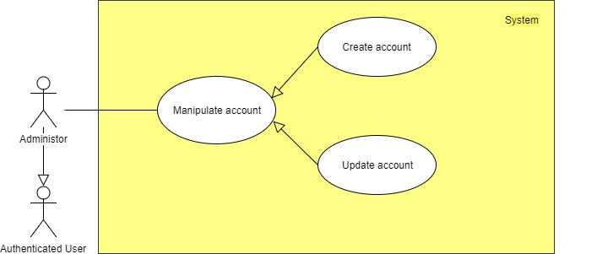

Figure 3: <Administrator> Overview UseCase

**2.3.1.1 < Administrator > Create account Usecase**

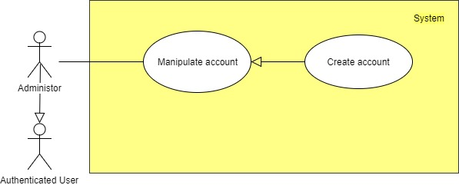

Figure 4: <Administrator> Create account Usecase

|  |  |  |  |
| --- | --- | --- | --- |
| **USE CASE – UC \_A.01** | | | |
| **Usecase No.** | A.01 | **Usecase Version** | 1.0 |
| **Usecase Name** | Create account | | |
| **Author** | KhoaNPA | | |
| **Date** | 17/01/2018 | **Priority** | Normal |
| **Actor:**   * Administrator.   **Summary:**   * This use case allows administrator to create a new account for staff.   **Goal:**   * Staff can login into system with role “Staff” by using this account.   **Triggers:**   * Administrator sends create account command to the system.   **Preconditions:**   * User must login into system with role Administrator.   **Post Conditions:**   * **Success**: New account is added to the system. * **Fail**: Show error message.   **Main Success Scenario:**   |  |  |  | | --- | --- | --- | | **Step** | **Actor Action** | **System Response** | | 1 | Administrator goes to create account view. | Create account view is shown with following labels and fields:   * Username: text, required, length 3 – 50 * Fullname: text, required, length 3 – 50 * Address: text, required, length 3 – 250 * City: dropdown list, require * Email: text, required, length 8 – 90 * Phone number: text, required, length 7 – 12 * Identity card: text, required, length 9 – 12 | | 2 | Administrator fills out the form. |  | | 3 | Administrator sends create account command. | Validate data.  [Exception 1]  Add new account in the system.  System shows message account has been created successfully. |   **Alternative Scenario:** N/A  **Exceptions:**   |  |  |  | | --- | --- | --- | | **No** | **Cause** | **System Response** | | 1 | Administrator sends command to create account. | System shows error message to ask administrator enters missing required fields. |   **Relationships:** N/A  **Business** **Rules**:   * In case of success scenarios, a new account would be added to the system. * Staff’s email must not be duplicate. * An email address must be validated by this regular expression:  /^([a-z0-9\_\.-]+)@([\da-z\.-]+)\.([a-z\.]{2,6})$/ * Phone number and Identity card must be string of numbers. * Staff’s identity code is automatic initialized by the system. * New account will be active in the system and has role Staff when it is created successfully. * Password default is “123456”, Staff has to change password by himself/herself. | | | |

**2.3.1.2 < Administrator > Edit account Usecase**

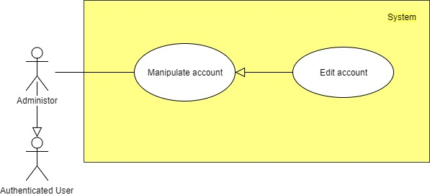

Figure 5: <Administrator> Edit account Usecase

|  |  |  |  |
| --- | --- | --- | --- |
| **USE CASE – UC \_A.02** | | | |
| **Usecase No.** | UC \_A.02 | **Usecase Version** | 2.0 |
| **Usecase Name** | Edit account | | |
| **Author** | KhoaNPA | | |
| **Date** | 17/01/2018 | **Priority** | Normal |
| **Actor**:   * Administrator.   **Summary**:   * This use case allows administrator to update account information of Staff.   **Goal**:   * Information will be customized to be reasonable.   **Triggers**:   * Administrator sends update account information command.   **Preconditions**:   * User must login into the system with role Administrator.   **Post Conditions**:   * **Success**: Staff’s information is updated succesfully. * **Fail**: Show error message.   **Main Success Scenario**:   |  |  |  | | --- | --- | --- | | **Step** | **Actor Action** | **System Response** | | 1 | Administrator goes to update account information | Update account view is shown with following labels and fields:   * Fullname: text, required, length 3 – 50 * Address: text, required, length 3 – 250 * City: dropdown list, require * Email: text, required, length 3 – 80 * Phone number: text, required, length 7 – 11 * Identify card: text, required, length 9 – 12 | | 2 | Administrator fills out the form. |  | | 3 | Administrator sends command to update account information. | Validate data  [Exception 1]  Update account information to the system.  Reload account detail |   **Alternative** **Scenario**: N/A  **Exceptions**:   |  |  |  | | --- | --- | --- | | **No** | **Cause** | **System Response** | | 1 | Administrator sends command to update account. | System shows error message to ask administrator to enter missing required fields. |   **Relationships**: N/A  **Business** **Rules**:   * Staff information is always loaded from the system. * In case of success scenarios, staff information would be updated to the system. * Reloaded customer detail will display customer updated information. * An email address must be validated by this regular expression: /^([a-z0-9\_\.-]+)@([\da-z\.-]+)\.([a-z\.]{2,6})$/ * Phone number and Identity card must be string of numbers. * Staff current information must be shown in its respective fields. | | | |

**2.3.2 < Authenticated User > Overview Usecase**

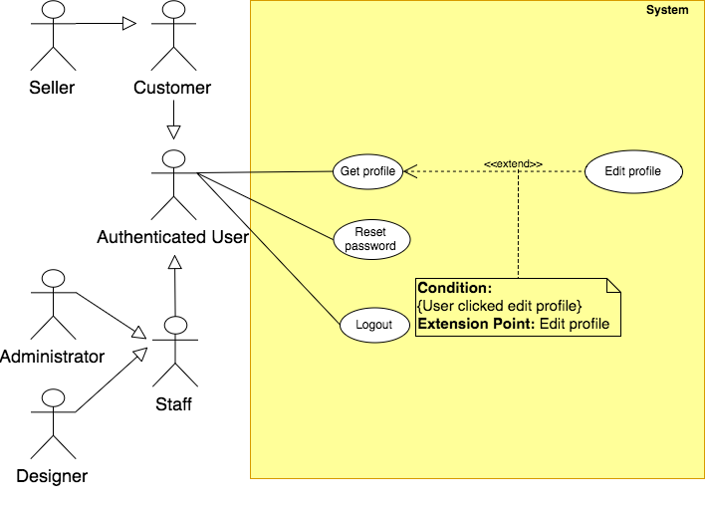

Figure 6: <Authenticated User> Overview Usecase

**2.3.2.1 < Authenticated User > Log out Usecase**

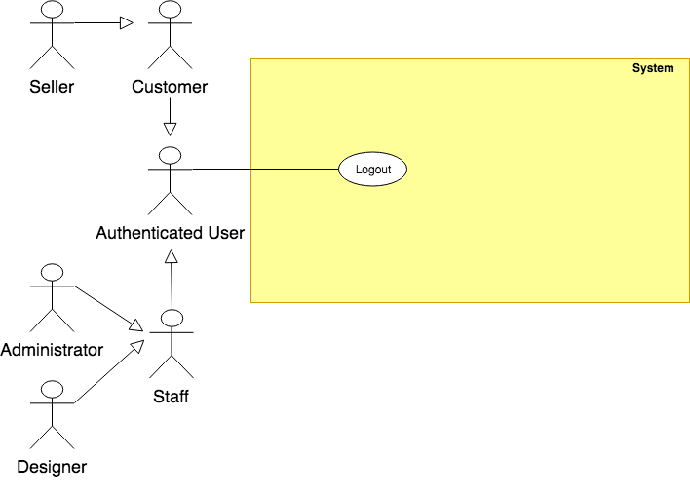

Figure 7: <Authenticated User> Log out Usecase

|  |  |  |  |
| --- | --- | --- | --- |
| **USE CASE – UC\_AU.01** | | | |
| **Usecase No.** | **UC\_AU.01** | **Usecase Version** | 1.0 |
| **Usecase Name** | Logout | | |
| **Author** | KhoaNPA | | |
| **Date** | 17/01/2018 | **Priority** | Normal |
| **Actor**:   * Authenticated User   **Summary**:   * This use case allows user to log out the system.   **Goal**:   * Authenticated user stops accessing the system. * User’s session is removed from the system.   **Triggers**:   * User sends the logout command.   **Preconditions**:   * User logged in the system.   **Post** **Conditions**:   * Success: User logs out the system. * Fail: Show error message.   **Main** **Success** **Scenario**:   |  |  |  | | --- | --- | --- | | **Step** | **Actor Action** | **System Response** | | 1 | User sends logout command. | User exits from the system. |   **Alternative** **Scenario**: N/A  **Exceptions**: N/A  **Relationships**: N/A  **Business** **Rules**:   * If user is inactive in 30 minutes, system automatically logouts user. | | | |

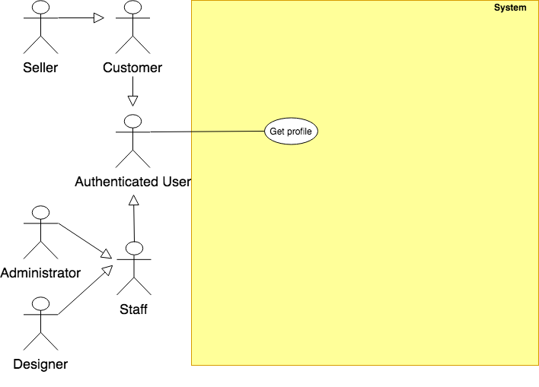2.3.2.2 < Authenticated User > Get Profile Usecase

Figure 8: <Authenticated User> Get profile Usecase

|  |  |  |  |
| --- | --- | --- | --- |
| **USE CASE – UC\_AU.02** | | | |
| **Usecase No.** | **UC\_AU.02** | **Usecase Version** | 1.0 |
| **Usecase Name** | Get profile | | |
| **Author** | KhoaNPA | | |
| **Date** | 17/01/2018 | **Priority** | Normal |
| **Actor**:   * Authenticated user.   **Summary**:   * This use case helps user to get his/her profile’s detail.   **Goal**:   * Authenticated user can get information from his/her profile’s detail   **Triggers**:   * Authenticated user sends get profile command.   **Preconditions**:   * User must login into the system. * If user role is staff, this account status must be “active”.   **Post** **Conditions**:   * **Success**: User’s profile is shown. * **Fail**: Show error message.   **Main** **Success** **Scenario**:   |  |  |  | | --- | --- | --- | | **Step** | **Actor Action** | **System Response** | | 1 | Authenticated user sgoes to get profile view. | System displays profile information:   * Role: text * Username: text * Full name: text * Birthday: text * Sexual: text * Email: text * Address: text * City: text |   **Exceptions:**   |  |  |  | | --- | --- | --- | | No | Actor Action | System Response | | 1 | User sends view personal information command | User has been logged out because of inactivity too long. |   **Relationships**: N/A  **Business** **Rules**:   * Profile information is always loaded from the system. * If user is inactive in 60 minustes, system will automatically log user out. | | | |

**2.3.2.3 < Authenticated User > Edit Profile Usecase**  
**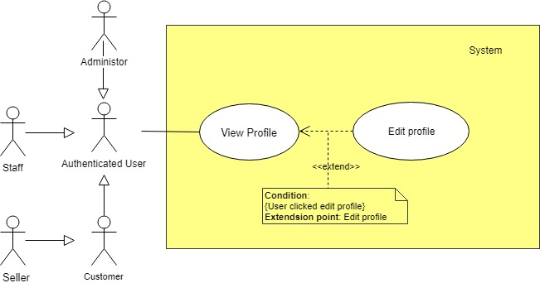**

Figure 9: <Authenticated User> Edit profile Usecase

|  |  |  |  |
| --- | --- | --- | --- |
| **USE CASE – UC\_AU.03** | | | |
| **Usecase No.** | **UC\_AU.03** | **Usecase Version** | 1.0 |
| **Usecase Name** | Edit profile | | |
| **Author** | KhoaNPA | | |
| **Date** | 17/01/2018 | **Priority** | Normal |
| **Actor**:   * Authenticated User.   **Summary**:   * This use case helps user to change their profile.   **Goal**:   * Authenticated user can change their information and password for security.   **Triggers**:   * User sends edit profile command.   **Preconditions**:   * User must login into the system. * If user role is staff, this account status mus be “active”.   **Post** **Conditions**:   * **Success**: Update user’s profile to the system. * **Fail**: Show error message.   **Main** **Success** **Scenario**:   |  |  |  | | --- | --- | --- | | **Step** | **Actor Action** | **System Response** | | 1 | User goes to edit profile view. | Display new view contains labels and textboxes for user to input their information, current and new password:   * Fullname: text, required, length 3-50 * Address: text, required, length 3-250 * City: dropdown list, required. * Email: text, required, length 8-90 * Phone number: text, required, length 7-12 * Identity card: text, required, length 9-10 * Current password: text, required, length 6-50 * New password: text, required, length 6-50 * Confirm new password: text, required, length 6-50   If user has “Customer” role, system displays more field and label:   * Request upgrade role to Seller: button.   [Alternative 1] | | 2 | User fill out required input. |  | | 3 | User sends edit profile command.  [Alternative 2] | Show message to notify that the profile has been updated successfully.  [Exception 1,2] |   **Alternative** **Scenario**:   |  |  |  | | --- | --- | --- | | **No** | **Cause** | **System Response** | | 1 | User goes to edit view | If user has “Customer” role and has sent command to Request upgrade role to Seller, system displays more fields and labels:   * Request upgrade role to Seler: text. * Status: text. | | 2 | If user has “Customer” role and sends command to Request upgrade role to Seller | Show message to notify that request succeed. |   **Exceptions**:   |  |  |  | | --- | --- | --- | | **No** | **Cause** | **System Response** | | 1 | If user inputs the wrong current password | Show message to notify that the current password is wrong. | | 2 | If the new password and the confirm password not matched. | Show message to notify that the confirm password is not matched with the new password. |   **Relationships**: N/A  **Business** **Rules**:   * In case of successful scenario, user profile would be updated to the system. * Password must be encrypted before save into the system. * The new password must different than the old password. * If user is inactive in 30 minutes, system will automatically log user out. * The user should be able to know how strong their password is when they input their new password * Request upgrade role to seller will be sent to the system with inputted information. * New request status will be set to “Pending”. * A notification will be sent to the staff after the process is completed. | | | |

**2.3.2.3 < Authenticated User > Reset password Usecase**

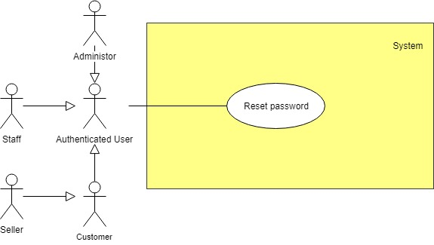

Figure 10: <Administrator> Reset passwrd Usecase

|  |  |  |  |
| --- | --- | --- | --- |
| **USE CASE – UC\_AU.03** | | | |
| **Usecase No.** | **UC\_AU.03** | **Usecase Version** | 1.0 |
| **Usecase Name** | Reset password | | |
| **Author** | KhoaNPA | | |
| **Date** | 17/01/2018 | **Priority** | Normal |
| **Actor**:   * Authenticated User.   **Summary**:   * This usecase allows user to reset password.   **Goal**:   * User can be received new password in their email by the system.   **Triggers**:   * User sends reset password command.   **Preconditions**: N/A  **Post** **Conditions**:   * **Success**: Systerm will send new password into user’s email. * **Fail**: Show error message.   **Main** **Success** **Scenario**:   |  |  |  | | --- | --- | --- | | **Step** | **Actor Action** | **System Response** | | 1 | User goes to login view. | Login view is shown with following labels and fields:   * Email or customer code: text * Password: text * Reset password: button. | | 2 | User goes to reset password view. | System display new view with required information label and textbox:   * User email: text, required, length 8-90   . | | 3 | User fills out require information |  | | 4 | User sends command to reset password | - Validate email  - System display reset password successfully, please check your email message.  - System will send new password into user’s email.  - The new password is updated in the system.  [Exception 1,2] |   **Alternative** **Scenario**: N/A  **Exceptions**:   |  |  |  | | --- | --- | --- | | **No** | **Cause** | **System Response** | | 1 | Missing of required fields | Show message notify user input missed fields | | 2 | Entered email is not existed in the system | Show message notify entered email not existed |   **Relationships**: N/A  **Business** **Rules**:   * System will check the entered email is existed in the database or not. * The new password is updated in the system. * User can login into the system with new password and change it with edit profile command. | | | |

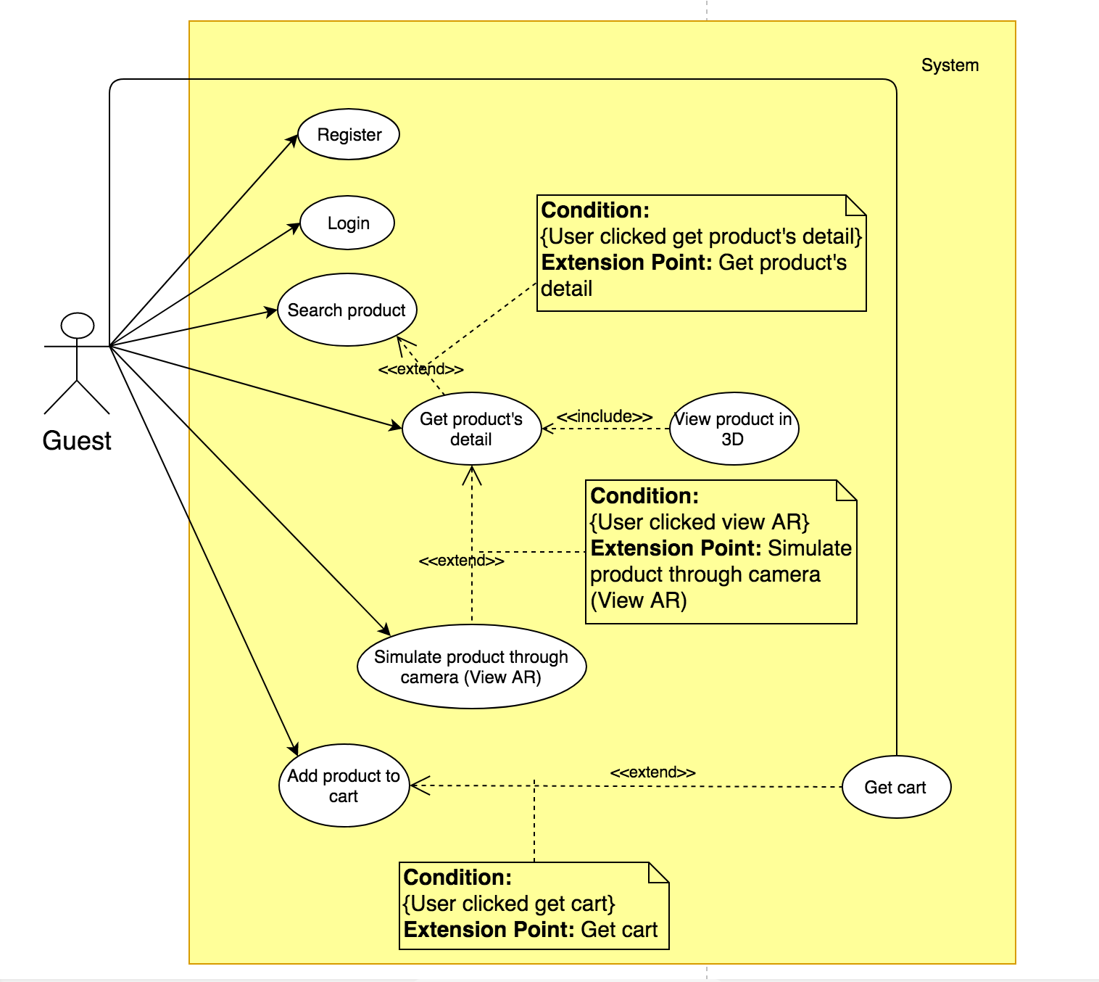**2.3.3 < Guest > Overview Usecase**

**Figure 11: <Guest> Overview Usecase**

**2.3.3.1 < Guest > Login Usecase**

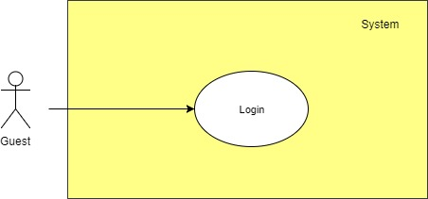

**Figure 12:<Guest> Log in Usecase**

|  |  |  |  |
| --- | --- | --- | --- |
| **USE CASE – UC\_G.01** | | | |
| **Usecase No.** | **UC\_G.01** | **Usecase Version** | 2.0 |
| **Usecase Name** | Login | | |
| **Author** | KhoaNPA | | |
| **Date** | 16/01/2018 | **Priority** | Normal |
| **Actor:**   * Guest   **Summary:**   * This use case allows guest to login into the system   **Goal:**   * Guest must be authenticated and authorized before access the system. * New session is created.   **Triggers:**   * Guest sends the login command.   **Preconditions:** N/A  **Post Conditions:**   * **Success:** Guest login the system. * **Fail:** Show error message.   **Main Success Scenario:**   |  |  |  | | --- | --- | --- | | **Step** | **Actor Action** | **System Response** | | **1** | Guest goes to login view. | System requires identity information from Guest:   * Username: text, required, length 3 – 50 * Password: text, required, length 6 – 50 | | **2** | Guest fill out information. |  | | **3** | Guest sends command to login to system | Guest will login system with their specific role  [Exception 1,2] |   **Alternative Scenario:** N/A | | | |
| **Exceptions:**   |  |  |  | | --- | --- | --- | | **No** | **Cause** | **System Response** | | **1** | Missing of required fields | System notify guest to enter their identity information | | **2** | Guest enter wrong identity information. | Wrong identity information, System shows error message. |   **Relationships:** N/A  **Business Rules:**   * Password are encrypted before being sent to server. * After login to system, guest will be redirected to specific view based on their role on the system:   + If role is “Staff”, the system will display to Staff Dashboard view.   + If role is “Administrator”, the system will display to Administrator Dashboard view.   + If role is “Customer”, the system will display to Customer view.   + If role is “Seller”, the system will display to Seller view. | | | |

**2.3.3.2 < Guest > Register Usecase**

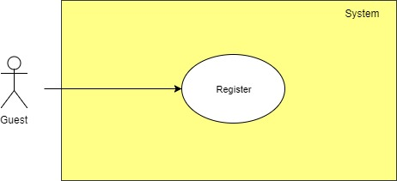

**Figure 13: <Guest> Register Usecase**

|  |  |  |  |
| --- | --- | --- | --- |
| **USE CASE – UC\_G.02** | | | |
| **Usecase No.** | **UC\_G.03** | **Usecase Version** | 2.0 |
| **Usecase Name** | Register | | |
| **Author** | KhoaNPA | | |
| **Date** | 17/01/2018 | **Priority** | Normal |
| **Actor:**   * Guest   **Summary:**   * This use case allows guest to register to system.   **Goal:**   * System can recognize the new account. * User can login into the system with role “Customer”.   **Triggers:**   * Guest sends register command.   **Preconditions:** N/A   * This username hasn’t existed in the system yet.   **Post Conditions:**   * **Success:** New account is added to the system. * **Fail: S**hows error me**s**sage.   **Main Success Scenario:**   |  |  |  | | --- | --- | --- | | **Step** | **Actor Action** | **System Response** | | 1 | Guest goes to Register view | Register view is shown with following labels and fields:   * Username: text, required, length 3 – 50 * Password: text, required, length 3 – 50 * Confirm password: text, required, length 3 – 50 * Fullname: text, required, length 3 – 50 * Address: text, required, length 3 – 250 * City: dropdown list, require * Email: text, required, length 8 – 90 * Phone number: text, required, length 7 – 12 | | 2 | Guest fill out the form |  | | 3 | Guest sends register command. | Validate data  [Exception 1, 2, 3, 4, 5]  Add new account to the system.  Display register success message. |   **Alternative Scenario:** N/A  **Exceptions:**   |  |  |  | | --- | --- | --- | | **No** | **Cause** | **System Response** | | 1 | Missing of required fields | Show message notifying guest inputed missed fields. | | 2 | Length of field’s value is out of range | Show message notifying guest which field’s value is out of range. | | 3 | Password and Confirm password don’t match. | Show message notifying Password and Confirm password don’t match. | | 4 | Entered email address is not a valid email | Show message notify entered email is not valid | | 5 | Entered email is existed in the system | Show message notify entered email is existed |  |  |  |  |  | | --- | --- | --- | --- | | **USE CASE – UC\_G.03** | | | | | **Usecase No.** | **UC\_G.02** | **Usecase Version** | 2.0 | | **Usecase Name** | Search product | | | | **Author** | KhoaNPA | | | | **Date** | 17/01/20178 | **Priority** | Normal | | **Actor:**   * Guest   **Summary:**   * This use case allows guest to search products in the system   **Goal**:   * Guest can view products and its detail. * Guest can simulate products through camera.   **Triggers:**   * Guest sends search command to the system.   **Preconditions: N/A**  **Post Conditions:**   * **Success:** System shows a list of products or message “Don’t have any product is matched with your requirement”. * **Fail:** System shows error page   **Main Success Scenario:**   |  |  |  | | --- | --- | --- | | **Step** | **Actor Action** | **System Response** | | 1 | Guest goes to search view. | System suggests actor input information to find some products with actor’s criteria:   * “Product Name”: text, require. | | 2 | Guest sends search command | System shows list of products.  [Exception 1] |   **Alternative Scenario**: N/A  **Exceptions:**   |  |  |  | | --- | --- | --- | | **No** | **Cause** | **System Response** | | 1 | System can not find any product for actor | System shows message “Don’t have any product is matched with your requirement”. |   **Relationships:** <Guest> Get product’s detail Usecase (G.07)  **Business Rules:**   * System finds product with approximate name. * The product just only be showed, if its status is “active”. | | | |   **Relationships:** N/A  **Business Rules:**   * In case of success scenarios, a new account would be added to the system. * An email address must be validated by this regular expression:   /^([a-z0-9\_\-]+)@([\da-z\.-]+)\.([a-z\.]{2,6})$/  - Phone number must be string of numbers.   * New account will be active in the system and has role Customer when it is created successfully. | | | |

**2.3.3.3 < Guest > Search product Usecase**  
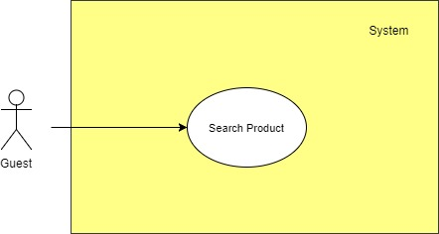

Figure 14: < Guest > Search product Usecase

**2.3.3.4 < Guest > Add to cart Usecase**  
**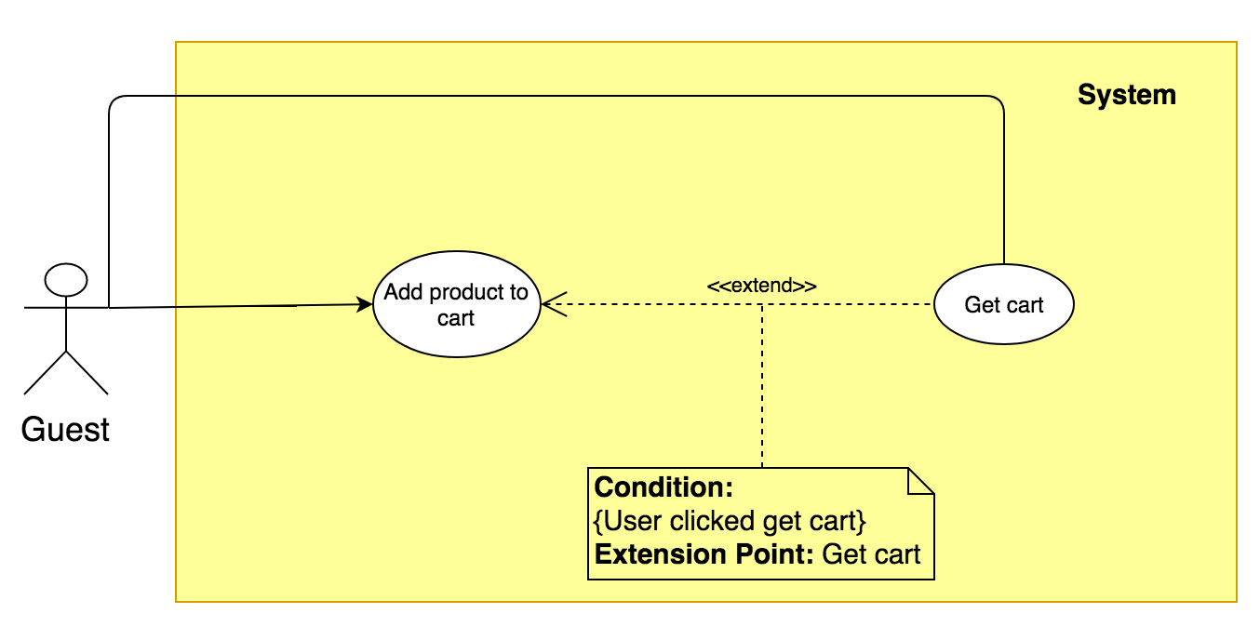**

Figure 15: < Guest > Add to cart Usecase

|  |  |  |  |
| --- | --- | --- | --- |
| **USE CASE – UC\_G.04** | | | |
| **Usecase No.** | **UC\_G.04** | **Usecase Version** | 1.0 |
| **Usecase Name** | Add product to cart | | |
| **Author** | KhoaNPA | | |
| **Date** | 17/01/20178 | **Priority** | Normal |
| **Actor:**   * Guest   **Summary:**   * This use case allows guest to add product to cart.   **Goal**:   * New product is added in guest’s cart. * If this product is already existed in guest shopping cart, quantity of product will be increase by one.   **Triggers:**   * Guest sends add product to cart command to the system.   **Preconditions:** N/A  **Post Conditions:**   * **Success:** This product is added to guest shopping cart. * **Fail:** System shows error page   **Main Success Scenario:**   |  |  |  | | --- | --- | --- | | **Step** | **Actor Action** | **System Response** | | 1 | Guest goes to Product detail view. | Product detail view is show information includes:   * Product name * Price * Product’s image * Product specifications | | 2 | Guest sends add to cart command to the system. | Systerm adds new product to guest shopping cart.  Display add to cart success message.  [Alternative 1] |   **Alternative Scenario**:   |  |  |  | | --- | --- | --- | | **No** | **Cause** | **System Response** | | 1 | This product is already existed in guest’cart. | System increases this product’s quantity in guest shopping cart by one. |   **Exceptions:** N/A  **Relationships:** <Guest> Get cart Usecase (G.5)  **Business Rules:**   * System must notify added action for guest. * If the product is existed in guest’s shopping cart, the quantity of the product is increased by one. | | | |

**2.3.3.5 < Guest > Get cart Usecase**



Figure 16: < Guest > Get cart Usecase

|  |  |  |  |
| --- | --- | --- | --- |
| **USE CASE – UC\_G.05** | | | |
| **Usecase No.** | **UC\_G.05** | **Usecase Version** | 2.0 |
| **Usecase Name** | Get cart | | |
| **Author** | KhoaNPA | | |
| **Date** | 17/01/20178 | **Priority** | Normal |
| **Actor:**   * Guest   **Summary:**   * This use case allows to show guest their cart information.   **Goal**:   * Guest can view their cart and its details. * Guest can change the quantity or remove product in their cart. * System show total price of shopping cart.   **Triggers:**   * Guest sends get cart command to the system.   **Preconditions: N/A**  **Post Conditions:**   * **Success:** System shows the guest shopping cart information. * **Fail:** System shows error page   **Main Success Scenario:**   |  |  |  | | --- | --- | --- | | **Step** | **Actor Action** | **System Response** | | 1 | Guest sends get cart command | Display cart view with each product’s details:   * Product image * Procduct name * Price * Quantity   and total price.  [Alternative 1] |   **Alternative Scenario**:   |  |  |  | | --- | --- | --- | | **No** | **Cause** | **System Response** | | 1 | There is no product in shopping cart. | Show message to notify that there is no product in shopping cart. |   **Exceptions:** N/A  **Relationships:**   * <Guest> Add to cart Usecase (G.04) * <Guest> Checkout Usecase (G.06)   **Business Rules:**   * The information is loaded from the system. * List of products is sorted by order date. * In each product, guest can change the quantity of products or remove products from cart. * The price in each product would be price of product. * The total price would be calculated by price of all products. * If product is changed about the quantity or is removed, the total price will be reloaded automatic. | | | |

**2.3.3.6 < Guest > Simulate product through camera Usecase**

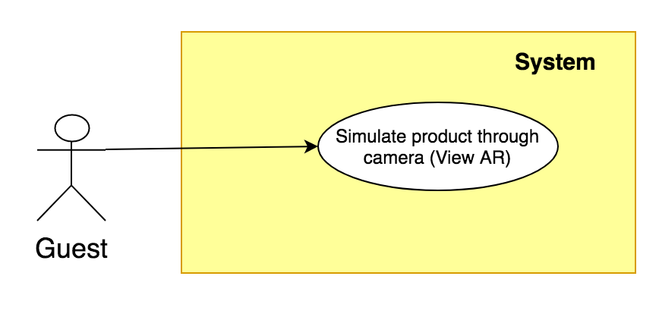

Figure 17: <Guest> Simulate product through camera Usecase

|  |  |  |  |
| --- | --- | --- | --- |
| **USE CASE – UC\_G.07** | | | |
| **Usecase No.** | **UC\_G.06** | **Usecase Version** | 2.0 |
| **Usecase Name** | Simulate product through camera (View AR) | | |
| **Author** | KhoaNPA | | |
| **Date** | 17/01/2018 | **Priority** | Normal |
| **Actor:**   * Guest   **Summary:**   * This use case allows guest to simulate product in real-word through camera.   **Goal**:   * Product’s 3D model is placed in flast surface or plane through camera. * Guest can use fingers to move or rotating the 3D model.   **Triggers:**   * Guest sends command to simulate furniture.   **Preconditions:** N/A  **Post Conditions:**   * **Success:** 3D model of product is putted to flast surface. * **Fail:** System shows error page   **Main Success Scenario:**   |  |  |  | | --- | --- | --- | | **Step** | **Actor Action** | **System Response** | | 1 | Guest goes to simulate view | System loaded list of products. | | 2 | Guest chooses a product and sends command to simulate. | System passess through the camera.  System displays 3D model of the product into camera monitor.  System detects plane, flat surface.  [Exception 1] | | 3 | Guest using one finger to move this object to planes, flat surfaces.  [Alternative 1, 2] | System tracks position of this object.  [Exception 2] |   **Alternative Scenario**:   |  |  |  | | --- | --- | --- | | **No** | **Cause** | **System Response** | | 1 | If guest want to simulate other furniture, sends command to simulater furniture. | System forwards to simulate view. | | 2 | Guest using two fingers to rotate the object. | System holds fixed the object on plane. | | 3 | Guest can move the phone through. | System tracks and hold fixed the object on the position where it is putted. |   **Exceptions:**   |  |  |  | | --- | --- | --- | | **No** | **Cause** | **System Response** | | 1 | System can not load 3D model of this product. | System shows error message. | | 2 | System can not detect the plane, flat surface. | System shows error message. |   **Relationships:** <Guest> Get product’s detail  **Business Rules:**   * System allows the phone to understand and track its position relate to the world. * System allows the phone to detect the size and location of flat horizontal surfaces. * System will hold fixed the 3D model in their position, the object won’t move while user moves the phone through. * User can interact (move, rotate) with objects by using their fingers. | | | |

**2.3.3.7 < Guest > Get product’s detail.**

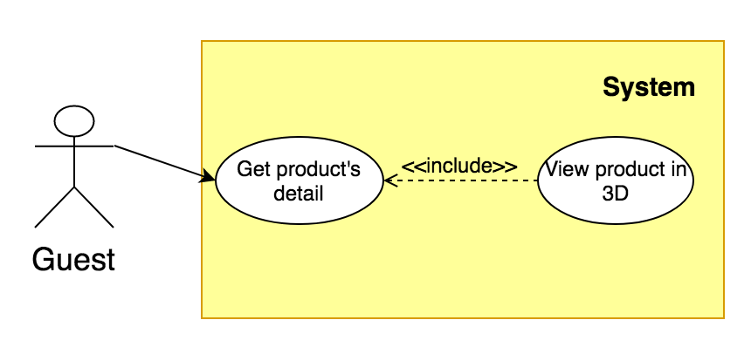

Figure 18: <Guest> Get product’s detail.

|  |  |  |  |
| --- | --- | --- | --- |
| **USE CASE – UC\_G.07** | | | |
| **Usecase No.** | **UC\_G.07** | **Usecase Version** | 2.0 |
| **Usecase Name** | ThienBT. | | |
| **Author** | KhoaNPA | | |
| **Date** | 17/01/2018 | **Priority** | Normal |
| **Actor:**   * Guest   **Summary:**   * This use case allows guest to get detail of product.   **Goal**:   * Guest can view information about product.   **Triggers:**   * Guest sends command to get product’s detail.   **Preconditions:** N/A  **Post Conditions:**   * **Success:** Product’s detail informations is displayed for guest. * **Fail:** System shows error page   **Main Success Scenario:**   |  |  |  | | --- | --- | --- | | **Step** | **Actor Action** | **System Response** | | 1 | Guest goes to products view | System loaded list of products. | | 2 | Guest chooses a product and sends command to get detail. | System displays product’s detail information.  [Exception 1] |   **Alternative Scenario**:   |  |  |  | | --- | --- | --- | | **No** | **Cause** | **System Response** | | 1 | If guest want to simulate product through camera (View AR), sends command to simulater product. | System forwards to simulate view. | | 2 | If guest want to view product in 3D, sends command to view product in 3D. | System displays product’s in 3D. |   **Exceptions:**   |  |  |  | | --- | --- | --- | | **No** | **Cause** | **System Response** | | 1 | System can not load product informations. | System shows error message. |   **Relationships:**   * <Guest> Search product (G.02) * <Guest> Simulate product through camera (View AR) (G.06)   **Business Rules:**   * System allow guest to view product’s detail. * Guest can view information of product. | | | |

**2.3.3.8 < Guest > View product in 3D.**



Figure 19: < Guest > View product in 3D

|  |  |  |  |
| --- | --- | --- | --- |
| **USE CASE – UC\_G.07** | | | |
| **Usecase No.** | **UC\_G.08** | **Usecase Version** | 2.0 |
| **Usecase Name** | View product in 3D. | | |
| **Author** | ThienBT | | |
| **Date** | 17/01/2018 | **Priority** | Normal |
| **Actor:**   * Guest   **Summary:**   * This use case allows guest to view product in 3D.   **Goal**:   * Guest can view intuitive and overall look in all directions of the product.   **Triggers:**   * Guest sends command to view product in 3D.   **Preconditions:**   * Guest get product’s detail.   **Post Conditions:**   * **Success:** Guest view product in 3D. * **Fail:** System shows error page   **Main Success Scenario:**   |  |  |  | | --- | --- | --- | | **Step** | **Actor Action** | **System Response** | | 1 | Guest chooses a product and sends command to get detail | System displays product’s detail information. | | 2 | Guest sends command to view product in 3D. | System load product and show product in 3D through mobile screen. |   **Alternative Scenario**: N/A  **Exceptions:**   |  |  |  | | --- | --- | --- | | **No** | **Cause** | **System Response** | | 1 | System can not load product in 3D. | System shows error message. |   **Relationships:**   * <Guest> Get product’s detail. (G.07)   **Business Rules:**   * System allow guest to view product in 3D. * Guest can rotate product by using their fingers to view intuitive and overall look in all directions of the product. | | | |

**2.3.4 < Customer > Overview Usecase**

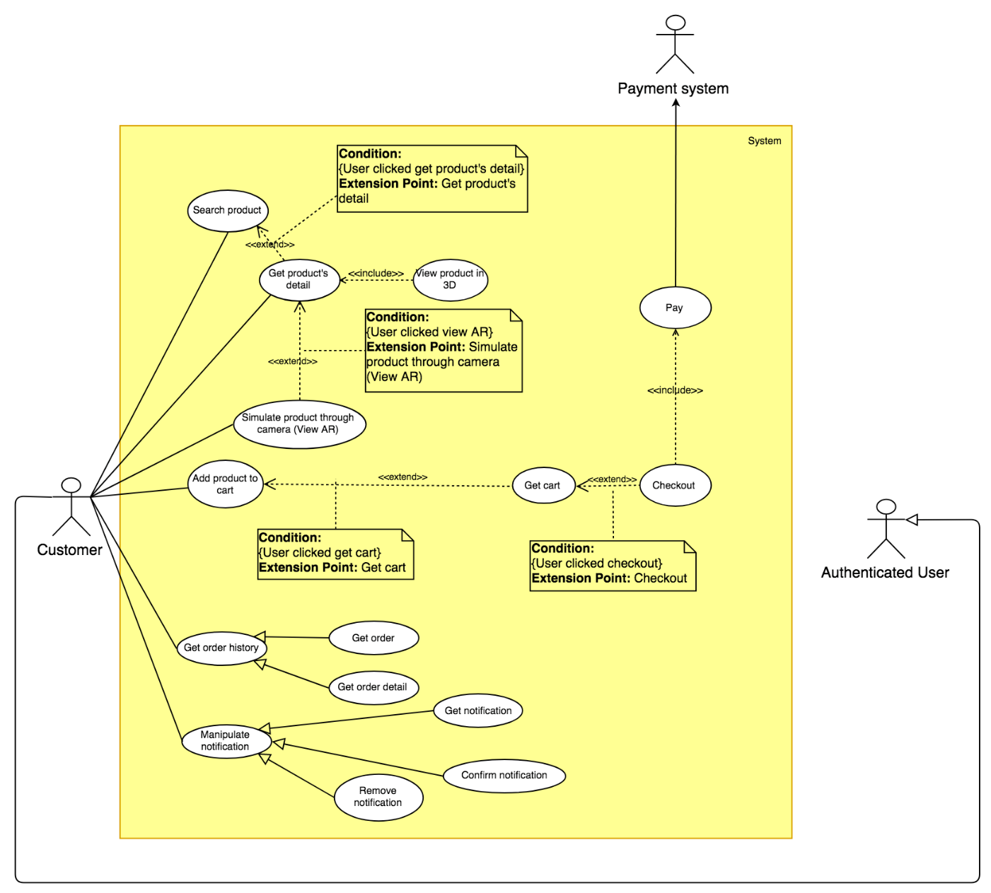

Figure 20: < Customer > Overview Usecase

**2.3.4.1 < Customer > Search Product Usecase**

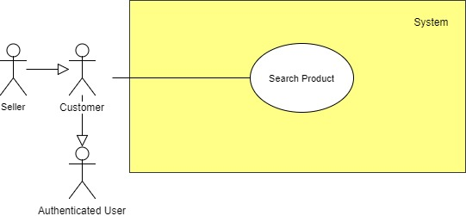

Figure 21:<Customer> Search product Usecase

|  |  |  |  |
| --- | --- | --- | --- |
| **USE CASE – UC\_C.01** | | | |
| **Usecase No.** | **UC\_C.01** | **Usecase Version** | 2.0 |
| **Usecase Name** | Search product | | |
| **Author** | DucPH | | |
| **Date** | 17/01/20178 | **Priority** | Normal |
| **Actor:**   * Customer   **Summary:**   * This use case allows Customer to search products in the system   **Goal**:   * Customer can view products and its detail.   **Triggers:**   * Customer sends search command to the system.   **Preconditions:** N/A  **Post Conditions:**   * **Success:** System shows a list of products. * **Fail:** System shows error message.   **Main Success Scenario:**   |  |  |  | | --- | --- | --- | | **Step** | **Actor Action** | **System Response** | | 1 | Customer goes to search view. | System suggest actor input information to find some products with actor’s criteria:   * “Product Name”: text, required. | | 2 | Customer send search command | System shows list of products.  [Exception 1] |   **Alternative Scenario**: N/A  **Exceptions:**   |  |  |  | | --- | --- | --- | | **No** | **Cause** | **System Response** | | 1 | System can not find any product for actor | System shows message “No result found”. |   **Relationships:** N/A  **Business Rules:**   * System finds product with approximate name. * The product just only be showed, if its status is “Approved”. | | | |

**2.3.4.2 < Customer > Add to cart Usecase**

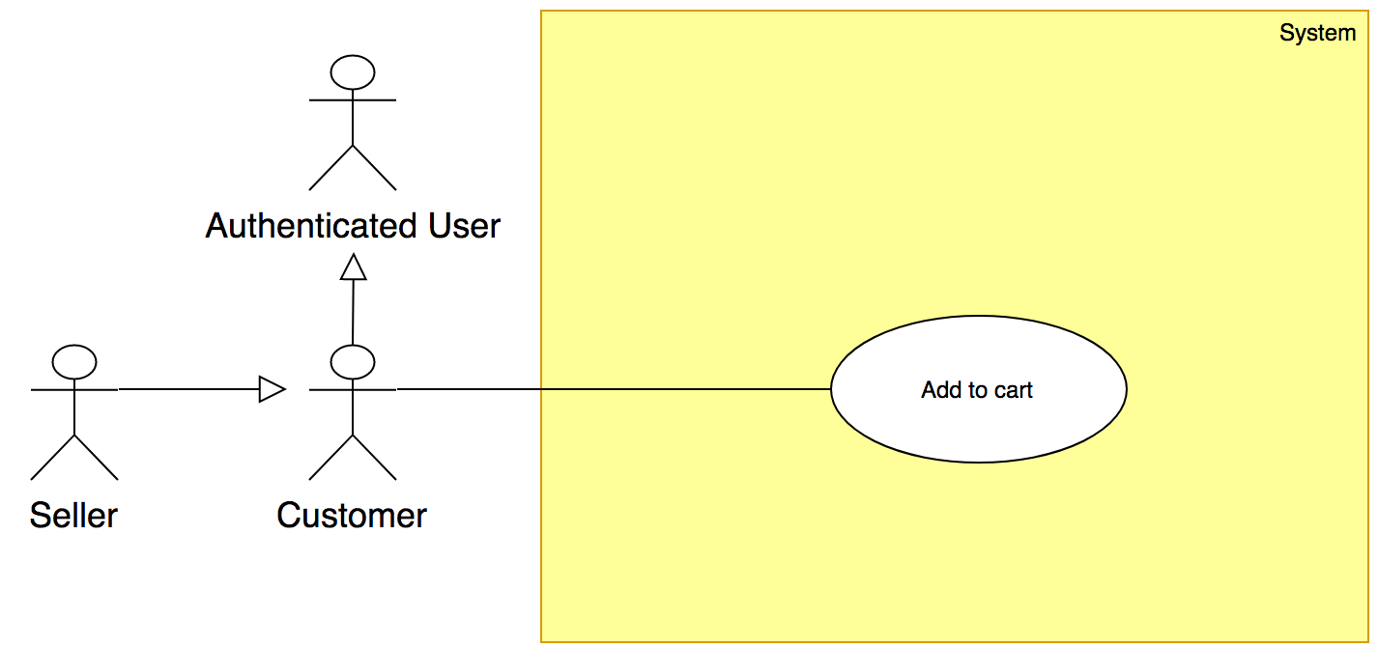

Figure 22: <Customer> Add to cart Usecase

|  |  |  |  |
| --- | --- | --- | --- |
| **USE CASE – UC\_C.02** | | | |
| **Usecase No.** | **UC\_C.02** | **Usecase Version** | 2.0 |
| **Usecase Name** | Add to cart | | |
| **Author** | DucPH | | |
| **Date** | 17/01/2018 | **Priority** | Normal |
| **Actor:**   * Customer   **Summary:**   * This use case allows customer to add product to their cart.   **Goal**:   * New product is added in shopping cart. * If this product is already existed in shopping cart, quantity of product will be increase by one   **Triggers:**   * Customer send add product to cart command to the system.   **Preconditions:** N/A  **Post Conditions:**   * **Success:** This product is added to customer’s cart. * **Fail:** System shows error message.   **Main Success Scenario:**   |  |  |  | | --- | --- | --- | | **Step** | **Actor Action** | **System Response** | | 1 | Customer sends add to cart command to the system. | System adds new product to customer shopping cart. |   **Alternative Scenario**: N/A  **Exceptions:** N/A  **Relationships:** <Customer> Get cart Usecase (C.02)  **Business Rules:**   * If the product is existed in customer’s shopping cart, the quantity of the product is increased by one. | | | |

**2.3.4.3 < Customer > Get cart Usecase**

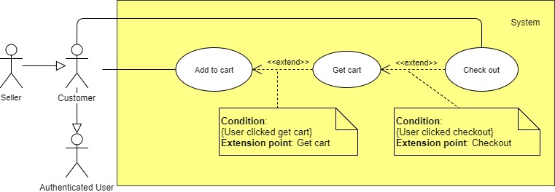

Figure 23: <Customer> Get cart Usecase

|  |  |  |  |
| --- | --- | --- | --- |
| **USE CASE – UC\_C.03** | | | |
| **Usecase No.** | **UC\_C.03** | **Usecase Version** | 2.0 |
| **Usecase Name** | Get cart | | |
| **Author** | DucPH | | |
| **Date** | 17/01/20178 | **Priority** | Normal |
| **Actor:**   * Customer   **Summary:**   * This use case allows to show customer’s shopping cart.   **Goal**:   * Customer can view their shopping cart and its details. * Customer can change the quantity or remove product in their shopping cart. * System show total price of shopping cart.   **Triggers:**   * Customer sends get cart command to the system.   **Preconditions:** N/A  **Post Conditions:**   * **Success:** System shows the customer’cart information. * **Fail:** System shows error message.   **Main Success Scenario:**   |  |  |  | | --- | --- | --- | | **Step** | **Actor Action** | **System Response** | | 1 | Customer sends get cart command | Display cart view with each product’s details:   * Product image: JPG * Product name: text * Product provider: text * Product price: numner * Product quantity: number * Total price: number   [Alternative 1] |   **Alternative Scenario**:   |  |  |  | | --- | --- | --- | | **No** | **Cause** | **System Response** | | 1 | There is no product in shopping cart. | Display cart view with message: “Your cart is empty”. |   **Exceptions:** N/A  **Relationships:**   * <Customer> Add to cart Usecase. (C.02) * <Customer> Checkout Usecase. (C.04)   **Business Rules:**   * The information is loaded from the system. * In each product, customer can change the quantity of products or remove products from cart. * The price in each product would be price of product. * The total price would be calculated by price of all products. * If product is changed about the quantity or is removed, the total price will be reloaded automatic. | | | |

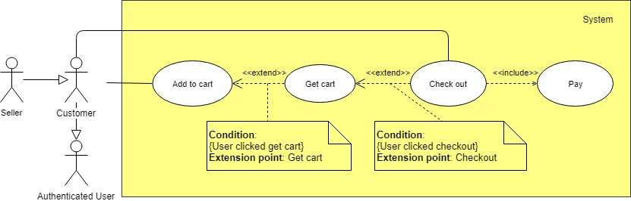**2.3.4.4 < Customer > Checkout Usecase**

Figure 24: < Customer > Checkout Usecase

|  |  |  |  |
| --- | --- | --- | --- |
| **USE CASE – UC\_C.04** | | | |
| **Usecase No.** | **UC\_C.04** | **Usecase Version** | 1.0 |
| **Usecase Name** | Checkout | | |
| **Author** | DucPH | | |
| **Date** | 17/01/2018 | **Priority** | Normal |
| **Actor:**   * Customer   **Summary:**   * This use case allows customer to check out their shopping cart.   **Goal:**   * Customer can fill out the delivery address (default is customer’s address). * Customer can choose the payment gateways. * System shows shopping cart’s information with total price.   **Triggers:**   * Customer sends check out command.   **Preconditions:**   * There is at least 1 product in customer shopping cart.   **Post Conditions:**   * **Success:** System shows customer shopping cart details and payment. * **Fail:** System shows error page   **Main Success Scenario:**   |  |  |  | | --- | --- | --- | | **Step** | **Actor Action** | **System Response** | | 1 | Customer goes to check out view | Display customer information as delivery address view with following labels and fields:   * Full name: text input, required, length 3-80. * Address: text input, required, length 3-250. * Phone number: number input, required, length 10-11.   [Exception 1] | | 2 | Customer sends processing payment command.  [Alternative 1, 2] | Display new view let user select one of following payment methods:   * Paypal payment. * COD payment. | | 3 | If customer chooses Paypal payment.  [Alternative 1] | Forward to Paypal payment view to process payment.  [Exception 2] |   **Alternative Scenario**:   |  |  |  | | --- | --- | --- | | **No** | **Cause** | **System Response** | | 1 | If customer chooses COD payment. | System shows shopping cart’s information with total fee. |   **Exceptions:**   |  |  |  | | --- | --- | --- | | **No** | **Cause** | **System Response** | | 1 | Customer sends processing payment command. | System shows error message to ask customer input missing required fields. | | 2 | If customer chooses Paypal payment. | Show message to notify customer that payment failed. |   **Relationships:**   * <Customer> Get cart Usecase (C.03) * <Payment System> Pay Usecase (PS.01)   **Business Rules:**   * Transaction code is automatic initialized by the system. * The fee in each product would be calculated by price multiplied by quantity. * Total fee would be calculated by products fee. | | | |

**2.3.4.5 < Customer > Simulate product through camera Usecase**

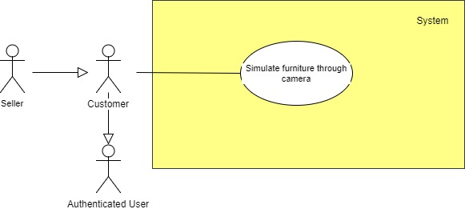

Figure 25: < Customer > Simulate product through camera Usecase

|  |  |  |  |
| --- | --- | --- | --- |
| **USE CASE – UC\_C.05** | | | |
| **Usecase No.** | **UC\_C.05** | **Usecase Version** | 2.0 |
| **Usecase Name** | Simulate furniture through camera | | |
| **Author** | DucPH | | |
| **Date** | 17/01/2018 | **Priority** | Normal |
| **Actor:**   * Customer   **Summary:**   * This use case allows customer put 3D model of product in real-word through camera.   **Goal**:   * Product’s 3D model is putted in flast surface or plane through camera. * Customer can use fingers to move or rotate the 3D model in camera.   **Triggers:**   * Customer sends command to simulate furniture.   **Preconditions:** N/A  **Post Conditions:**   * **Success:** 3D model of product is putted to flat surface. * **Fail:** System shows error message.   **Main Success Scenario:**   |  |  |  | | --- | --- | --- | | **Step** | **Actor Action** | **System Response** | | 1 | Customer goes to product view | System loaded list of products. | | 2 | Customer chooses a product and sends command to simulate. | System detect planes, flat surfaces.  System display 3D model of the product into camera monitor.  [Exception 1] | | 3 | Customer using one finger to move or rotate this object to planes, flat surfaces.  [Alternative 1, 2,3] | System tracks position of this object.  [Exception 2] |   **Alternative Scenario**:   |  |  |  | | --- | --- | --- | | **No** | **Cause** | **System Response** | | 1 | If guest wants to simulate other furniture, sends command to simulator furniture. | System forward to simulate view. | | 2 | Customer using two fingers to rotate the object. | System holds fixed the object on plane. | | 3 | Customer can move the phone through. | System tracks and hold fixed the object on position where it is putted. |   **Exceptions:**   |  |  |  | | --- | --- | --- | | **No** | **Cause** | **System Response** | | 1 | System can not load 3D model of this product. | System shows error message. | | 2 | System can not detect the plane or flat surface. | System shows error message. |   **Relationships:** N/A  **Business Rules:**   * System allows the phone to understand and track its position relate to the world. * System allows the phone to detect the size and location of flat horizontal surfaces. * System will hold fixed the 3D model in their position, the object won’t move while user move the phone through. * User can interact (move, rotate) with objects by using their fingers. | | | |

**2.3.4.6 < Customer > Get product’s detail Usecase**

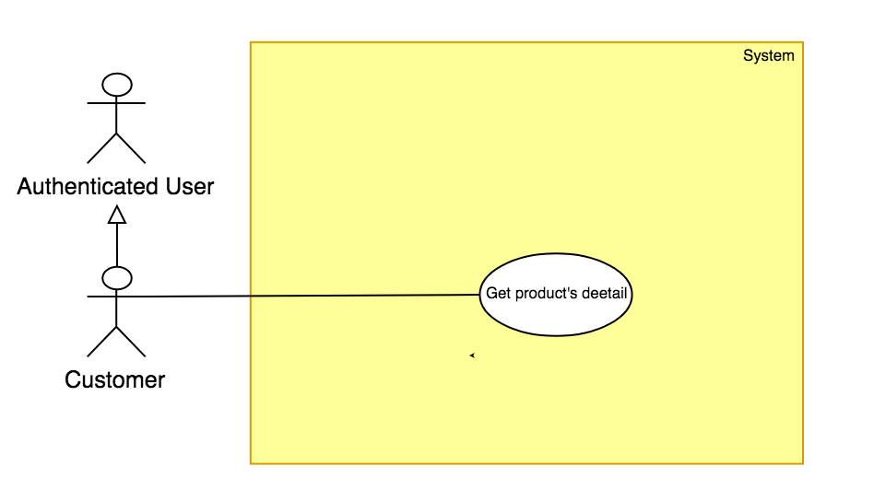

Figure 26: < Customer > Get product’s detail Usecase

|  |  |  |  |
| --- | --- | --- | --- |
| **USE CASE – UC\_C.05** | | | |
| **Usecase No.** | **UC\_C.05** | **Usecase Version** | 2.0 |
| **Usecase Name** | Get product’s detail | | |
| **Author** | DucPH | | |
| **Date** | 17/01/2018 | **Priority** | Normal |
| **Actor:**   * Customer   **Summary:**   * This use case allows customer to get product’s detail.   **Goal**:   * Customer can view product’s detail.   **Triggers:**   * Customer sends view product’s detail command.   **Preconditions:** N/A  **Post Conditions:**   * **Success:** Product’s detail information is shown. * **Fail:** System shows error message.   **Main Success Scenario:**   |  |  |  | | --- | --- | --- | | **Step** | **Actor Action** | **System Response** | | 1 | Seller goes to Manipulate order view. | System shows list of products. | | 2 | Seller selects order to view their detail information. | Display a view with product’s information:   * Name. * Origin. * Category. * Material. * Store. * Length. * Width. * Height. * Weight. * Price. * Quantity. * Describe. * Price. |   **Alternative Scenario**: N/A  **Exceptions:** N/A  **Relationships:** N/A  **Business Rules:**   * Product’s information is always loaded from the system. | | | |

**2.3.4.7 < Customer > View product in 3D Usecase**

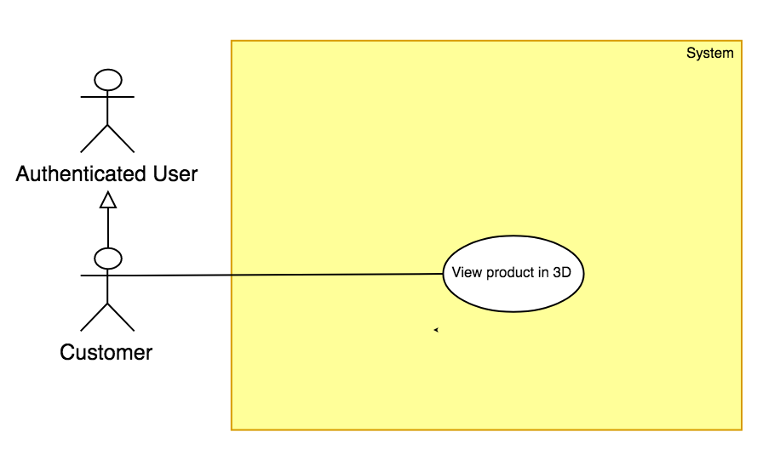

Figure 27: < Customer > View product in 3D Usecase

|  |  |  |  |
| --- | --- | --- | --- |
| **USE CASE – UC\_C.05** | | | |
| **Usecase No.** | **UC\_C.05** | **Usecase Version** | 2.0 |
| **Usecase Name** | View product in 3D | | |
| **Author** | DucPH | | |
| **Date** | 17/01/2018 | **Priority** | Normal |
| **Actor:**   * Customer   **Summary:**   * This use case allows customer to view product in 3D.   **Goal**:   * Customer can view product in 3D.   **Triggers:**   * Customer sends view product in 3D command.   **Preconditions:** N/A  **Post Conditions:**   * **Success:** View product in 3D is shown. * **Fail:** System shows error message.   **Main Success Scenario:**   |  |  |  | | --- | --- | --- | | **Step** | **Actor Action** | **System Response** | | 1 | Seller goes to View product view. | System shows product in 3D. |   **Alternative Scenario**: N/A  **Exceptions:** N/A  **Relationships:** N/A  **Business Rules:**   * Product’s 3D model is always loaded from the system. | | | |

**2.3.4.8 < Customer > Get order** Usecase  
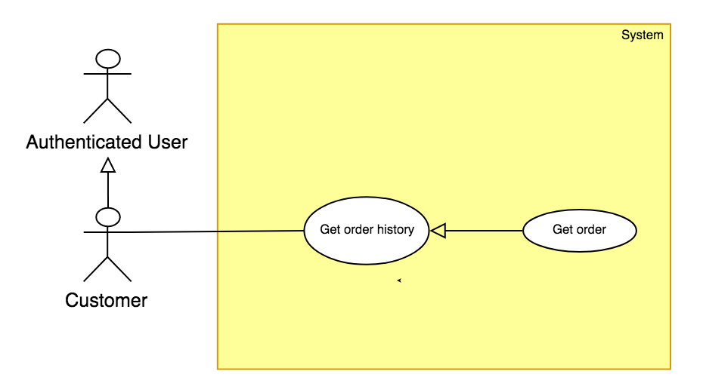

Figure 28: < Seller > Get order Usecase

|  |  |  |  |
| --- | --- | --- | --- |
| **USE CASE – UC\_SL.04** | | | |
| **Usecase No.** | **SL.04** | **Usecase Version** | 1.0 |
| **Usecase Name** | Get order | | |
| **Author** | DucPH | | |
| **Date** | 18/01/2018 | **Priority** | Normal |
| **Actor:**   * Customer.   **Summary:**   * This use case allows customer to get their order details.   **Goal:**   * Customer can view their order. * Customer can view order’s detail information   **Triggers:**   * Customer sends view order’s detail information command.   **Preconditions:**   * User must login into system with role Customer.   **Post Conditions:**   * **Success:** Order’s detail information is shown. * **Fail:** Show error message.   **Main Success Scenario:**   |  |  |  | | --- | --- | --- | | **Step** | **Actor Action** | **System Response** | | 1 | Customer goes to order history view. | Display a table shows list of order:   * Order ID: text * Customer name: text * Product ordered: text * Purchased date: date time * Arrival date: date time * Total: number | | 2 | Customer selects order to view their detail information. | Display a table shows list of products in order:   * Product ID: text * Quantity: number * Price: number |   **Alternative Scenario: N/A**  **Exceptions: N/A**  **Relationships:** N/A  **Business Rules:**   * List of order and their detail information is always loaded from the system. | | | |

**2.3.4.9 < Customer > Get order detail** Usecase  
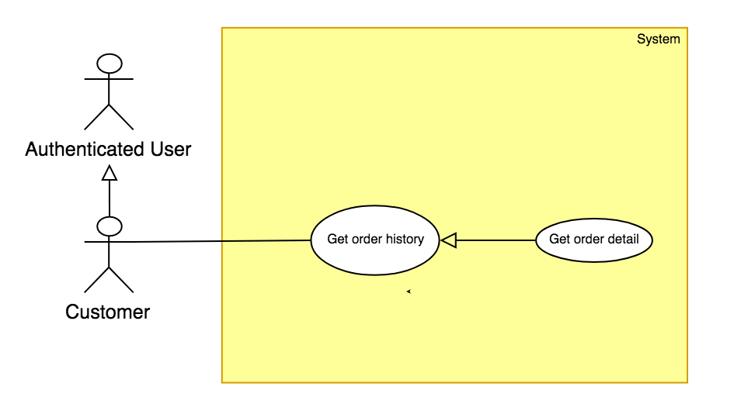

Figure 29: < Seller > Get order detail Usecase

|  |  |  |  |
| --- | --- | --- | --- |
| **USE CASE – UC\_SL.04** | | | |
| **Usecase No.** | **SL.04** | **Usecase Version** | 1.0 |
| **Usecase Name** | Get order detail | | |
| **Author** | DucPH | | |
| **Date** | 18/01/2018 | **Priority** | Normal |
| **Actor:**   * Customer.   **Summary:**   * This use case allows customer to get their order detail.   **Goal:**   * Customer can view their order detail. * Customer can view order detail.   **Triggers:**   * Customer sends view order detail command.   **Preconditions:**   * User must login into system with role Customer.   **Post Conditions:**   * **Success:** Order detail information is shown. * **Fail:** Show error message.   **Main Success Scenario:**   |  |  |  | | --- | --- | --- | | **Step** | **Actor Action** | **System Response** | | 1 | Seller goes to order history view. | Display a order detail information:   * Product ID: text * Quantity: number * Price: number |   **Alternative Scenario: N/A**  **Exceptions: N/A**  **Relationships:** N/A  **Business Rules:**   * Order detail information is always loaded from the system. | | | |

**2.3.5.0 < Customer > Get notification Usecase**

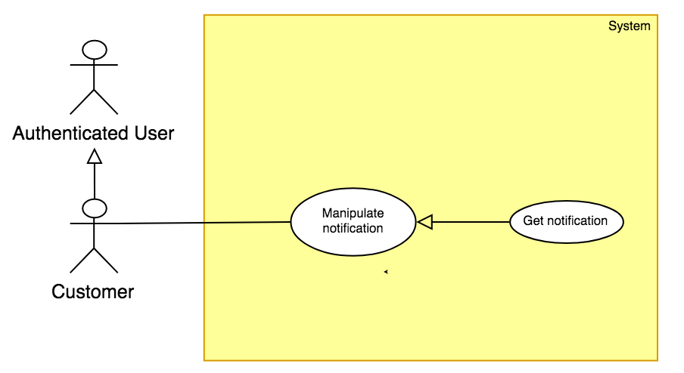

Figure 30: <Customer> Get notification Usecase

|  |  |  |  |
| --- | --- | --- | --- |
| **USE CASE – UC\_C.03** | | | |
| **Usecase No.** | **UC\_C.03** | **Usecase Version** | 2.0 |
| **Usecase Name** | Get notification | | |
| **Author** | DucPH | | |
| **Date** | 17/01/20178 | **Priority** | Normal |
| **Actor:**   * Customer   **Summary:**   * This use case allows to show notification’s information.   **Goal**:   * Customer can view their notification’s detail.   **Triggers:**   * Customer sends get notification command to the system.   **Preconditions:** N/A  **Post Conditions:**   * **Success:** System shows the notification’s information. * **Fail:** System shows error message.   **Main Success Scenario:**   |  |  |  | | --- | --- | --- | | **Step** | **Actor Action** | **System Response** | | 1 | Customer sends get notification command | Display a table shows list of notifications |   **Alternative Scenario**:   |  |  |  | | --- | --- | --- | | **No** | **Cause** | **System Response** | | 1 | There is no notification. | Display cart view with message: “No notification yet”. |   **Exceptions:** N/A  **Relationships:** N/A  **Business Rules:**   * List of notifications is always loaded from the system. | | | |

**2.3.5.1 < Customer > Confirm notification Usecase**

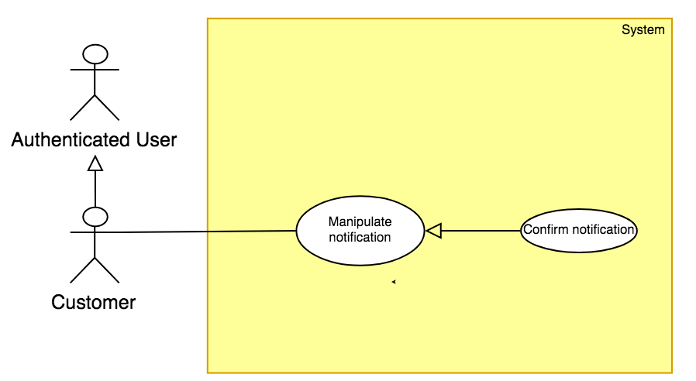

Figure 31: <Customer> Confirm notification Usecase

|  |  |  |  |
| --- | --- | --- | --- |
| **USE CASE – UC\_C.03** | | | |
| **Usecase No.** | **UC\_C.03** | **Usecase Version** | 2.0 |
| **Usecase Name** | Confirm notification | | |
| **Author** | DucPH | | |
| **Date** | 17/01/20178 | **Priority** | Normal |
| **Actor:**   * Customer   **Summary:**   * This use case allows to confirm notification.   **Goal**:   * Customer can confirm their notification.   **Triggers:**   * Customer sends confirm notification command to the system.   **Preconditions:** N/A  **Post Conditions:**   * **Success:** System update the notification status. * **Fail:** System shows error message.   **Main Success Scenario:**   |  |  |  | | --- | --- | --- | | **Step** | **Actor Action** | **System Response** | | 1 | Customer goes to “Notification view” | Display a table shows list of notifications | | 2 | Customer sends confirm notification command |  |   **Alternative Scenario**: N/A  **Exceptions:** N/A  **Relationships:** N/A  **Business Rules:**   * Notification seen value will be set to 1. | | | |

**2.3.5.2 < Customer > Remove notification Usecase**

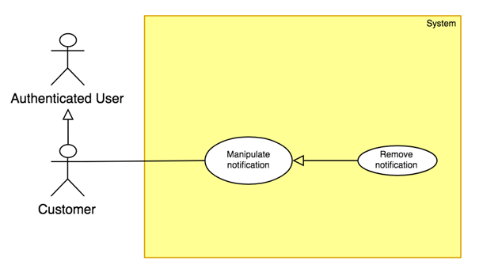

Figure 32: <Customer> Remove notification Usecase

|  |  |  |  |
| --- | --- | --- | --- |
| **USE CASE – UC\_C.03** | | | |
| **Usecase No.** | **UC\_C.03** | **Usecase Version** | 2.0 |
| **Usecase Name** | Remove notification | | |
| **Author** | DucPH | | |
| **Date** | 17/01/20178 | **Priority** | Normal |
| **Actor:**   * Customer   **Summary:**   * This use case allows to remove notification.   **Goal**:   * Customer can remove their notification.   **Triggers:**   * Customer sends remove notification command to the system.   **Preconditions:** N/A  **Post Conditions:**   * **Success:** System removes the notification. * **Fail:** System shows error message.   **Main Success Scenario:**   |  |  |  | | --- | --- | --- | | **Step** | **Actor Action** | **System Response** | | 1 | Customer goes to “Notification view” | Display a table shows list of notifications. | | 2 | Customer choose notification to remove |  | | 3 | Customer send remove notification command to the system | System notifies removing notification successfully. |   **Alternative Scenario**: N/A  **Exceptions:** N/A  **Relationships:** N/A  **Business Rules:**   * Notification will be removed from system. | | | |

#### 2.3.5 < Seller > Overview Usecase

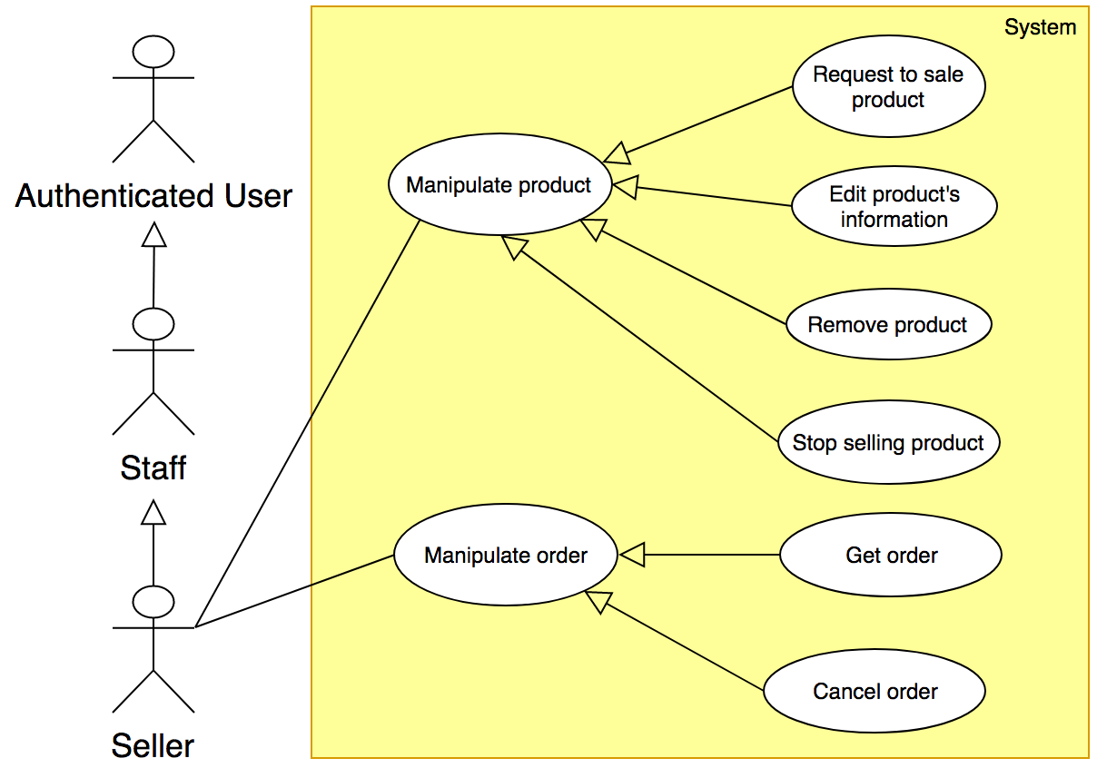

Figure 33: <Seller> Overview UseCase

2.3.5.1 < Seller > Request to sale product Usecase

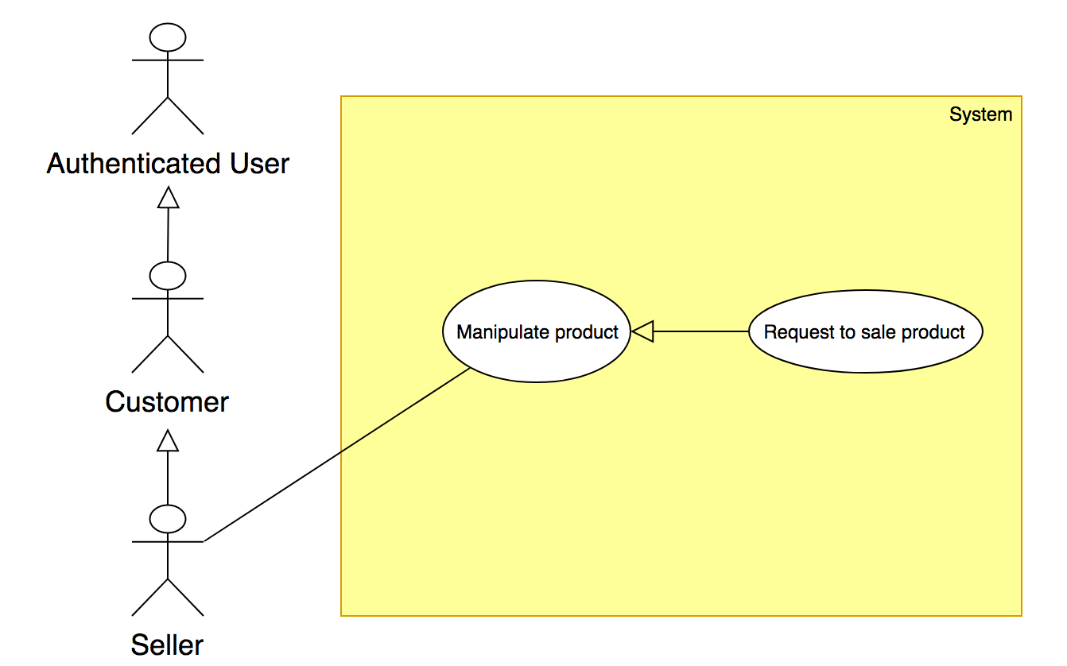

Figure 34: < Seller > Request to sale product Usecase

|  |  |  |  |
| --- | --- | --- | --- |
| **USE CASE – UC \_SL.01** | | | |
| **Usecase No.** | SL.01 | **Usecase Version** | 1.0 |
| **Usecase Name** | Request to sale product | | |
| **Author** | DucPH | | |
| **Date** | 17/01/2018 | **Priority** | High |
| **Actor:**   * Seller.   **Summary:**   * This usecase allows seller to request to sale new product.   **Goal:**   * 3D model can be generated from series of picutres. * 3D model is used to demonstrate seller’s product on marketplace. * New seller’s product request will be sent.   **Triggers:**   * Seller sends sale product command.   **Preconditions:**   * User must login into system with role as Seller. * Balance must be higher than 3D generating fee.   **Post Conditions:**   * **Success:** Request sale new product will be sent. * **Fail:** System shows error message.   **Main Success Scenario:**   |  |  |  | | --- | --- | --- | | **Step** | **Actor Action** | **System Response** | | 1 | Seller goes to sale new product view | System return “Create product” view with following required fields:  Display new view require user input some information:   * Name: text, required, length 1-100. * Origin: text, required, length 1-50. * Category: text, required, length 1-50. * Material: text, required, length 1-50. * Store: text, required, length 1-50. * Length: number (greater than 0) * Width: number (greater than 0) * Height: number (greater than 0) * Weight: number (greater than 0) * Price: number (greater than 0) * Quantity: number (greater than 0) * Describe: text, required, length 1-1000. * Series of pictures: JPG format, ratio 3:4 | | 2 | Seller send “Sale product” command. | If request succeed:  Show message request successful.  [Exception 1] |   **Alternative Scenario:** N/A  **Exceptions:**   |  |  |  | | --- | --- | --- | | **No** | **Cause** | **System Response** | | 1 | If request failed | Show message to notify authenticated seller that request failed. |   **Relationships:** N/A  **Business Rules:**   * The product request successfully only when staff approves request. * When staff doesn’t approve request, request status will change from “Pending” to “Rejected” with reason message. * The format of the 2D picture and 3D model are JPEG and SCN respectively. * At one time, one request is modified by one staff only. * Designer will edit 3D model manually to upgrade model’s quality. | | | |

##### 2.3.5.2 < Seller > Remove product Usecase

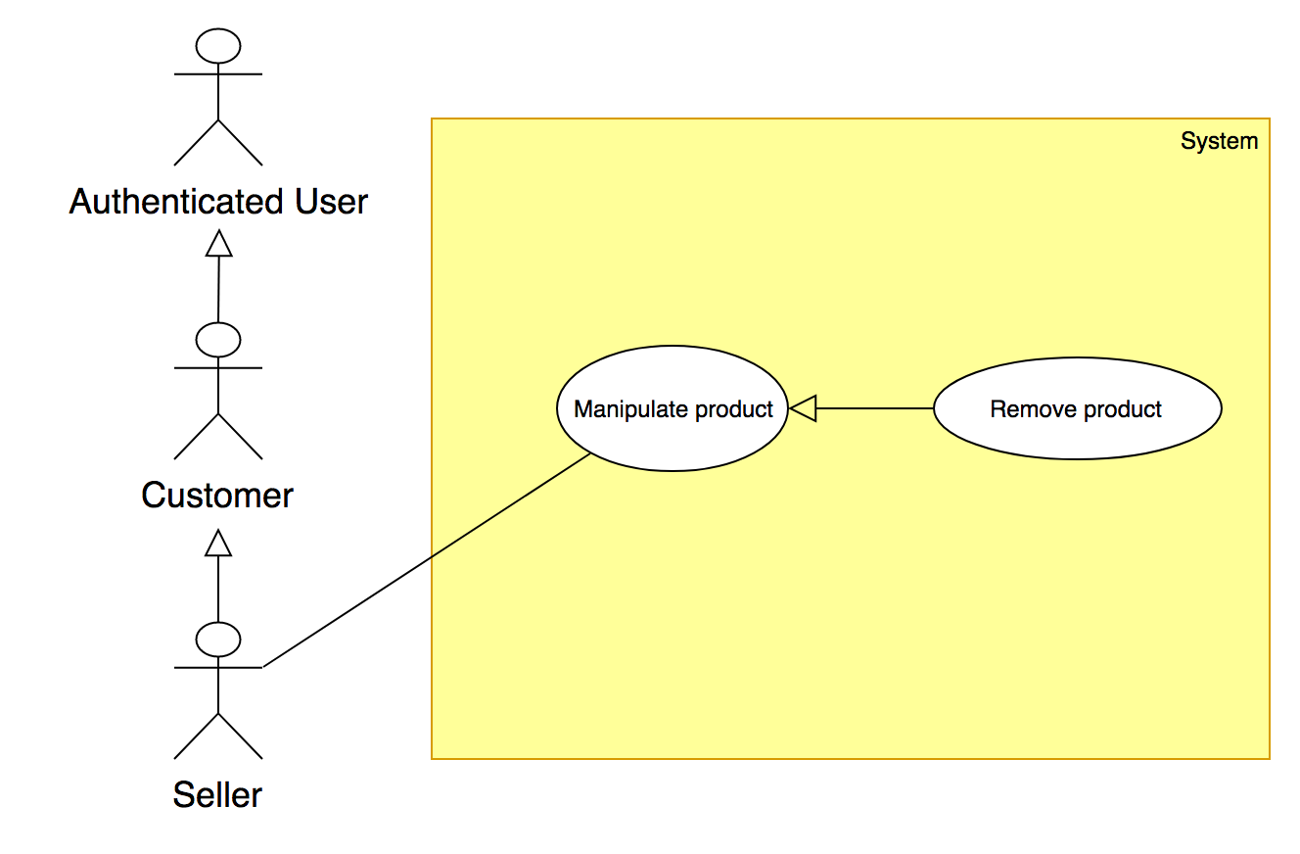

Figure 35: < Seller > Remove product Usecase

|  |  |  |  |
| --- | --- | --- | --- |
| **USE CASE – UC\_SL.02** | | | |
| **Usecase No.** | **SL.02** | **Usecase Version** | 1.0 |
| **Usecase Name** | Remove product | | |
| **Author** | DucPH | | |
| **Date** | 17/01/2018 | **Priority** | Normal |
| **Actor:**   * Seller   **Summary:**   * This use case allows seller to remove their product.   **Goal:**   * Product is removed from seller’s storage and system’s storage.   **Triggers:**   * Seller sends remove product command.   **Preconditions:**   * User must login into system with role Seller.   **Post Conditions:**   * **Success:** Product will be removed by seller. * **Fail:** Show error message.   **Main Success Scenario:**   |  |  |  | | --- | --- | --- | | **Step** | **Actor Action** | **System Response** | | 1 | Seller goes to manipulate product view. | Display a table shows list of seller’s products. | | 2 | Seller chooses product to remove. |  | | 3 | Seller sends remove product command. | System starts removing product.  System show message remove successful.  [Exception 1] |   **Alternative Scenario: N/A**  **Exceptions:**   |  |  |  | | --- | --- | --- | | **No** | **Cause** | **System Response** | | 1 | If remove failed | Show message to notify user that remove failed. |   **Relationships:** N/A  **Business Rules:**   * System will check is product created. * Product must be existed in system, then product will be removed. * Search bar on the top help user finding product faster. | | | |

##### 2.3.5.3 < Seller > Edit product’s information Usecase

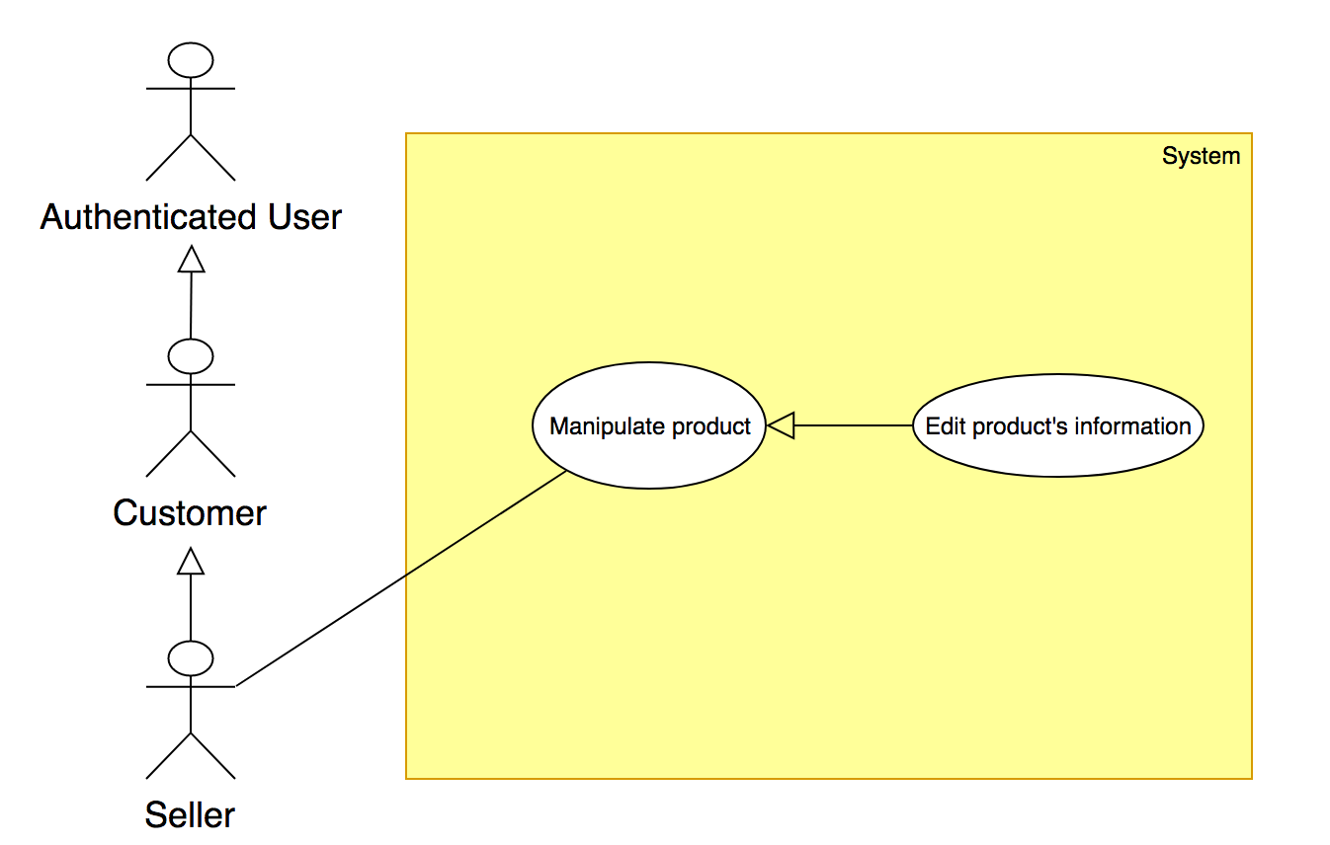

Figure 36: < Seller > Edit product’s information Usecase

|  |  |  |  |
| --- | --- | --- | --- |
| **USE CASE – UC\_SL.03** | | | |
| **Usecase No.** | SL.03 | **Usecase Version** | 1.0 |
| **Usecase Name** | Edit product’s information | | |
| **Author** | DucPH | | |
| **Date** | 17/01/2018 | **Priority** | High |
| **Actor:**   * Seller   **Summary:**   * This use case allows seller to update their product’s information.   **Goal:**   * Seller can update their product’s information.   **Triggers:**   * Seller sends sell update product’s information command.   **Preconditions:**   * User must login into system with role Seller.   **Post Conditions:**   * **Success:** Product’s information will be updated by seller. * **Fail:** Show error message.   **Main Success Scenario:**   |  |  |  | | --- | --- | --- | | **Step** | **Actor Action** | **System Response** | | 1 | Seller goes to manipulate product view. | Display a table shows list of seller’s product. | | 2 | Seller chooses product to edit. | Display new view require user input some information:   * Name: text, required, length 1-100. * Origin: text, required, length 1-50. * Category: text, required, length 1-50. * Material: text, required, length 1-50. * Store: text, required, length 1-50. * Length: number (greater than 0) * Width: number (greater than 0) * Height: number (greater than 0) * Weight: number (greater than 0) * Price: number (greater than 0) * Quantity: number (greater than 0) * Describe: text, required, length 1-1000.   3D model: file upload input. | | 3 | Seller sends update product’s information command. | System starts update product.  System show message update successful.  [Exception 1] |   **Alternative Scenario: N/A**  **Exceptions:**   |  |  |  | | --- | --- | --- | | **No** | **Cause** | **System Response** | | 1 | If update product failed | Show message to notify user that update product’s information failed. |   **Relationships:** N/A  **Business Rules:**   * The product’s information is loaded from the system. * List of products will be sorted by date in descending order. * Weight unit is kilogram (kg). * Width, Length, Height unit is millimeter (mm). | | | |

2.3.5.4 < Seller > Stop selling product Usecase  
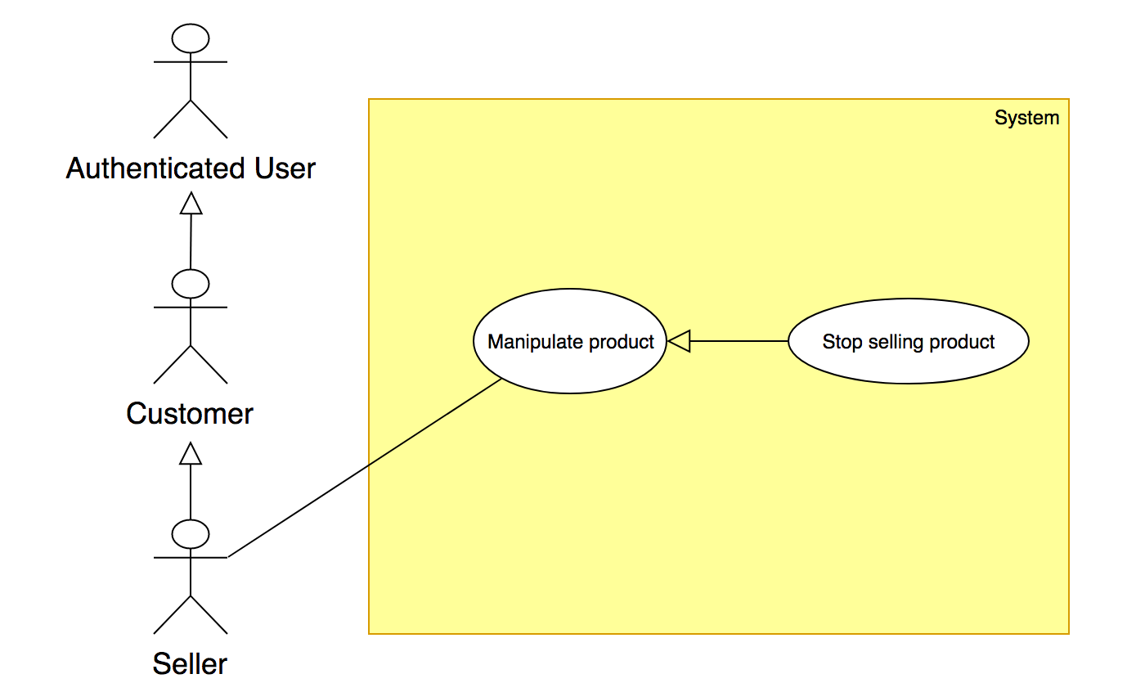

Figure 37: < Seller > Stop selling product Usecase

|  |  |  |  |
| --- | --- | --- | --- |
| **USE CASE – UC\_SL.04** | | | |
| **Usecase No.** | **SL.04** | **Usecase Version** | 1.0 |
| **Usecase Name** | Stop selling product | | |
| **Author** | DucPH | | |
| **Date** | 18/01/2018 | **Priority** | Normal |
| **Actor:**   * Seller.   **Summary:**   * This use case allow seller to stop selling product.   **Goal:**   * Seller can stop selling their product.   **Triggers:**   * Seller sends stop selling product command.   **Preconditions:**   * User must login into system with role Seller.   **Post Conditions:**   * **Success:** Product’s status will be updated by seller. * **Fail:** Show error message.   **Main Success Scenario:**   |  |  |  | | --- | --- | --- | | **Step** | **Actor Action** | **System Response** | | 1 | Seller goes to manipulate product view. | Display a table shows list of seller’s products. | | 2 | Seller chooses their product to stop selling. |  | | 3 | Seller sends stop selling product command.  [Exception 1] | System starts update product’s status.  System show message stop selling product successful.  [Exception 1] |   **Alternative Scenario: N/A**  **Exceptions:**   |  |  |  | | --- | --- | --- | | **No** | **Cause** | **System Response** | | 1 | If stop selling product failed | Show message to notify user that stop selling product failed. |   **Relationships:** N/A  **Business Rules:**   * The information is loaded from the system. * Seller can stop selling only one product at a time. * When seller choose 3d model to upload, the 3D model has created by seller before. * After seller sends stop selling product command, system displays message to notify user that system is processing and a pending list will display with status “Out of stock”. | | | |

**2.3.5.5 < Seller > Get order** Usecase  
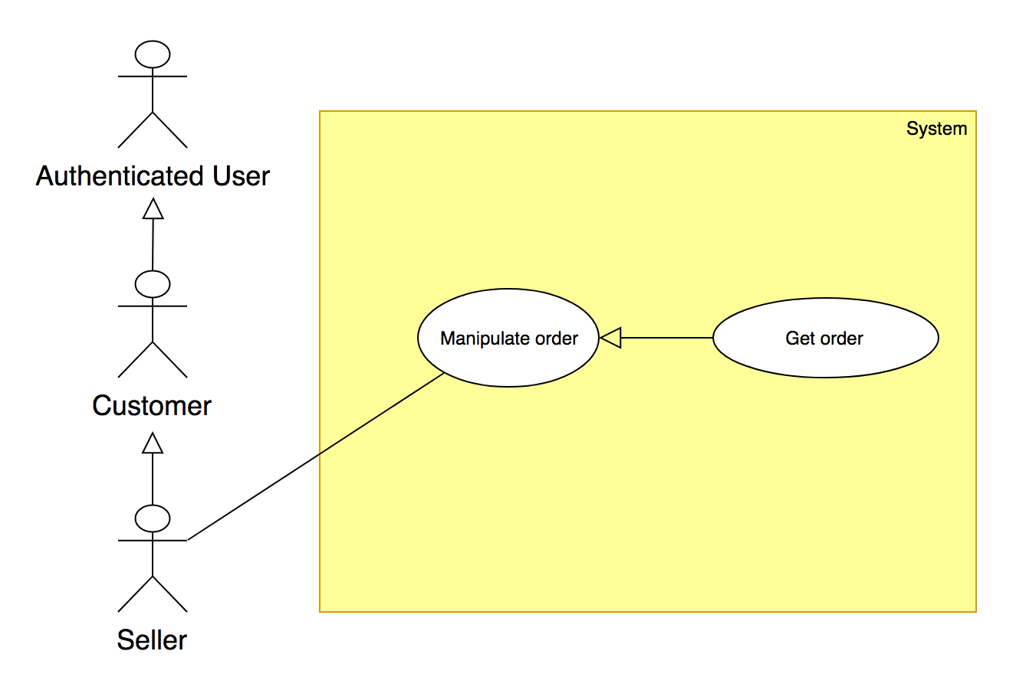

Figure 38: < Seller > Get order Usecase

|  |  |  |  |
| --- | --- | --- | --- |
| **USE CASE – UC\_SL.04** | | | |
| **Usecase No.** | **SL.04** | **Usecase Version** | 1.0 |
| **Usecase Name** | Get order | | |
| **Author** | DucPH | | |
| **Date** | 18/01/2018 | **Priority** | Normal |
| **Actor:**   * Seller.   **Summary:**   * This use case allows seller to get their order details.   **Goal:**   * Seller can view their order. * Seller can view order’s detail information   **Triggers:**   * Seller sends view order’s detail information command.   **Preconditions:**   * User must login into system with role Seller.   **Post Conditions:**   * **Success:** Order’s detail information is shown. * **Fail:** Show error message.   **Main Success Scenario:**   |  |  |  | | --- | --- | --- | | **Step** | **Actor Action** | **System Response** | | 1 | Seller goes to Manipulate order view. | Display a table shows list of order:   * Order ID: text * Customer name: text * Product ordered: text * Purchased date: date time * Arrival date: date time * Total: number | | 2 | Seller selects order to view their detail information. | Display a table shows list of products in order:   * Product ID: text * Quantity: number * Price: number |   **Alternative Scenario: N/A**  **Exceptions: N/A**  **Relationships:** N/A  **Business Rules:**   * List of order and their detail information is always loaded from the system. | | | |

**2.3.5.6 < Seller > Cancel Order** Usecase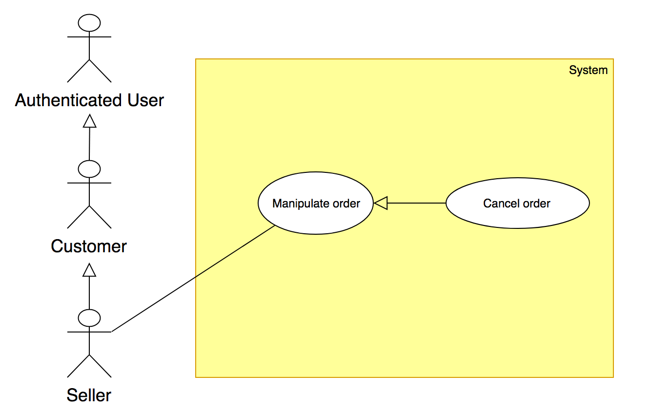

Figure 39: < Seller > Cancel Order Usecase

|  |  |  |  |
| --- | --- | --- | --- |
| **USE CASE – UC\_SL.04** | | | |
| **Usecase No.** | **SL.04** | **Usecase Version** | 1.0 |
| **Usecase Name** | Cancel order | | |
| **Author** | DucPH | | |
| **Date** | 18/01/2018 | **Priority** | Normal |
| **Actor:**   * Seller.   **Summary:**   * This use case allows seller to cancel their order.   **Goal:**   * Seller can cancel their order.   **Triggers:**   * Seller sends cancel order command.   **Preconditions:**   * User must login into system with role Seller.   **Post Conditions:**   * **Success:** The will be canceled successful. * **Fail:** Show error message.   **Main Success Scenario:**   |  |  |  | | --- | --- | --- | | **Step** | **Actor Action** | **System Response** | | 1 | Seller goes to Manipulate order view. | Display a table shows list of order:   * Order ID: text * Customer name: text * Product ordered: text * Purchased date: date time * Arrival date: date time * Total: number | | 2 | Seller selects order to view their detail information. | Display a table shows list of products in order:   * Product ID: text * Quantity: number * Price: number | | 3 | Seller send cancel order command | System starts update order’s status.  System show message cancel order successful.  [Exception 1] |   **Alternative Scenario:** N/A  **Exceptions:**   |  |  |  | | --- | --- | --- | | **No** | **Cause** | **System Response** | | 1 | If cancel order failed | Show message to notify user that cancel order failed. |   **Relationships:** N/A  **Business Rules:**   * List of bills and their detail information is always loaded from the system. | | | |

#### 2.3.6 < Staff > Overview Usecase

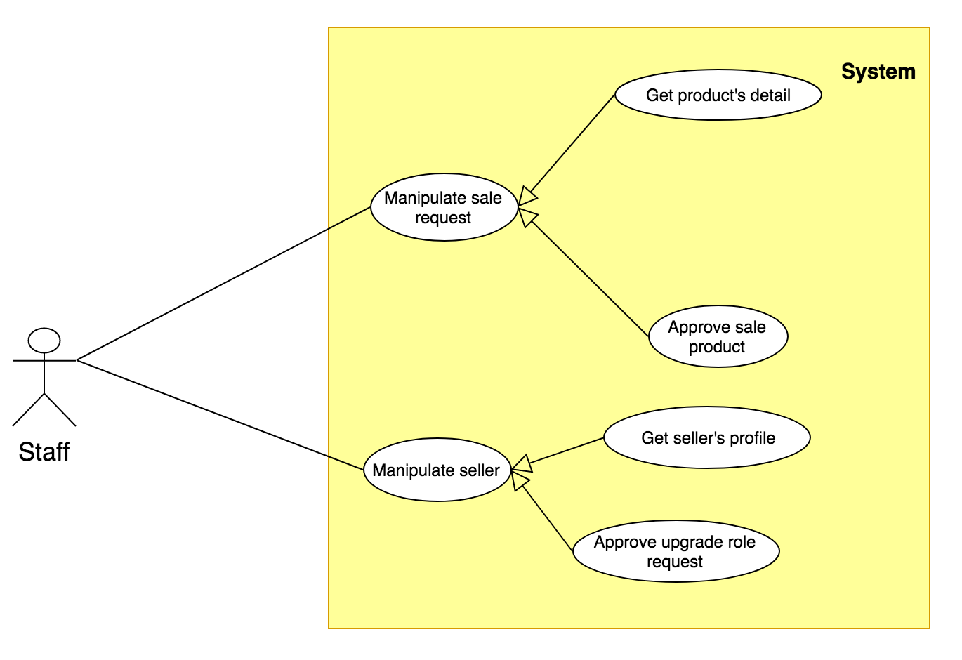

Figure 40: < Staff > Overview Usecase

##### 2.3.6.1 < Staff > Get product’s detail

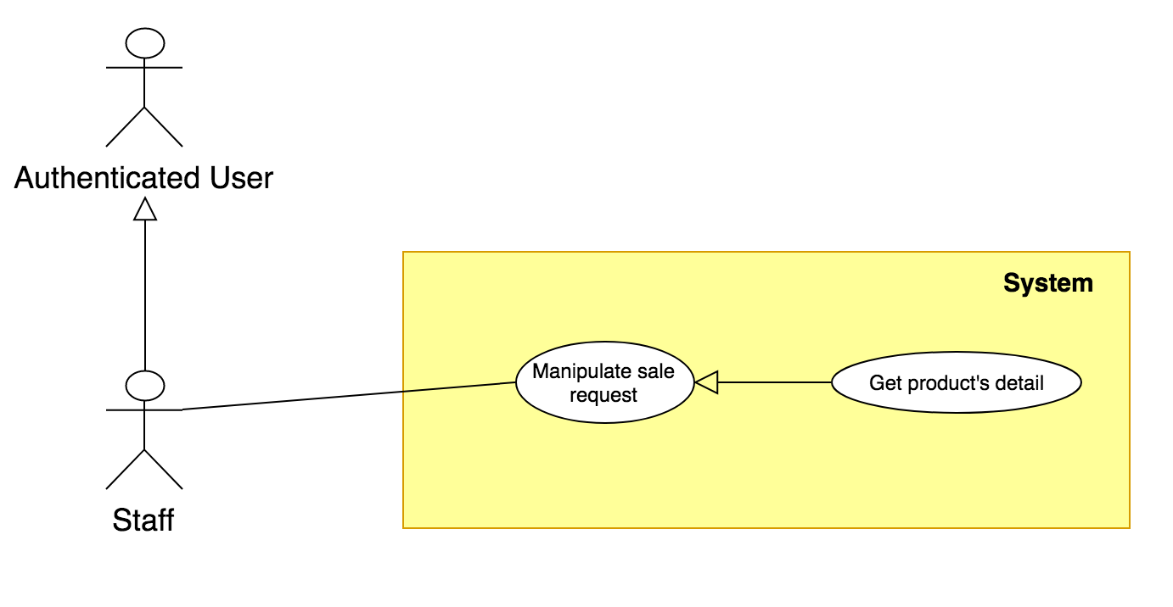

Figure 41: < Staff > Get product’s detail Usecase

|  |  |  |  |
| --- | --- | --- | --- |
| **USE CASE – UC\_ST.01** | | | |
| **Usecase No.** | **UC\_ST.01** | **Usecase Version** | 2.0 |
| **Usecase Name** | Get product’s detail | | |
| **Author** | ThienBT | | |
| **Date** | 23/01/2018 | **Priority** | Normal |
| **Actor:**   * Staff   **Summary:**   * This use case allows staff to get detail of product.   **Goal**:   * Staff can view information about product.   **Triggers:**   * Staff sends command to get product’s detail.   **Preconditions:** N/A  **Post Conditions:**   * **Success:** Product’s detail informations is displayed for staff. * **Fail:** System shows error page   **Main Success Scenario:**   |  |  |  | | --- | --- | --- | | **Step** | **Actor Action** | **System Response** | | 1 | Staff goes to seller request manipulate | System loaded list of seller request. | | 2 | Guest chooses a product and sends command to get detail. | System displays product’s detail information:   * Product name: text * Seller's Username: text * Seller's Store: text * Status: text * Price: Double * Quantity: Integer * Category: text * Origin: text * Size: Width x Length x Height: number * Weight: text * Material: text * Color: text * Created Date: yyyy/MM/dd HH:mm:ss * Updated Date: yyyy/MM/dd HH:mm:ss   Description: text  [Exception 1] |   **Alternative Scenario**: N/A  **Exceptions:**   |  |  |  | | --- | --- | --- | | **No** | **Cause** | **System Response** | | 1 | System can not load product informations. | System shows error message. |   **Relationships:** N/A  **Business Rules:**   * Staff go to seller request and choose product to view detail. * System will show product’s information. | | | |

##### 2.3.6.2 < Staff > Approve sale Product

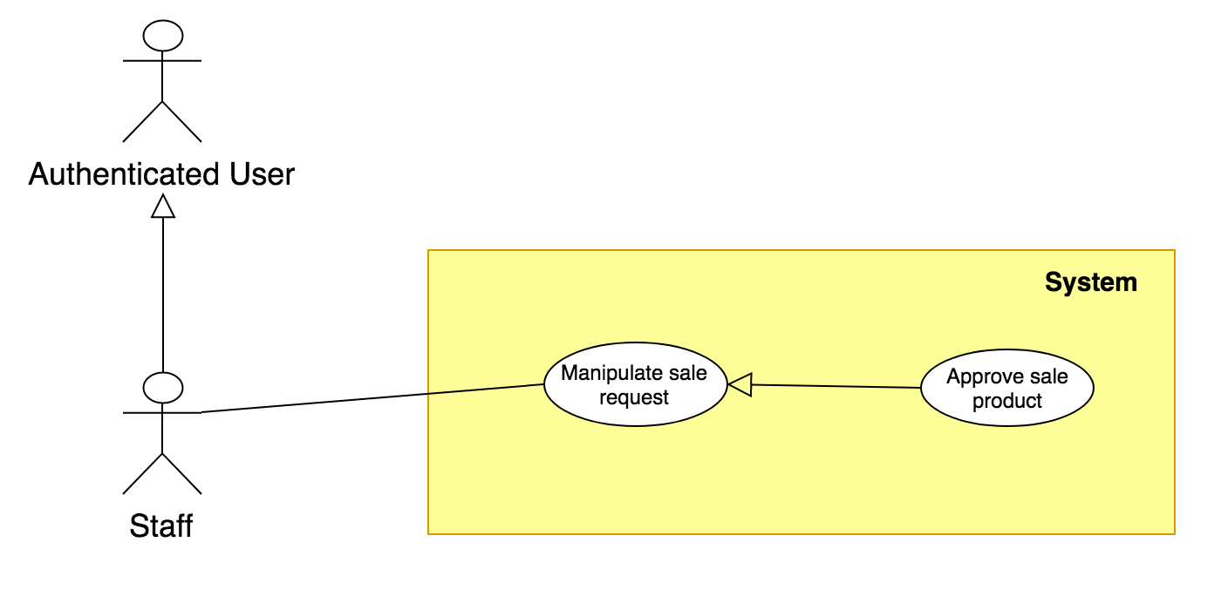

Figure 42: < Staff > Approve sale Product Usecase

|  |  |  |  |
| --- | --- | --- | --- |
| **USE CASE – UC\_ST.02** | | | |
| **Usecase No.** | **UC\_ ST.02** | **Usecase Version** | 2.0 |
| **Usecase Name** | Approve sale Product | | |
| **Author** | ThienBT | | |
| **Date** | 23/01/2018 | **Priority** | Normal |
| **Actor:**   * Staff.   **Summary:**   * This use case allows staff approve request from seller.   **Goal**:   * Staff will approve product to generate 3D model of product and product is display in marketplace. * For any approval to request, user will be notified.   **Triggers:**   * Staff sends command to approve.   **Preconditions:**   * User must log into the system as Staff role. * There is has at least 01 request from other user in the system   **Post Conditions:**   * **Success:** System shows staff message approve successfully. * **Fail:** System shows error page   **Main Success Scenario:**   |  |  |  | | --- | --- | --- | | **Step** | **Actor Action** | **System Response** | | 1 | Staff goes to manipulate seller’s request view | Shows list out of information of requests:   * Product name: text * Seller's Username: text * Seller's Store: text * Status: text * Price: Double * Quantity: Integer * Category: text * Origin: text * Size: Width x Length x Height: number * Weight: text * Material: text * Color: text * Created Date: yyyy/MM/dd HH:mm:ss * Updated Date: yyyy/MM/dd HH:mm:ss * Description: text | | 2 | If staff insert service’s pricing send command to approve request  [Alternative 1] | Change status of request and send notification to seller |   **Alternative Scenario**:   |  |  |  | | --- | --- | --- | | **No** | **Cause** | **System Response** | | 1 | If staff send command to reject | Change status of request and send notification to seller |   **Exceptions:** N/A  **Relationships: N/A**  **Business Rules:**   * The information of request is always loaded in the system. * When staff is checking request details, status of request is changed to “Waiting seller confirm”. * If staff send price and approve request, status of request is change and notify to seller * If staff reject any request, status of request is change and notify to seller | | | |

##### 2.3.6.3 < Staff > Get seller’s profile

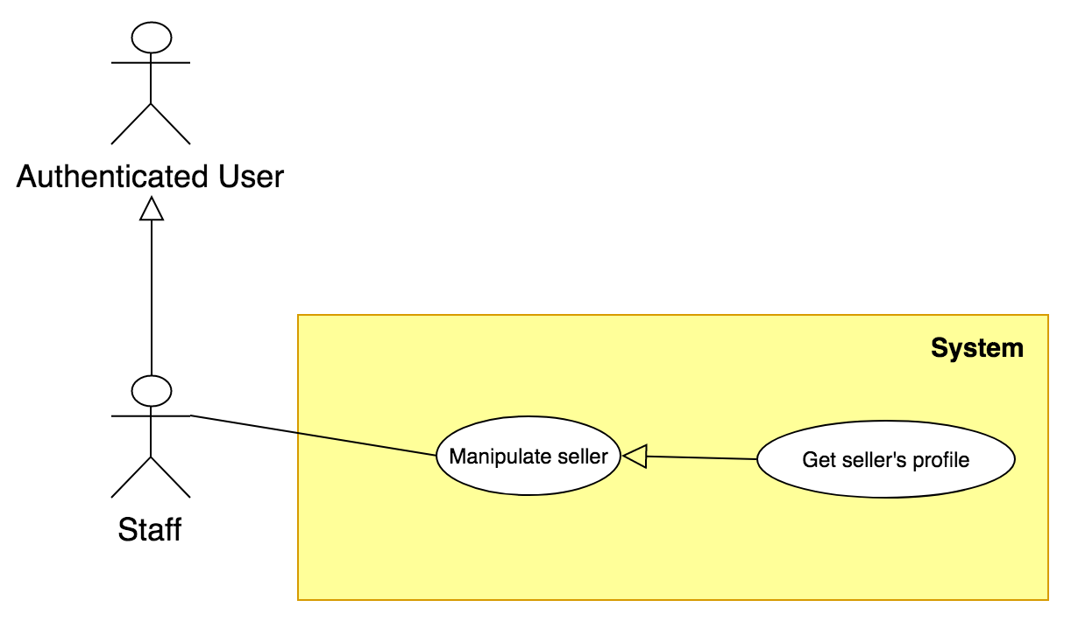

Figure 43: < Staff > Get product’s detail Usecase

|  |  |  |  |
| --- | --- | --- | --- |
| **USE CASE – UC\_ST.01** | | | |
| **Usecase No.** | **UC\_ST.03** | **Usecase Version** | 2.0 |
| **Usecase Name** | Get seller’s profile | | |
| **Author** | ThienBT | | |
| **Date** | 23/01/2018 | **Priority** | Normal |
| **Actor:**   * Staff   **Summary:**   * This use case allows staff to get seller’s profile.   **Goal**:   * Staff can view information about seller.   **Triggers:**   * Staff sends command to get seller’s profile.   **Preconditions:** N/A  **Post Conditions:**   * **Success:** Seller’s detail informations is displayed for staff. * **Fail:** System shows error page   **Main Success Scenario:**   |  |  |  | | --- | --- | --- | | **Step** | **Actor Action** | **System Response** | | 1 | Staff goes to manipulate user | System loaded list of seller. | | 2 | Guest chooses a seller and sends command to get detail. | System displays seller’s detail information:   * Product name: text * Seller's Username: text * Seller's Store: text * Status: text * Price: Double * Quantity: Integer * Category: text * Origin: text * Size: Width x Length x Height: number * Weight: text * Material: text * Color: text * Created Date: yyyy/MM/dd HH:mm:ss * Updated Date: yyyy/MM/dd HH:mm:ss   Description: text  [Exception 1] |   **Alternative Scenario**: N/A  **Exceptions:**   |  |  |  | | --- | --- | --- | | **No** | **Cause** | **System Response** | | 1 | System can not load seller informations. | System shows error message. |   **Relationships:** N/A  **Business Rules:**   * Staff go to manipulate user and choose seller to view detail. * System will show seller’s information. | | | |

##### 2.3.6.4 < Staff > Approve upgrade role request

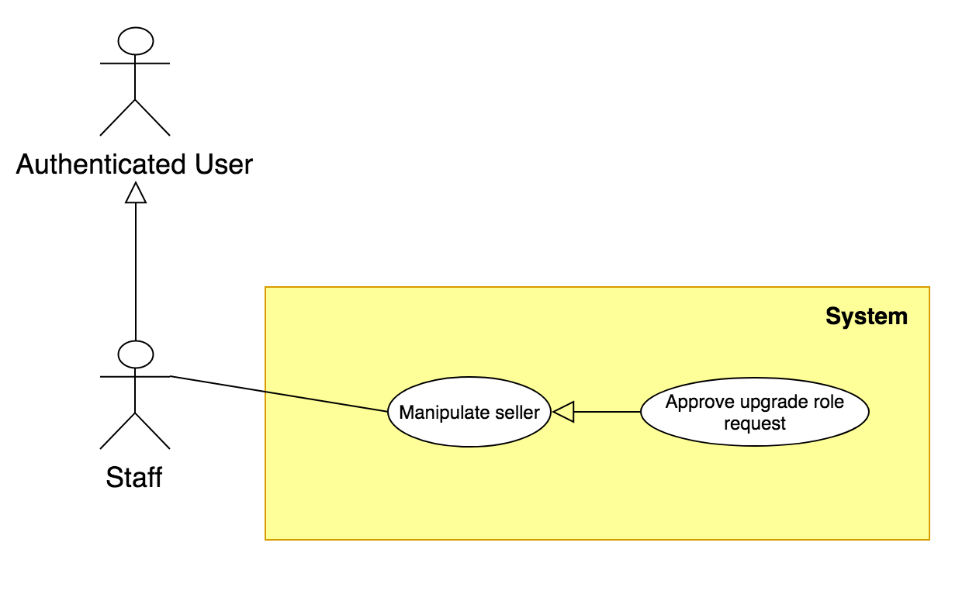

Figure 44: < Staff > Approve upgrade role request Usecase

|  |  |  |  |
| --- | --- | --- | --- |
| **USE CASE – UC\_ST.02** | | | |
| **Usecase No.** | **UC\_ ST.02** | **Usecase Version** | 2.0 |
| **Usecase Name** | Approve upgrade role request | | |
| **Author** | ThienBT | | |
| **Date** | 23/01/2018 | **Priority** | Normal |
| **Actor:**   * Staff.   **Summary:**   * This use case allows staff approve upgrade role request.   **Goal**:   * Staff accept request upgrade role from customer to seller, customer information will be updated with role “Seller”. * For any approval to request, user will be notified.   **Triggers:**   * Staff sends command to approve.   **Preconditions:**   * User must log into the system as Staff role. * There is has at least 01 request from customer in the system   **Post Conditions:**   * **Success:** System shows staff message approve successfully. * **Fail:** System shows error page   **Main Success Scenario:**   |  |  |  | | --- | --- | --- | | **Step** | **Actor Action** | **System Response** | | 1 | Staff goes to manipulate User request view | Shows list out of information of requests:   * Username: text * Full name: text * Birth: dd/MM/yyyy * Address: text * Email: text * Phone: number * Create Date: yyyy/MM/dd HH:mm:ss * Status: text * Store name: text * ID Card: number * Store’s phone: text * Store Address: text * Store Create Date: yyyy/MM/dd HH:mm:ss * Store Update Date: yyyy/MM/dd HH:mm:ss | | 2 | If staff send command to approve request  [Alternative 1] | Change role to become seller. |   **Alternative Scenario**:   |  |  |  | | --- | --- | --- | | **No** | **Cause** | **System Response** | | 1 | If staff send command to reject | Send notification to customer |   **Exceptions:** N/A  **Relationships:**  **Business Rules:**   * The information of request is always loaded in the system. * When staff is checking request details, status of request is changed to “In-process”. * If staff approve request customer role is updated to seller in the system, notify to customer. * If staff reject, its notify to customer. | | | |

#### 2.3.6 < Scheduler > Overview Usecase

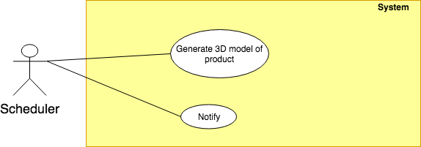

Figure 45: < Scheduler > Overview Usecase

##### 2.3.6.1 < Scheduler > Generate 3D model of product Usecase

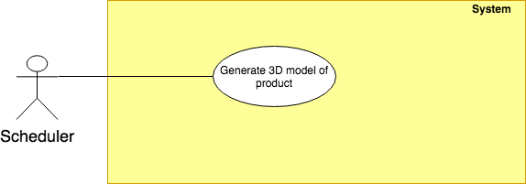

Figure 46: < Scheduler > Generate 3D model of product Usecase

|  |  |  |  |
| --- | --- | --- | --- |
| **USE CASE – UC \_SC.01** | | | |
| **Usecase No.** | SC.01 | **Usecase Version** | 1.0 |
| **Usecase Name** | Generate 3D model of product | | |
| **Author** | KhoaNPA | | |
| **Date** | 17/01/2018 | **Priority** | High |
| **Actor**:   * Scheduler.   **Summary**:   * Scheduler will generate 3D model of product from series of product’s overlap pictures.   **Goals**:   * 3D model of product is created.   **Triggers**:   * Seller sends generate 3D model command.   **Preconditions**:   * The seller provided product’s pictures and information. * The staff approved sale product request. * The seller approved service pricing.   **Post** **Conditions**:   * **Success**: 3D model is created and notify to staff. * **Fail**: write log file and notify error to staff.   **Main** **Success** **Scenario**:   |  |  |  | | --- | --- | --- | | **Step** | **Actor Action** | **System Response** | | 1 | Scheduler sends command generated 3D model. | System starts generating 3D model. | | 2 |  | System returns 3D model in zip format.  [Exception 1] |   **Alternative** **Scenario**: N/A  **Exceptions**:   |  |  |  | | --- | --- | --- | | **Step** | **Cause** | **System Response** | | 1 | Pictures are captured wrong aspects. | System return zip file with empty data. |   **Relationships**:   * < Seller > Request to sell product. (SL.01) * < Staff > Approve sale product. (ST.02)   **Business** **Rules**:   * Seller captures pictures with all aspects of product. * Pictures with ratio 3:4 and with format JPG. * Seller must provide at least 40 pictures of product. | | | |

##### 2.3.6.2 < Scheduler > Notify Usecase

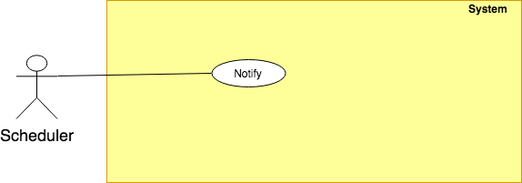

Figure 47: < Scheduler > Notify Usecase

|  |  |  |  |
| --- | --- | --- | --- |
| **USE CASE – UC \_SC.02** | | | |
| **Usecase No.** | SC.02 | **Usecase Version** | 1.0 |
| **Usecase Name** | Notify | | |
| **Author** | KhoaNPA | | |
| **Date** | 17/01/2018 | **Priority** | Normal |
| **Actor**:   * Scheduler.   **Summary**:   * Scheduler will notify notifications to user.   **Goals**:   * User’s received notifications.   **Triggers**:   * After staff approves/rejects user’s requests (request to sell product, request to upgrade role). * Sale product is started selling on market. * Product is bought.   **Preconditions**:   * User sent requests to system. * Product is sold on marketplace.   **Post** **Conditions**:   * **Success**: Notification is sent to user. * **Fail**: write log file.   **Main Success Scenario:**   |  |  |  | | --- | --- | --- | | **Step** | **Actor Action** | **System Response** | | 1 | Scheduler sends send notification command. | System sends notification to user. |   **Alternative** **Scenario**: N/A  **Exceptions**: N/A  **Relationships**:   * < Staff > Approve sale product (ST.02) * < Staff> Approve upgrade role request (ST.04) * < Customer > Checkout   **Business** **Rules**: N/A | | | |

2.3.7 < Designer > Overview Usecase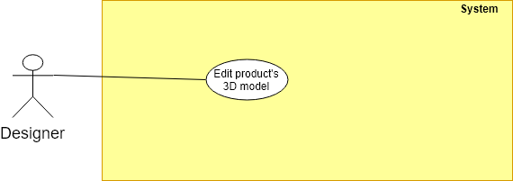

Figure 48: < Designer > Overview Usecase

**2.3.7.1 < Designer > Edit product’s 3D model Usecase**

Figure 49: < Designer > Edit product’s 3D model Usecase

|  |  |  |  |
| --- | --- | --- | --- |
| **USE CASE – UC \_D.01** | | | |
| **Usecase No.** | D.01 | **Usecase Version** | 1.0 |
| **Usecase Name** | Edit product’s 3D model | | |
| **Author** | KhoaNPA | | |
| **Date** | 17/01/2018 | **Priority** | High |
| **Actor**:   * Designer.   **Summary**:   * Designer will upgrade 3D model’s quality, remove redundant textures.   **Goals**:   * 3D model is upgraded quality.   **Triggers**:   * Scheduler notifies that 3D model generating is finished.   **Preconditions**:   * Scheduler finished generating 3D model.   **Post** **Conditions**:   * **Success**: 3D model is ready to represent product. * **Fail**: Designer notifies error.   **Main Success Scenario**:   |  |  |  | | --- | --- | --- | | **Step** | **Actor Action** | **System Response** | | 1 | Designer sends command to download raw 3D model. | System returns raw 3D model. | | 2 | Designer edits 3D model. |  | | 3 | Designer send command tp upload edited 3D model. | System shows message notifying model is uploaded.  [Exception 1] |   **Alternative** **Scenario**: N/A  **Exceptions:**   |  |  |  | | --- | --- | --- | | **Step** | **Cause** | **System Response** | | 1 | Designer send command tp upload edited 3D model. | System shows connection error message. |   **Relationships:**   * < Staff > Approve sale product (ST.02) * < Scheduler > Generate 3D model of product Usecase (SC.01)   **Business Rules:**   * Designer uses 3D editors such as Autodesk Maya, Autodesk 3DS MAX, Blender… to edit 3D model. | | | |

2.3.8 < Payment System > Overview Usecase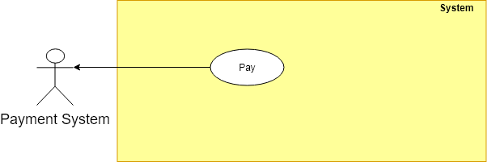

Figure 50: < Payment System > Overview Usecase

2.3.8.1 < Payment System > Pay Usecase

Figure 51: <Payment System > Pay Usecase

|  |  |  |  |
| --- | --- | --- | --- |
| **USE CASE – UC \_PS.01** | | | |
| **Usecase No.** | PS.01 | **Usecase Version** | 1.0 |
| **Usecase Name** | Pay | | |
| **Author** | KhoaNPA | | |
| **Date** | 17/01/2018 | **Priority** | High |
| **Actor**:   * Payment System.   **Summary**:   * This use case allows payment system processes the payment transaction.   **Goals**:   * Payment process is completed.   **Triggers**:   * Customer sends pay for charge by payment system command.   **Preconditions**:   * Scheduler finished generating 3D model.   **Post** **Conditions**:   * **Success**: Payment is completed successfully. * **Fail**: Show error message.   **Main Success Scenario:**   |  |  |  | | --- | --- | --- | | **Step** | **Actor Action** | **System Response** | | 1 | Customer select payment via PayPal. | Summary of user’s payment:   * Description: text. * Amount: text. * Total: text.   Payment view is shown with following labels and fields:   * User’s PayPal account: free text input, required, length 3 – 250 * User’s PayPal password: free text input, required, length 6 – 32 | | 2 | User fills out the form. |  | | 3 | User sends pay command. | Validate data  [Alternative 1]  [Exception 1, 2, 3]  Process payment in PayPal |   **Alternative** **Scenario**:   |  |  |  | | --- | --- | --- | | **No** | **Actor Action** | **System Response** | | 1 | Identity information is not match. | Show message notify user input wrong email or password. |   **Exceptions:**   |  |  |  | | --- | --- | --- | | **No** | **Cause** | **System Response** | | 1 | Missing of required fields | Show message notify user input missed fields | | 2 | Length of field’s value is out of range | Show message notify user which field’s value is out of range | | 3 | Entered email address is not a valid email | Show message notify entered email is not valid |   **Relationships:**   * < Customer > Checkout Usecase (C.04)   **Business Rules:**   * Use PayPal API to validate customer email and password. * PayPal will send notification to alert transaction is failed or succeeded. * An email address must be validated by this regular expression:   /^([a-z0-9\_\.-]+)@([\da-z\.-]+)\.([a-z\.]{2,6})$/ | | | |

## 3. Software System Attribute

### 3.1 Usability

* UI website is fit for each browser in each device
* Font style: Helvetica, Arial, Helvetica Neue, Roboto, Arial, Droid Sans, sans-serif
* Font size: 12px -26px
* Color: green, black, red, white, blue, Light Slate Grey, Fuego, Honeysuckle…
* Background: White, Catalina Blue, Whisper…
* Theme: Gentelela
* UI mobile application mobile is scalable with each monitor of smart phone:
* Font size: 13-30pt
* Font style: San Francisco.
* Color: Black, Light Gray, Orange, Blue…
* Background: White, Light Grey…

### 3.2 Reliability

* View AR on mobile successfully with at light level from 35 lux to brighter.
* 3D model generated by system has acceptable quality with accuracy is 80%.

### 3.3 Availability

* System replies in maximum 2 seconds.

### 3.4 Security

* Each role of user has a specific permission to interact with the system.
* System always checks for authorization and authentication before doing anything.
* Input data is validated before saving to database.

### 3.5 Maintainability

* The system is divided into separated modules for easy maintain.

### 3.6 Portability

* User can use the mobile application on devices running on iPhone 6S or later with iOS 11.3 or later.
* Web application can be run on Chrome browser version 42 or later.

### 3.7 Performance

* Camera can detect surface under 5 seconds on almost surfaces with light level upper 35 lux.
* User can view maxium with 10 products in AR view.

## 4. Conceptual Diagram

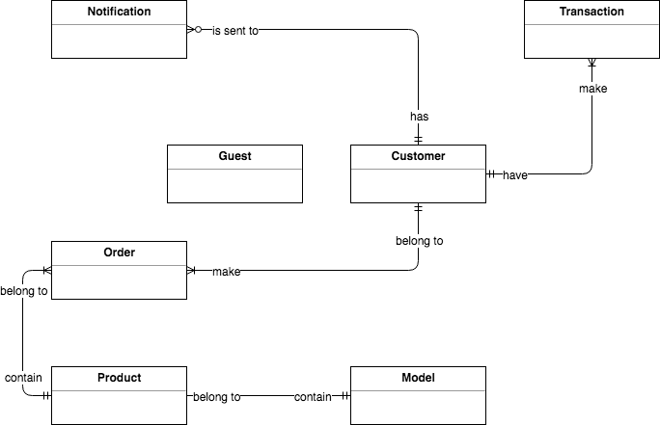

Figure 52: Conceptual diagram

**Data Dictionary**

|  |  |
| --- | --- |
| **Entity Data dictionary:** describe all content of all entities | |
| **Entity Name** | **Description** |
| Notification | Contain the notification information. |
| Transaction | Contain the transaction information. |
| User | Abstract entity describes a user in system |
| Order | Contain customer’s order information |
| Product | Contain the product information provided by seller |
| Model | Contain the model information associated with its product |

# D. Report No. 4 Software Design Description

1. Design Overview

This document describes the technical and user interface design of **ifAR System**. It includes the architectural design, the detailed design of common functions and business functions and the design of database model.

The architectural design describes the overall architecture of the system and the architecture of each main component and subsystem*.*

The detailed design describes static and dynamic structure for each component and functions. It includes class diagrams, class explanations and sequence diagrams for each use cases*.*

The database design describes the relationships between entities and details of each entity*.*

Document overview:

* + Section 2: gives an overall description of the system architecture design.
  + Section 3: gives component diagrams that describe the connection and integration of the system.
  + Section 4: gives the detail design description which includes class diagram, class explanation, and sequence diagram to details the application functions.
  + Section 5: describe screens design.
  + Section 6: describe a fully attributed ERD.
  + Section 7: describe algorithms**.**

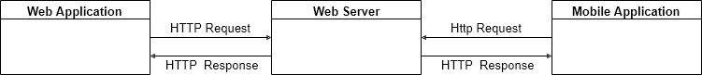2. System Architectural Design

Figure 53 System overview architecture

### 2.1 Web Server Architecture Description

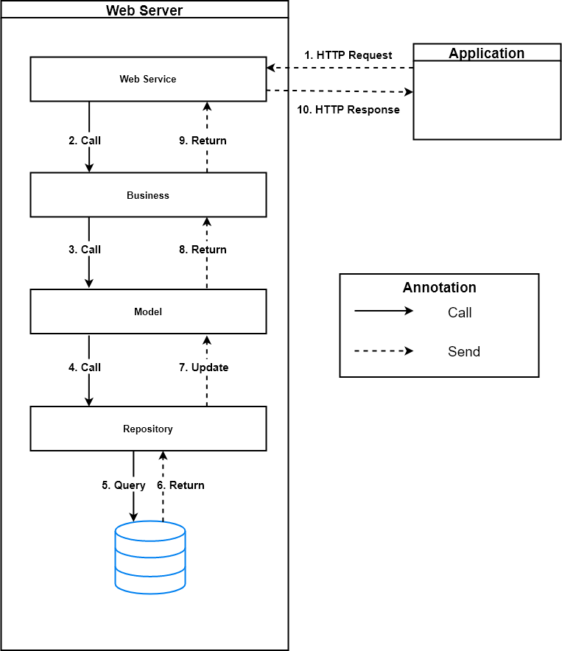

Figure 54 Web server architecture

In Web Application, the system is developed under Spring MVC architecture style. We choose this architecture for Web application because of following advantages:

* Web application contains a Web service (public API for mobile app), with MVC architecture, we can separate business code with Controller and View, so we can use the business code in web service without repeat the code.
* Spring comes with some of the existing technologies like Hibernate framework, security framework and J2EE etc. Hence, we don’t need to integrate explicitly those technologies.
* Spring can eliminate the creation of the singleton and factory classes and well defined interface to business layer
* By separating concerns into 3 distinct pieces, we can perform unit testing easily. Our Presentation layer can be tested free of the Model or Controller, and vice-a-versa
* Spring supports all aspects of application development, Business aspects, persistence aspects, etc., so we can develop a complete application.

This project follows MVC architecture with following components:

* **Spring Controller**: is the parts of the application that acts like event handler to handles user interaction. Typically, controller reads data from a request and calls appropriate Business’s method then selects view to return to user.
* **View**: The view renders the contents of a model. It gets data from the model and specifies how that data should be presented. It updates data presentation when the model changes. A view also forwards user input to a controller. Depending on the task being performed by the user the model can be looked at from different perspectives.
* **Model**: Represents the business data and any business logic that govern access to and modification of the data. The model notifies views when it changes and lets the view query the model about its state. It also lets the controller access application functionality encapsulated by the model. Typically, when a change in the model is to be reflected from user, it should be reflected in all the model’s views.

### 2.2 iOS Application Architecture Description

Figure 55 iOS MVC architecture

(Reference: <https://medium.com/ios-os-x-development/ios-architecture-patterns-ecba4c38de52>)

In iOS application, the system is developed under MVC architecture style. We choose this architecture for iOS because of following advantages**:**

* **Distribution** — the View and the Model in fact separated, but the View and the Controller are tightly coupled.
* **Testability** — due to the bad distribution you’ll probably only test your Model.
* **Ease of use** — the least amount of code among other patterns. In addition, everyone is familiar with it, thus, it’s easily maintained even by the unexperienced developers.

### 2.3 Web Application Architecture Description C:\Users\Thuans\Downloads\Untitled Diagram (5).png

Figure 56 Web applicaiton architecture

In web application, the system is developed under MVC architecture for single-page application style. We choose this architecture for web application because of following advantages:

* With thetwo-way data binding, the user interface changes are immediately reflected in the underlying data model. Restrict web page refresh each time request to server, web application becomes friendly.

Web application follows MVC architecture with following components:

* **Controller**: is the parts of the application that acts like event handler to handles user interaction.
* **View**: The view renders the contents of a model. It gets data from the model and specifies how that data should be presented. In web application, view often descripts html pages.
  + - **Model**: Represents the business data and any business logic that govern access to and modification of the data. The model notifies views when it changes and lets the view query the model about its state.
    - **Two ways binding mechanism**: Two ways data-binding is an automatic way of updating the view whenever the model changes, as well as updating the model whenever the view changes.

## ****3.**** Component Diagram

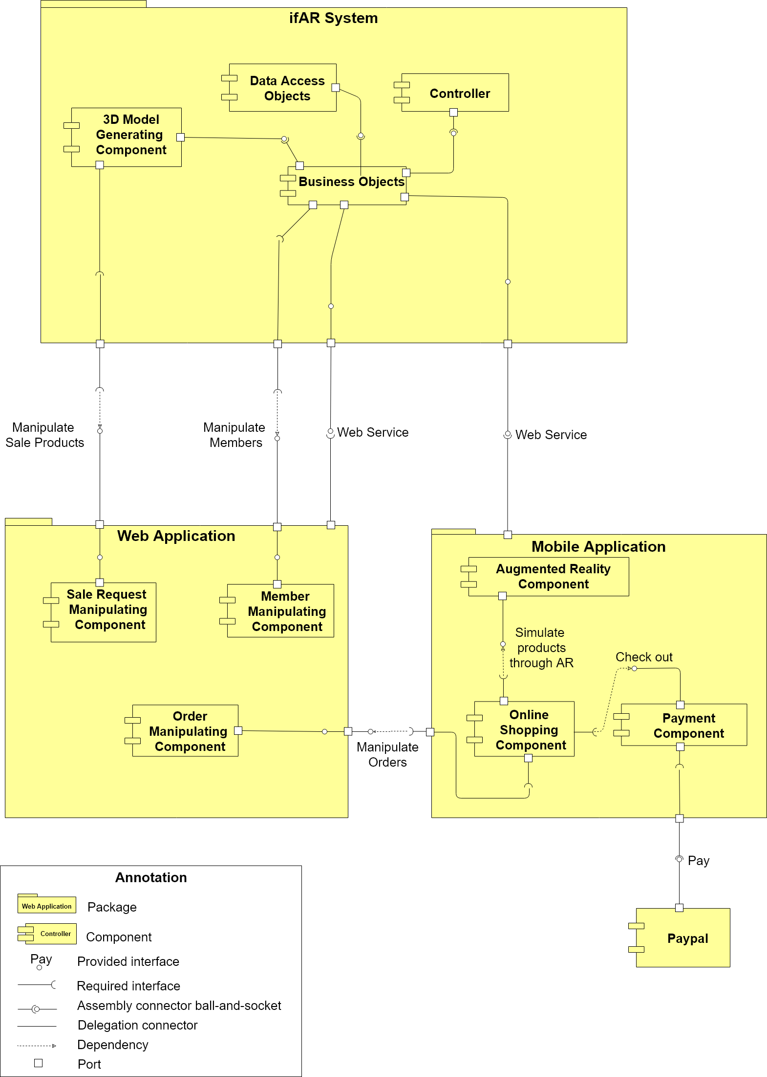

Figure 57 Component diagram

**Data dictionary**

|  |  |
| --- | --- |
| **Name** | **Description** |
| ifAR System | Interior Furniture Augmented Reality System package |
| Web Application | Web application package |
| Mobile Application | Mobile application package |
| Data Access Objects | Component to handle interaction between the system and database |
| Business Objects | Common objects to handle domain business operations for each component |
| Sale Request Manipulating Component | Component to handle seller’s sale requests manipulating processes |
| Controller | Component to handle business management |
| 3D Model Generating Component | Component to handle 3D model generating process |
| Member Manipulating Component | Component to handle members manipulating process |
| Order Manipulating Component | Component to handle orders manipulating process |
| Augmented Reality Component | Component to handle products simulating in augmented reality view |
| Online Shopping Component | Component to handle online shopping |
| Payment Component | Component to handle payment process |
| Paypal | Handle payment process with PayPal API |
| Web Service | Provide API for mobile applications and web application to interact with the system. |
| Manipulate Sale Products | Handle sale products |
| Manipulate Members | Handle members in system |
| Manipulate Orders | Handle orders manipulating |
| Pay | Handle payment processes |
| Check out | Handle check out processes of online shopping |
| Simulate products through AR | Handle products simulating in augmented reality view |

## 

## 4. Detailed Description

### 4.1 Class Diagram

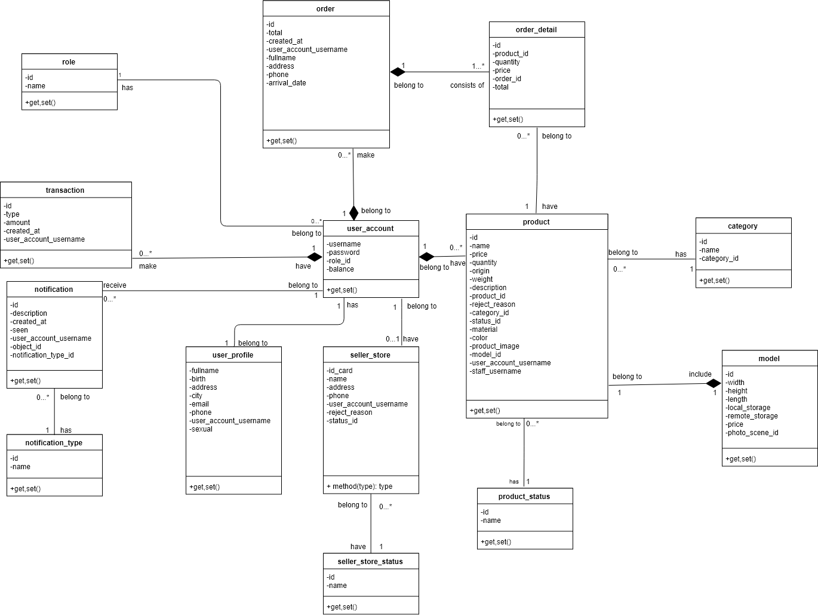

Figure 58 Class diagram

|  |  |  |
| --- | --- | --- |
| **Class Name** | **Mapping column with Conceptual diagram** | **Description** |
| role | N/A | Not exist in conceptual diagram. It’s used to contain role information. |
| order | order | Contain customer’s order information. |
| order detail | N/A | Not exist in conceptual diagram. It’s used to contain order detail information. |
| transaction | transaction | Contain customer’s transaction information. |
| notification | notification | Contain notification information. |
| notification\_type | N/A | Not exist in conceptual diagram. It’s used to contain notification type of notification. |
| user\_account | user | Contain customer’s information. |
| user\_profile | N/A | Not exist in conceptual diagram. It’s used to contain user profile information of user account. |
| seller\_store | store | Contain seller’s store information. |
| seller\_store\_status | N/A | Not exist in conceptual diagram. It’s used to contain store status of seller store. |
| product | product | Contain product’s information. |
| product\_status | product\_status | Not exist in conceptual diagram. It’s used to contain product status of product. |
| category | N/A | Not exist in conceptual diagram. It’s used to contain category information of product. |
| model | model | Contain model’s information of product. |

Table 7 Class dictionary

### 4.2 Class Diagram Explanation

#### 4.2.1 role

**Attribute**

|  |  |  |  |
| --- | --- | --- | --- |
| **Attribute** | **Type** | **Visibility** | **Description** |
| id | UUID | Private | Unique identifier of role. |
| name | String | Private | Role name. |

**Method**

|  |  |  |  |
| --- | --- | --- | --- |
| **Method** | **Return type** | **Visibility** | **Description** |
| Getter | Attribute type | Public | Get attribute value |
| Setter | Void | Public | Set value of attribute |

#### 4.2.2 order

**Attribute**

|  |  |  |  |
| --- | --- | --- | --- |
| **Attribute** | **Type** | **Visibility** | **Description** |
| id | UUID | Private | Unique identifier of order |
| total | Double | Private | Order total price |
| created\_at | Date time | Private | Order created date |
| user\_account\_username | String | Private | Username of customer |
| fullname | String | Private | Full name of customer |
| address | String | Private | Delivery address |
| phone | String | Private | Delivery phone number |
| arrival\_date | Date time | Private | Arrival date of order |

**Method**

|  |  |  |  |
| --- | --- | --- | --- |
| **Method** | **Return type** | **Visibility** | **Description** |
| Getter | Attribute type | Public | Get attribute value |
| Setter | Void | Public | Set value of attribute |

#### 4.2.3 order\_detail

**Attribute**

|  |  |  |  |
| --- | --- | --- | --- |
| **Attribute** | **Type** | **Visibility** | **Description** |
| id | UUID | Private | Unique identifier of order detail |
| product\_id | UUID | Private | Identifier of product in order detail |
| quantity | Int | Private | Quantity of order detail |
| price | Double | Private | Selling price of product |
| order\_id | UUID | Private | Identifier of order |
| total | Double | Private | Order detail total price |

**Method**

|  |  |  |  |
| --- | --- | --- | --- |
| **Method** | **Return type** | **Visibility** | **Description** |
| Getter | Attribute type | Public | Get attribute value |
| Setter | Void | Public | Set value of attribute |

#### 4.2.4 transaction

**Attribute**

|  |  |  |  |
| --- | --- | --- | --- |
| **Attribute** | **Type** | **Visibility** | **Description** |
| id | Int | Private | Unique identifier of transaction |
| type | Boolean | Private | Type of transaction |
| amout | Double | Private | Amount of transaction |
| created\_at | Date time | Private | Created date of transaction |
| user\_account\_username | String | Private | Username |

**Method**

|  |  |  |  |
| --- | --- | --- | --- |
| **Method** | **Return type** | **Visibility** | **Description** |
| Getter | Attribute type | Public | Get attribute value |
| Setter | Void | Public | Set value of attribute |

#### 4.2.5 notification

**Attribute**

|  |  |  |  |
| --- | --- | --- | --- |
| **Attribute** | **Type** | **Visibility** | **Description** |
| id | Int | Private | Unique identifier of assistant type |
| description | String | Private | Notification description information |
| created\_at | Date time | Private | Created date of notification |
| seen | Boolean | Private | Seen status of notification |
| user\_account\_username | String | Private | Username of user account |

**Method**

|  |  |  |  |
| --- | --- | --- | --- |
| **Method** | **Return type** | **Visibility** | **Description** |
| Getter | Attribute type | Public | Get attribute value |
| Setter | Void | Public | Set value of attribute |

#### 4.2.6 notification\_type

**Attribute**

|  |  |  |  |
| --- | --- | --- | --- |
| **Attribute** | **Type** | **Visibility** | **Description** |
| id | Int | Private | Unique identifier of notification type |
| name | String | Private | Name of notification type |

**Method**

|  |  |  |  |
| --- | --- | --- | --- |
| **Method** | **Return type** | **Visibility** | **Description** |
| Getter | Attribute type | Public | Get attribute value |
| Setter | Void | Public | Set value of attribute |

#### 4.2.7 user\_account

**Attribute**

|  |  |  |  |
| --- | --- | --- | --- |
| **Attribute** | **Type** | **Visibility** | **Description** |
| username | String | Private | Unique identifier of user account |
| password | String | Private | Password |
| role\_id | Int | Private | Identify of role |
| balance | Double | Private | Balance of account |

**Method**

|  |  |  |  |
| --- | --- | --- | --- |
| **Method** | **Return type** | **Visibility** | **Description** |
| Getter | Attribute type | Public | Get attribute value |
| Setter | Void | Public | Set value of attribute |

#### 4.2.8 user\_profile

**Attribute**

|  |  |  |  |
| --- | --- | --- | --- |
| **Attribute** | **Type** | **Visibility** | **Description** |
| fullname | String | Private | Full name of user profile |
| birth | Date time | Private | Birthdate of user profile |
| address | String | Private | Address of user profile |
| city | String | Private | City of user profile |
| email | String | Private | Email of user profile |
| phone | String | Private | Phone of user profile |
| user\_account\_username | String | Private | Username of user account |
| sexual | Int | Private | Sex of user |

**Method**

|  |  |  |  |
| --- | --- | --- | --- |
| **Method** | **Return type** | **Visibility** | **Description** |
| Getter | Attribute type | Public | Get attribute value |
| Setter | Void | Public | Set value of attribute |

#### 4.2.9 seller\_store

**Attribute**

|  |  |  |  |
| --- | --- | --- | --- |
| **Attribute** | **Type** | **Visibility** | **Description** |
| id\_card | String | Private | ID card of seller store |
| name | String | Private | Unique identifier of seller store |
| address | String | Private | Address of seller store |
| phone | String | Private | Phone number of seler store |
| user\_account\_username | String | Private | Username of seller |
| reject\_reason | String | Private | Reject reason of seller store |
| status\_id | Int | Pricate | Status identifier of seller store |

**Method**

|  |  |  |  |
| --- | --- | --- | --- |
| **Method** | **Return type** | **Visibility** | **Description** |
| Getter | Attribute type | Public | Get attribute value |
| Setter | Void | Public | Set value of attribute |

#### 4.2.10 seller\_store\_status

**Attribute**

|  |  |  |  |
| --- | --- | --- | --- |
| **Attribute** | **Type** | **Visibility** | **Description** |
| id | UUID | Private | Identifier of seller store status |
| name | String | Private | Name of seller store status |

**Method**

|  |  |  |  |
| --- | --- | --- | --- |
| **Method** | **Return type** | **Visibility** | **Description** |
| Getter | Attribute type | Public | Get attribute value |
| Setter | Void | Public | Set value of attribute |

#### 4.2.11 product

**Attribute**

|  |  |  |  |
| --- | --- | --- | --- |
| **Attribute** | **Type** | **Visibility** | **Description** |
| id | int | Private | Unique identifier of product |
| name | String | Private | Name of product |
| price | Double | Private | Price of product |
| quantity | Int | Private | Quantity of product |
| origin | String | Private | Origin of product |
| weight | Double | Private | Weight of product |
| description | String | Private | Description of product |
| product\_id | Int | Private | Parent ID of product |
| reject\_reason | String | Private | Reject reason of product |
| category\_id | Int | Private | Category identify of product |
| status\_id | Int | Private | Status identify of product |
| material | String | Private | Material of product |
| color | String | Private | Color of product |
| product\_image | String | Private | Image reference link of product |
| model\_id | Int | Private | 3D model identifier of product |
| user\_account\_username | String | Private | Username of seller |
| staff\_username | String | Private | Username of staff |

**Method**

|  |  |  |  |
| --- | --- | --- | --- |
| **Method** | **Return type** | **Visibility** | **Description** |
| Getter | Attribute type | Public | Get attribute value |
| Setter | Void | Public | Set value of attribute |

#### 4.2.12 product\_status

**Attribute**

|  |  |  |  |
| --- | --- | --- | --- |
| **Attribute** | **Type** | **Visibility** | **Description** |
| id | int | Private | Unique identifier of product status |
| name | String | Private | Name of product status |

**Method**

|  |  |  |  |
| --- | --- | --- | --- |
| **Method** | **Return type** | **Visibility** | **Description** |
| Getter | Attribute type | Public | Get attribute value |
| Setter | Void | Public | Set value of attribute |

#### 4.2.13 category

**Attribute**

|  |  |  |  |
| --- | --- | --- | --- |
| **Attribute** | **Type** | **Visibility** | **Description** |
| id | UUID | Private | Unique identifier of category |
| name | String | Private | Name of category |
| category\_id | Int | Private | Parent ID of category |

**Method**

|  |  |  |  |
| --- | --- | --- | --- |
| **Method** | **Return type** | **Visibility** | **Description** |
| Getter | Attribute type | Public | Get attribute value |
| Setter | Void | Public | Set value of attribute |

#### 4.2.14 model

**Attribute**

|  |  |  |  |
| --- | --- | --- | --- |
| **Attribute** | **Type** | **Visibility** | **Description** |
| id | UUID | Private | Unique identifier of 3D model |
| width | Int | Private | Width of model |
| length | Int | Private | Length of model |
| height | Int | Private | Height of model |
| local\_storage | String | Private | Reference link at local |
| remote\_storage | String | Private | Reference link at remote storage |
| price | Double | Private | Servcice pricing of approving product |
| photo\_scene\_id | String | Private | The photo scene id generated from third party API when create 3D model |

**Method**

|  |  |  |  |
| --- | --- | --- | --- |
| **Method** | **Return type** | **Visibility** | **Description** |
| Getter | Attribute type | Public | Get attribute value |
| Setter | Void | Public | Set value of attribute |

### 4.3 Interaction Diagram

#### 4.3.1 Sequence Diagram

##### 4.3.1.1 Search product

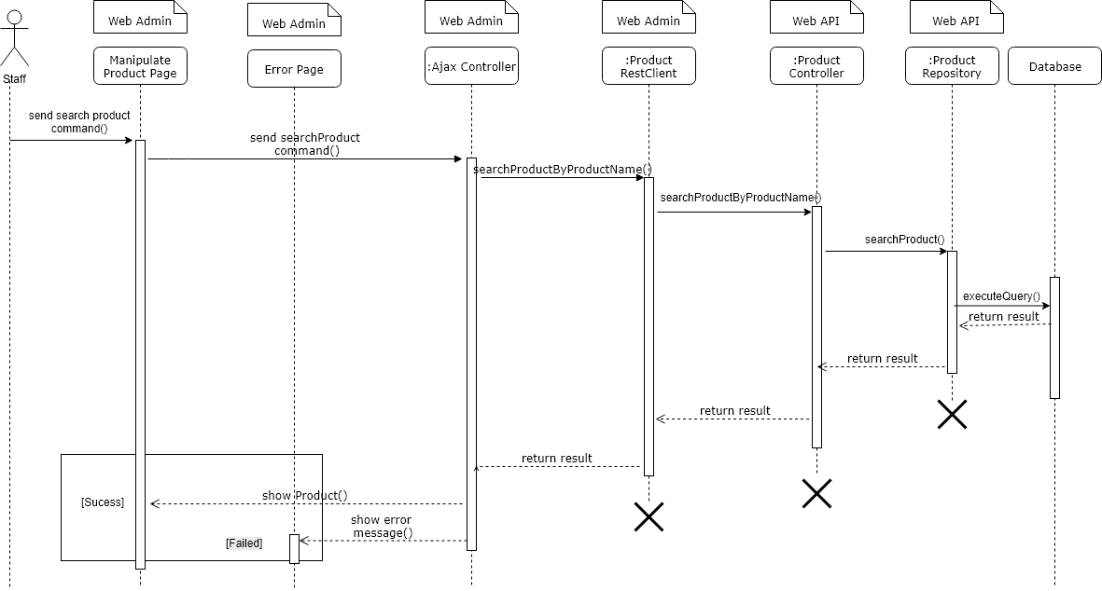

##### 4.3.1.2 Approve upgrade role request

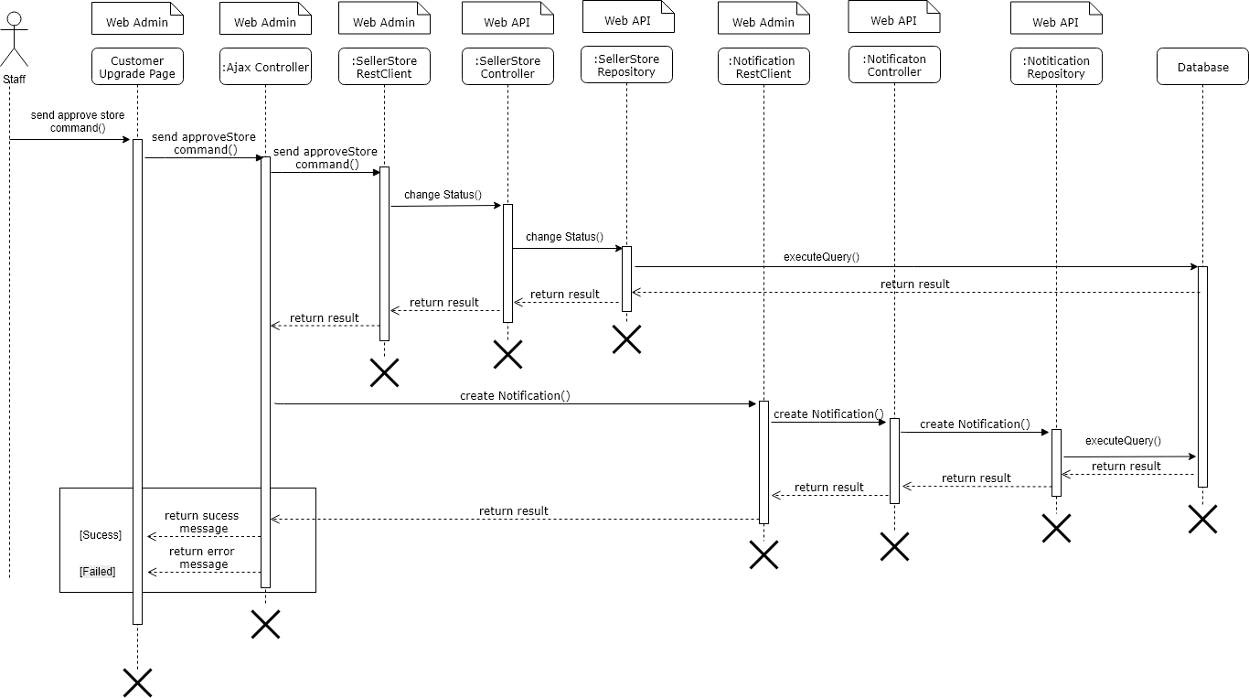

##### 4.3.1.3 Reject upgrade role request

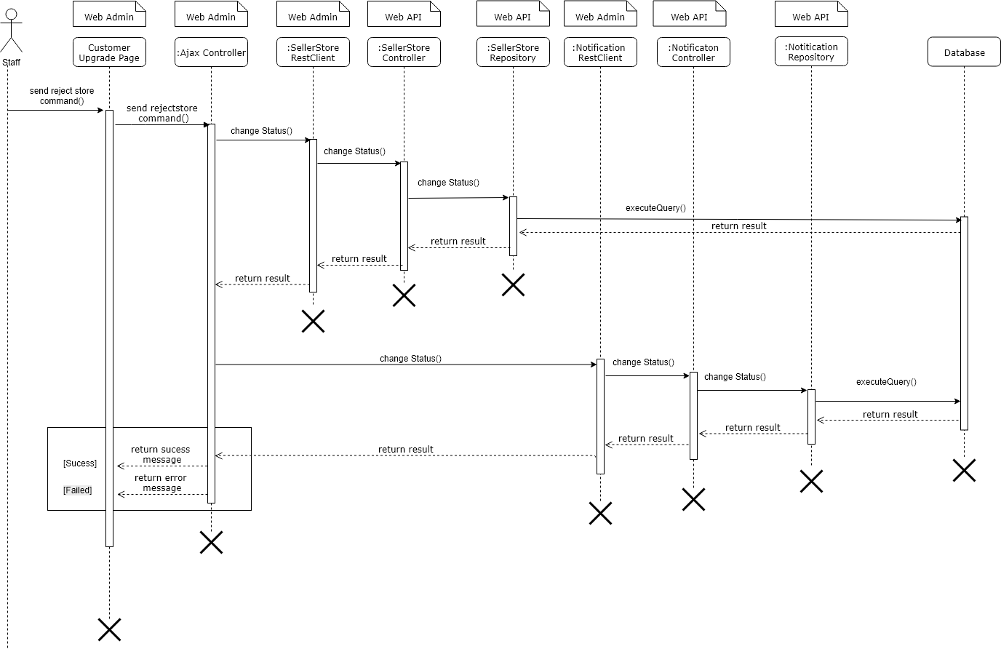

##### 4.3.1.4 Re-upload 3D model

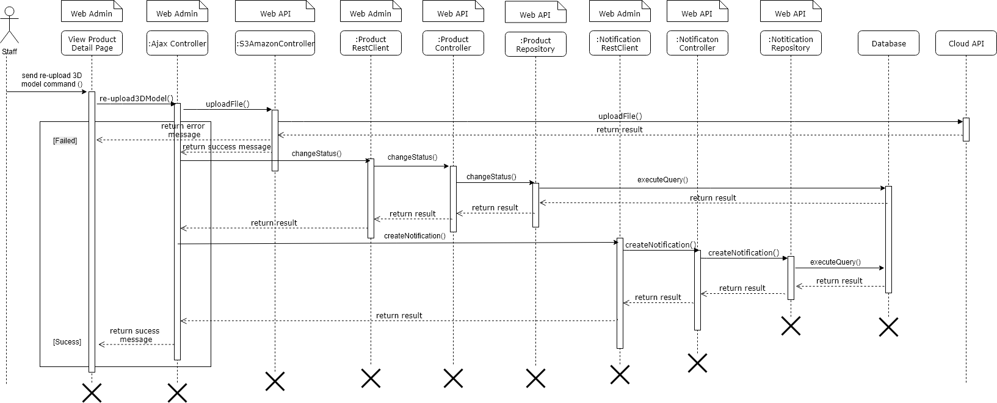

#### 4.3.2 Activity Diagram

##### **4.3.2.1 Checkout**

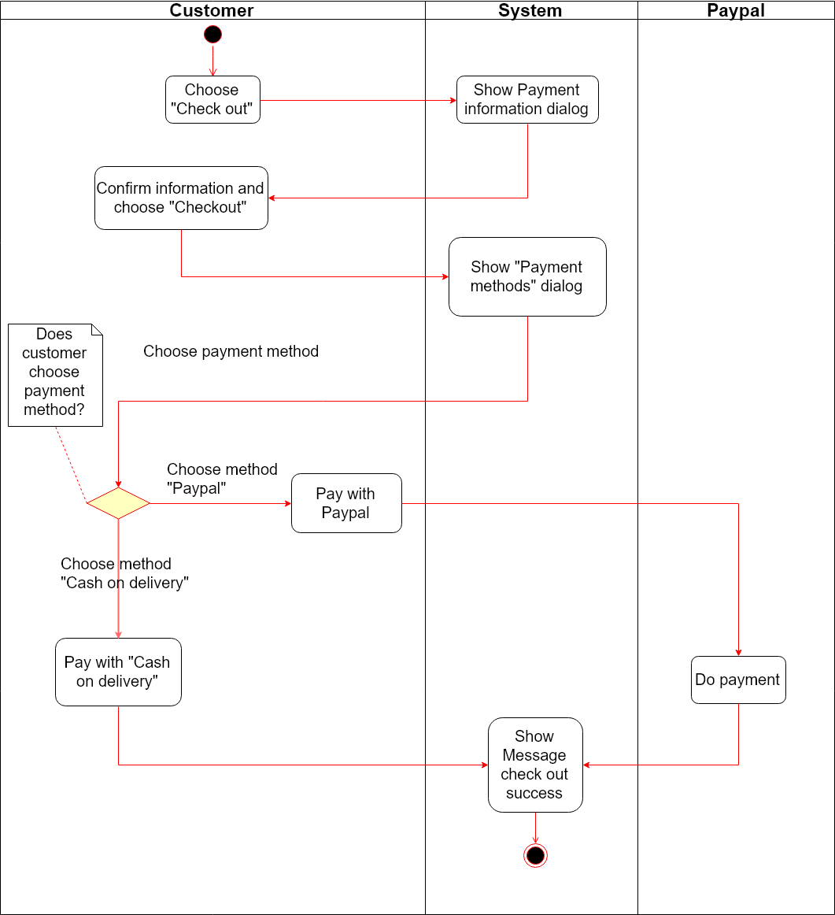

##### 4.3.2.2 View product in AR view

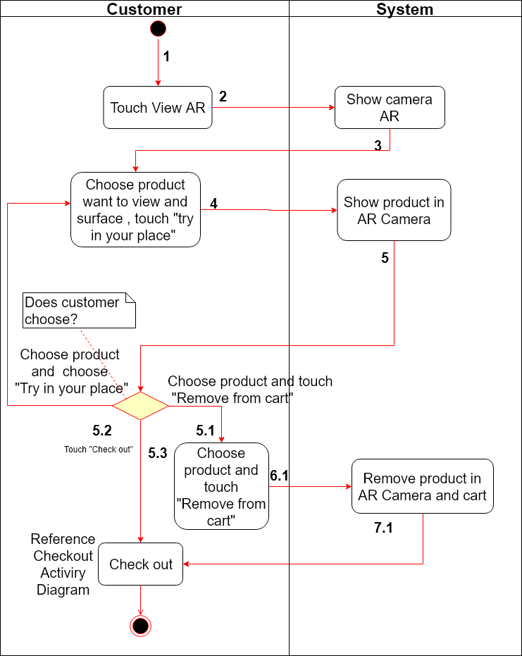

##### 4.3.2.3 Seller request to sell product

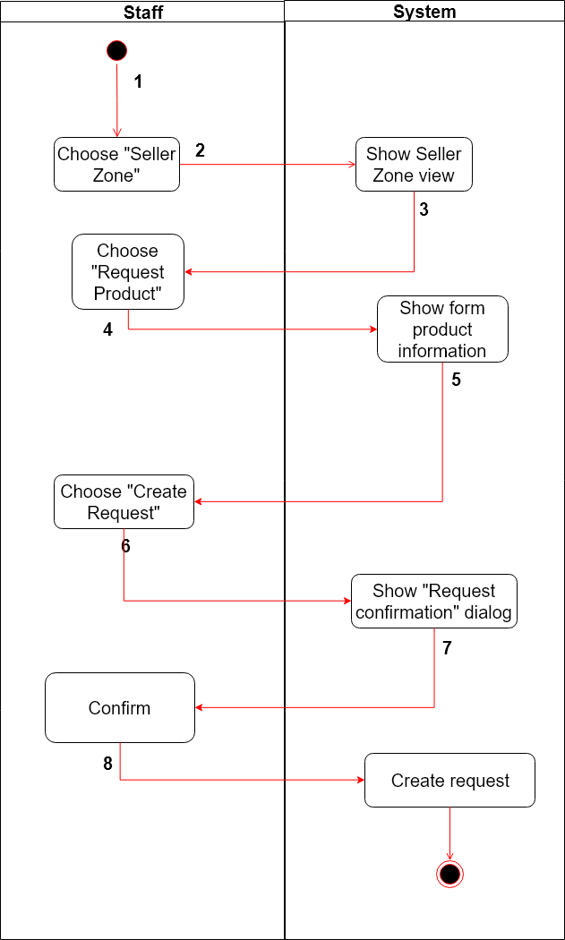

## 5. Interface

### 5.1 Staff & Designer

##### 5.1.1 Display role request

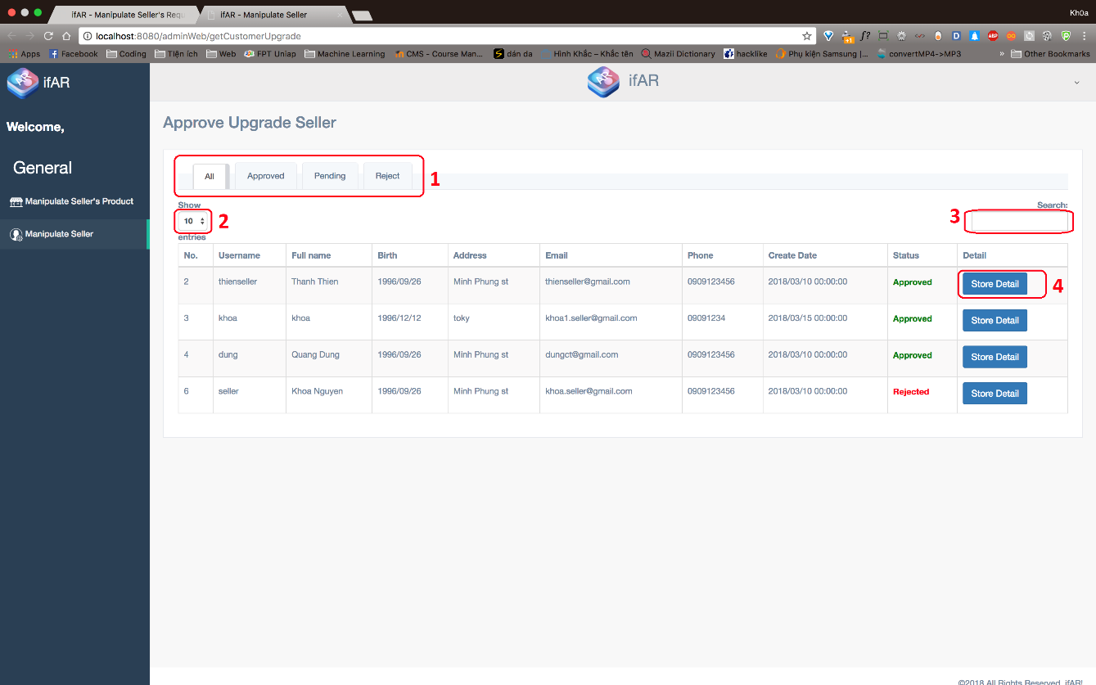

***Fields***

|  |  |  |  |  |  |  |  |
| --- | --- | --- | --- | --- | --- | --- | --- |
| ***No*** | ***Field Name*** | ***Description*** | ***Read only*** | ***Mandatory*** | ***Control Type*** | ***Data Type*** | ***Length*** |
| *2* | *Choose number of entries* | *Choose number of entries will be display in table* | *No* | *Yes* | *Textbox* | *String* | *3* |
| *3* | *Search seller* | *Search seller by username or store name* | *No* | *Yes* | *Textbox* | *String* | *N/A* |

***Buttons/Hyperlinks***

|  |  |  |  |  |
| --- | --- | --- | --- | --- |
| ***No*** | ***Function*** | ***Description*** | ***Validation*** | ***Outcome*** |
| *1* | *Change Tab* | *Switch to other tab following seller’s status* | *N/A* | *Change tab* |
| *4* | *Show detail of seller* | *Open pop-up which shows seller’s detail* | *N/A* | *Show pop-up* |

##### 5.1.2 Display role request’s detail

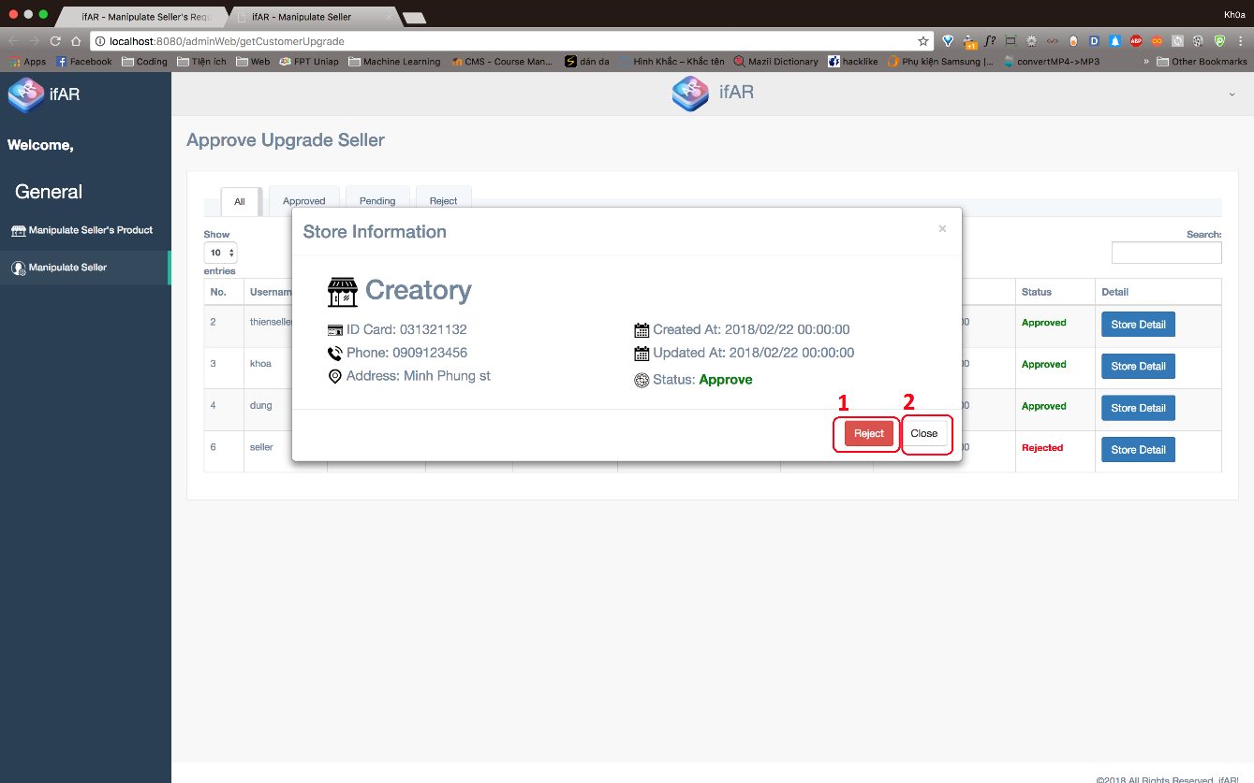

***Buttons/Hyperlinks***

|  |  |  |  |  |
| --- | --- | --- | --- | --- |
| ***No*** | ***Function*** | ***Description*** | ***Validation*** | ***Outcome*** |
| *1* | *Reject* | *Reject upgrade role* | *N/A* | *Open pop-up to fill reject reason* |
| *2* | *Close* | *Close pop-up* | *N/A* | *Close pop-up* |

##### 5.1.3 Reject role request

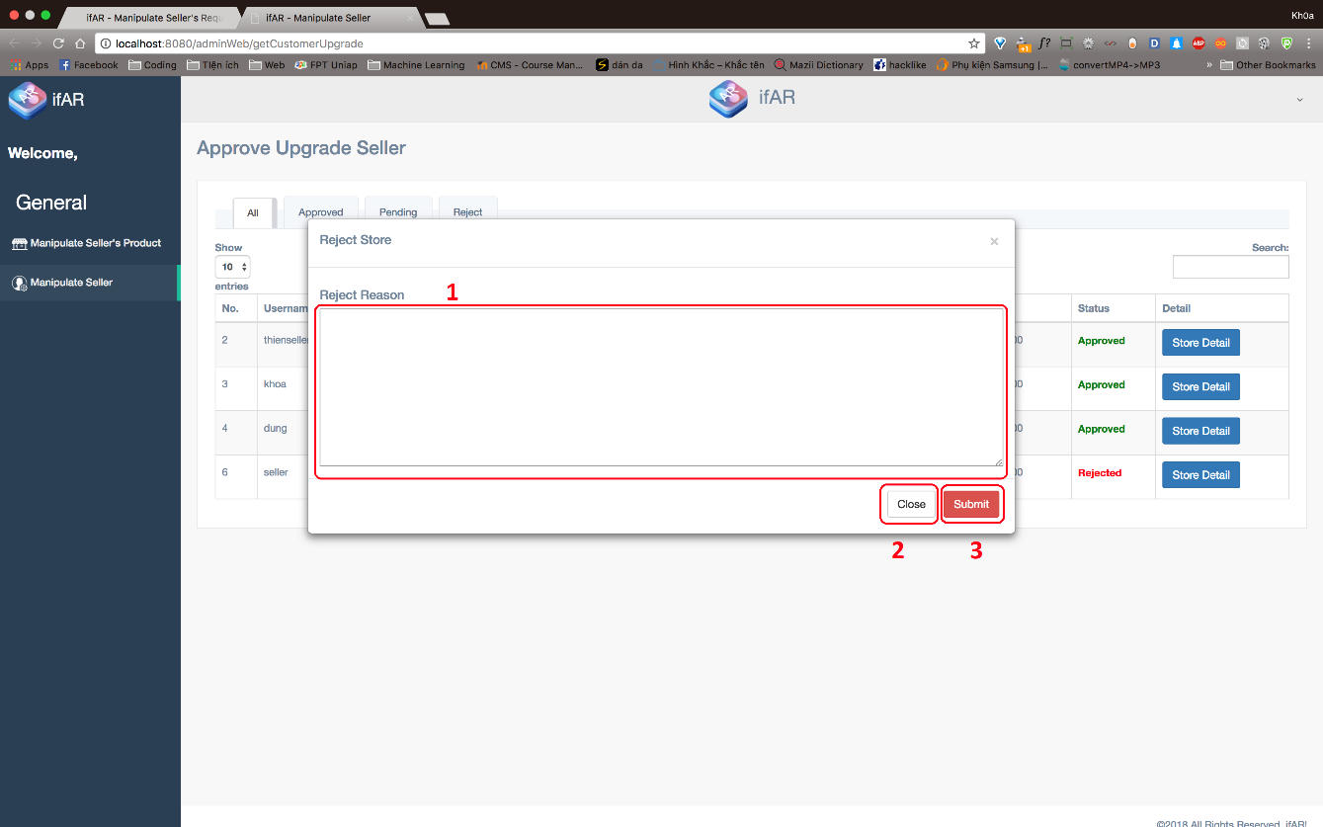

***Fields***

|  |  |  |  |  |  |  |  |
| --- | --- | --- | --- | --- | --- | --- | --- |
| ***No*** | ***Field Name*** | ***Description*** | ***Read only*** | ***Mandatory*** | ***Control Type*** | ***Data Type*** | ***Length*** |
| *1* | *Reject Reason* | *Fill reject reason why staff rejects this request* | *No* | *Yes* | *TextArea* | *String* | *250* |

***Buttons/Hyperlinks***

|  |  |  |  |  |
| --- | --- | --- | --- | --- |
| ***No*** | ***Function*** | ***Description*** | ***Validation*** | ***Outcome*** |
| *2* | *Close* | *Close pop-up* | *N/A* | *Close pop-up* |
| *3* | *Submit* | *Submit reason to system* | *N/A* | *Close pop-up* |

##### 5.1.4 Display sale product

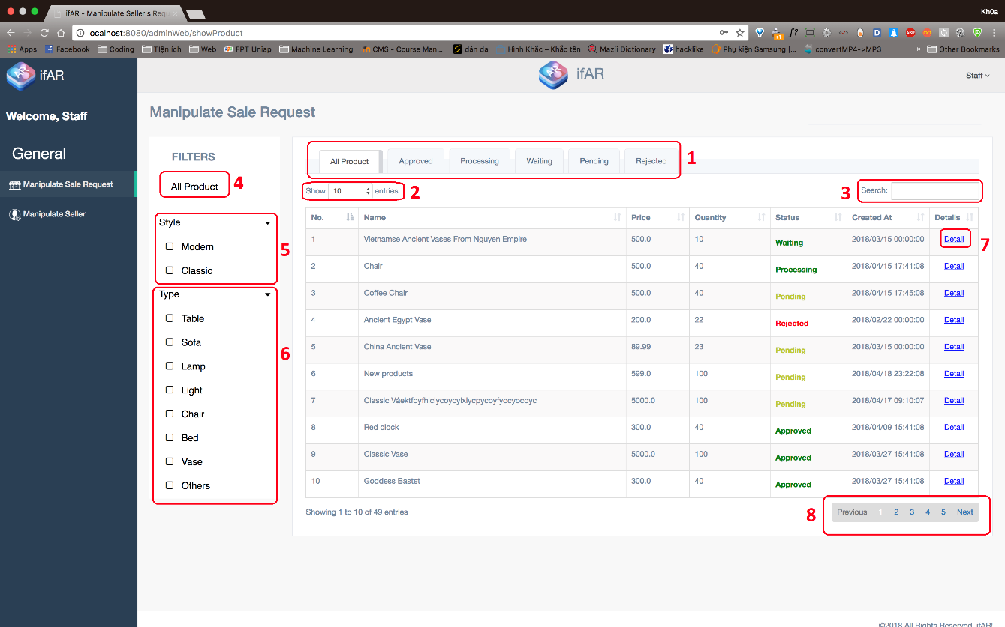

***Fields***

|  |  |  |  |  |  |  |  |
| --- | --- | --- | --- | --- | --- | --- | --- |
| ***No*** | ***Field Name*** | ***Description*** | ***Read only*** | ***Mandatory*** | ***Control Type*** | ***Data Type*** | ***Length*** |
| *2* | *Choose number of entries* | *Choose number of entries will be display in table* | *No* | *Yes* | *Textbox* | *String* | *3* |
| *3* | *Search seller* | *Search seller by username or store name* | *No* | *Yes* | *Textbox* | *String* | *N/A* |

***Buttons/Hyperlinks***

|  |  |  |  |  |
| --- | --- | --- | --- | --- |
| ***No*** | ***Function*** | ***Description*** | ***Validation*** | ***Outcome*** |
| *1* | *Change Tab* | *Switch to other tabs following seller’s status* | *N/A* | *Change tab* |
| *4* | *Display all products* | *Display all products in table* | *N/A* | *Display new data to table* |
| *5* | *Filter product by Style* | *Display products following style in table* | *N/A* | *Display new data to table* |
| *6* | *Filter product by Category* | *Display products following category in table* | *N/A* | *Display new data to table* |
| *7* | *Show detail of seller* | *Open pop-up which shows seller’s detail* | *N/A* | *Show pop-up* |
| *8* | *Paging* | *Separate data into pages* | *N/A* | *Change page* |

##### 5.1.5 Display sale product detail

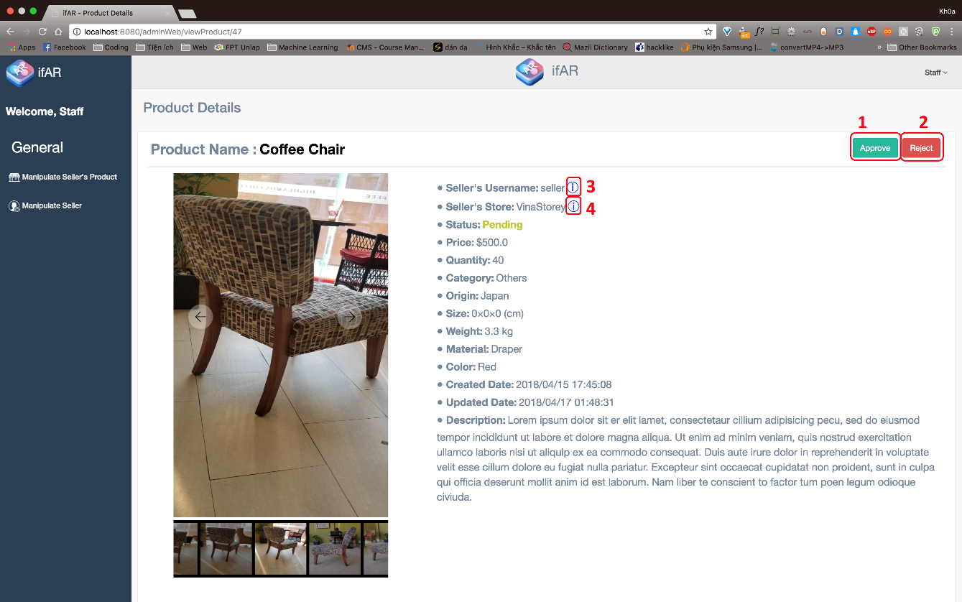

***Buttons/Hyperlinks***

|  |  |  |  |  |
| --- | --- | --- | --- | --- |
| ***No*** | ***Function*** | ***Description*** | ***Validation*** | ***Outcome*** |
| *1* | *Approve* | *Approve sale request* | *N/A* | *Show pop-up to fill service pricing* |
| *2* | *Reject* | *Reject sale request* | *N/A* | *Show pop-up to fill reject reason* |
| *3* | *Seller’s information* | *Show seller’s information* | *N/A* | *Show pop-up seller’s information* |
| *4* | *Store’s information* | *Show store’s information* | *N/A* | *Show pop-up store’s information* |

##### 5.1.6 Approve sale product request

##### 

***Fields***

|  |  |  |  |  |  |  |  |
| --- | --- | --- | --- | --- | --- | --- | --- |
| ***No*** | ***Field Name*** | ***Description*** | ***Read only*** | ***Mandatory*** | ***Control Type*** | ***Data Type*** | ***Length*** |
| *1* | *Service pricing* | *Pricing for approve and generate 3D model of product* | *No* | *Yes* | *Textfield* | *String* | *8* |

***Buttons/Hyperlinks***

|  |  |  |  |  |
| --- | --- | --- | --- | --- |
| ***No*** | ***Function*** | ***Description*** | ***Validation*** | ***Outcome*** |
| *1* | *Submit* | *Submit pricing to system* | *N/A* | *Close pop-up* |
| *2* | *Close* | *Close pop-up* | *N/A* | *Close pop-up* |

##### 5.1.7 Reject sale product request

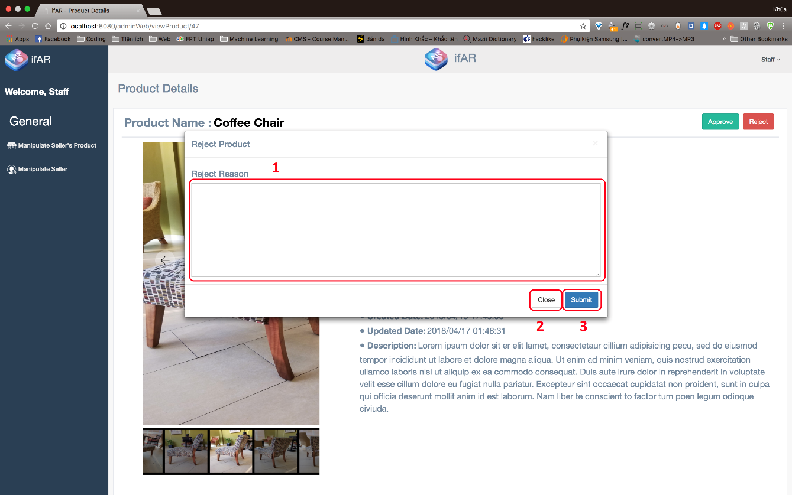

***Fields***

|  |  |  |  |  |  |  |  |
| --- | --- | --- | --- | --- | --- | --- | --- |
| ***No*** | ***Field Name*** | ***Description*** | ***Read only*** | ***Mandatory*** | ***Control Type*** | ***Data Type*** | ***Length*** |
| *1* | *Reject Reason* | *Fill reject reason why staff rejects this request* | *No* | *Yes* | *TextArea* | *String* | *250* |

***Buttons/Hyperlinks***

|  |  |  |  |  |
| --- | --- | --- | --- | --- |
| ***No*** | ***Function*** | ***Description*** | ***Validation*** | ***Outcome*** |
| *2* | *Close* | *Close pop-up* | *N/A* | *Close pop-up* |
| *3* | *Submit* | *Submit reason to system* | *N/A* | *Close pop-up* |

### 5.2 Customer

##### 5.2.1 Select product

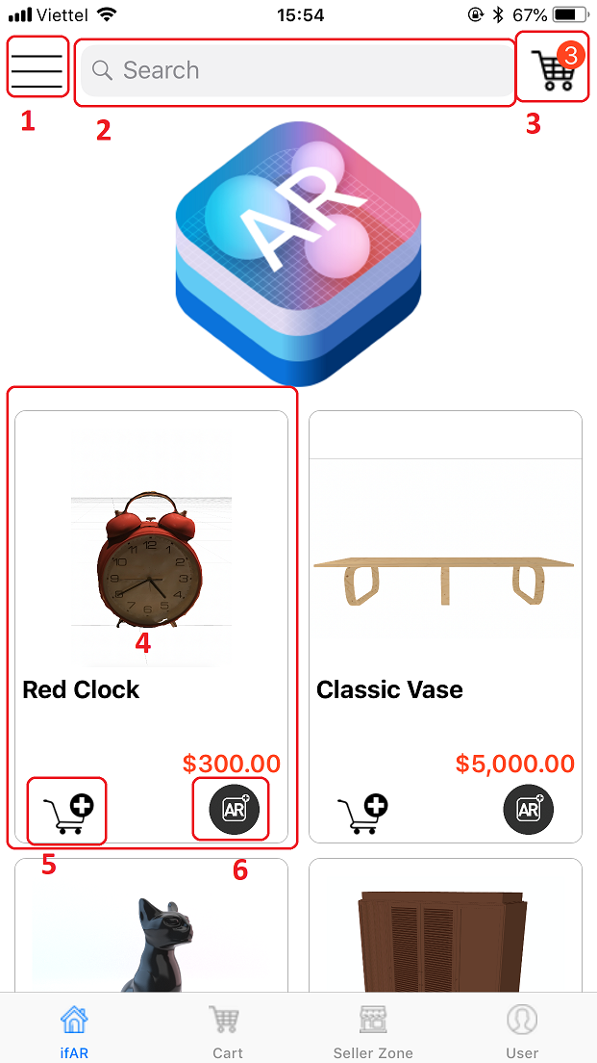

***Fields***

|  |  |  |  |  |  |  |  |
| --- | --- | --- | --- | --- | --- | --- | --- |
| ***No*** | ***Field Name*** | ***Description*** | ***Read only*** | ***Mandatory*** | ***Control Type*** | ***Data Type*** | ***Length*** |
| *2* | *Search product* | *Search product by name* | *No* | *Yes* | *TextArea* | *String* | *50* |

***Buttons/Hyperlinks***

|  |  |  |  |  |
| --- | --- | --- | --- | --- |
| ***No*** | ***Function*** | ***Description*** | ***Validation*** | ***Outcome*** |
| *1* | *Option* | *Open option* | *No* | *Show pop-up option* |
| *3* | *Get cart* | *Get cart* | *No* | *Move to cart view* |
| *4* | *Get product’s detail* | *View product detail* | *No* | *Move to product’s detail view* |
| *5* | *Add to cart* | *Add product to cart* | *No* | *Add this product to cart* |
| *6* | *View AR* | *View product in AR view* | *No* | *Move to AR view* |

##### 5.2.2 Product detail

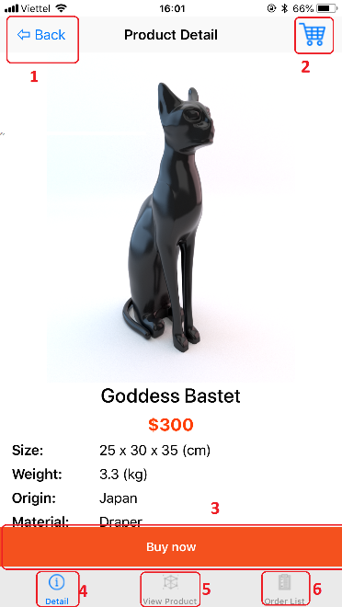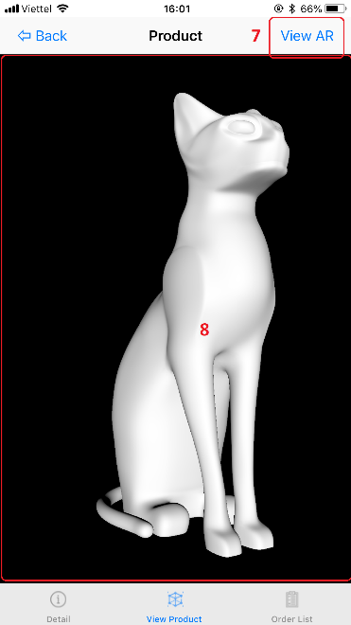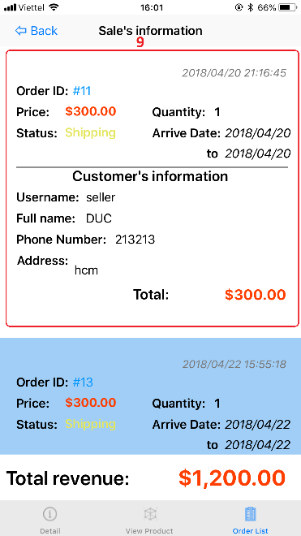

***Buttons/Hyperlinks***

|  |  |  |  |  |
| --- | --- | --- | --- | --- |
| ***No*** | ***Function*** | ***Description*** | ***Validation*** | ***Outcome*** |
| *1* | *Back* | *Back to previous view* | *No* | *Display previous view* |
| *2* | *Get cart* | *Get cart* | *No* | *Move to cart view* |
| *3* | *Add to cart* | *Add product to cart* | *No* | *Add this product to cart* |
| *4* | *Product detail* | *Get product detail* | *No* | *Move to product’s detail view* |
| *5* | *View product in 3D view* | *Simulate product in 3D view* | *No* | *Move to 3D view* |
| *6* | *Get order list* | *Get orders of this product* | *No* | *Move to order list view* |
| *7* | *View AR* | *View product in AR view* | *No* | *Move to AR view* |
| *8* | *Rotate product* | *Rotate product following user’s action* | *No* | *Rotate product in 3D view* |
| *9* | *Manipulate order* | *Manipulate order of this product* | *No* | *Manipulate order of this product* |

##### 5.2.3 Simulate products in AR view

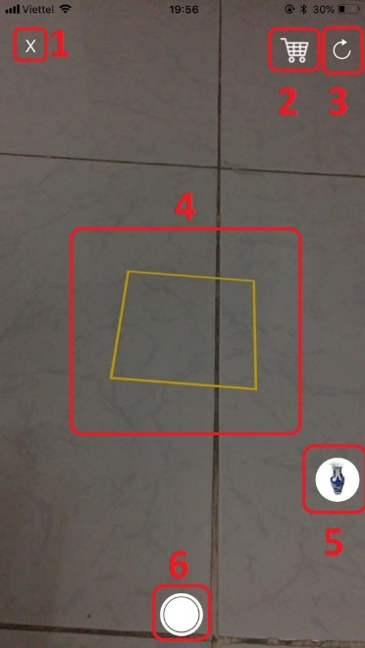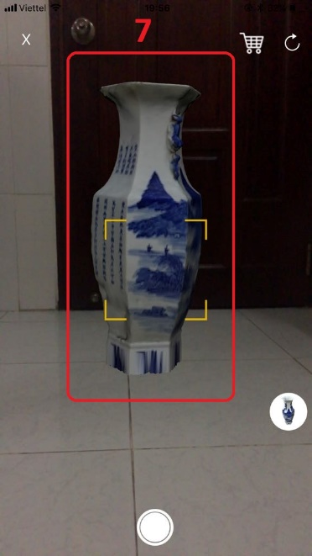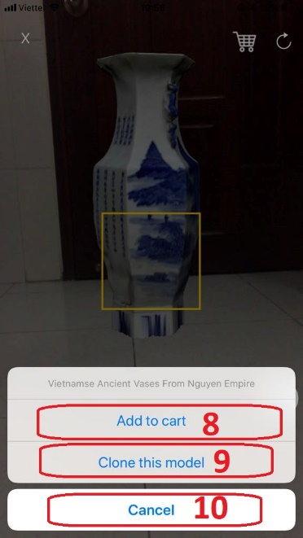

***Buttons/Hyperlinks***

|  |  |  |  |  |
| --- | --- | --- | --- | --- |
| ***No*** | ***Function*** | ***Description*** | ***Validation*** | ***Outcome*** |
| *1* | *Exit* | *Back to previous view* | *No* | *Display previous view* |
| *2* | *Get cart* | *Get cart* | *No* | *Move to cart view* |
| *3* | *Reset* | *Resest everything in AR view* | *No* | *Reset surface detection and model in AR view* |
| *4* | *Detect surface* | *Detect surface* | *No* | *Surface is detected* |
| *5* | *More option* | *More option of product (8, 9, 10)* | *No* | *List buttons (8, 9, 10)* |
| *6* | *Screenshot* | *Screenshot* | *No* | *Screenshot in Photos* |
| *7* | *Interact product* | *Interact with product in AR view* | *No* | *Change product’s aspect* |
| *8* | *Add to cart* | *Add to cart* | *No* | *Product is added to card* |
| *9* | *Clone model* | *Clone one more product* | *No* | *One more product is added* |
| *10* | *Cancel* | *Cancle* | *No* | *Cancle selection option* |

##### 5.2.4 Check out

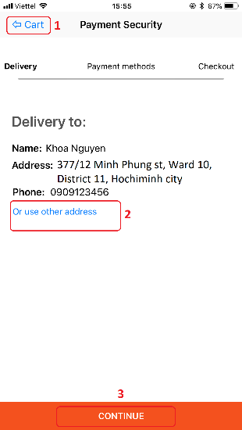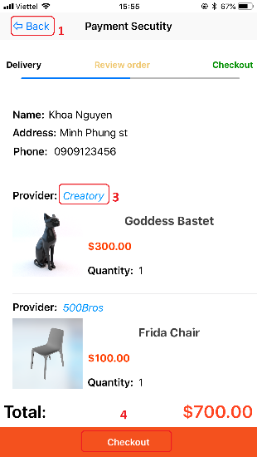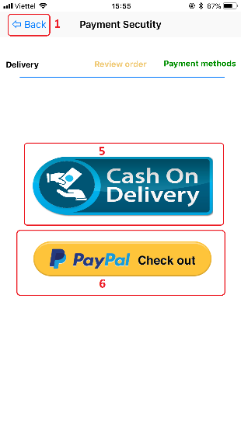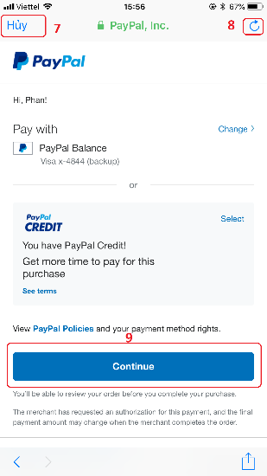

***Buttons/Hyperlinks***

|  |  |  |  |  |
| --- | --- | --- | --- | --- |
| ***No*** | ***Function*** | ***Description*** | ***Validation*** | ***Outcome*** |
| *1* | *Back* | *Back to previous view* | *No* | *Display previous view* |
| *2* | *Change address* | *Change delivery address* | *No* | *Show address form* |
| *3* | *Get store ‘s information* | *Get store’s information of product* | *No* | *Show store’s information* |
| *4* | *Checkout* | *Execute payment* | *No* | *Move to payment view* |
| *5* | *Cash on delivery* | *Execute payment with Cash on delivery* | *No* | *Finish payment* |
| *6* | *Paypad* | *Execute payment with paypal* | *No* | *Open Paypal webview* |
| *7* | *Cancel* | *Cancel payment* | *No* | *Display previous view* |
| *8* | *Refresh* | *Refresh data* | *No* | *Apply new data* |
| *9* | *Checkout* | *Finish payment* | *No* | *Finish payment* |

### 5.3 Seller

##### 5.3.1 Request to sell product

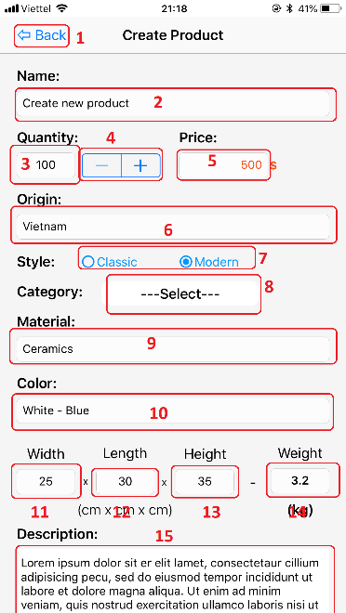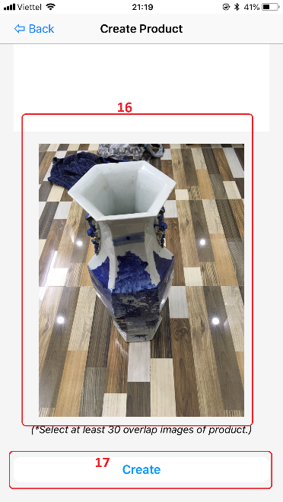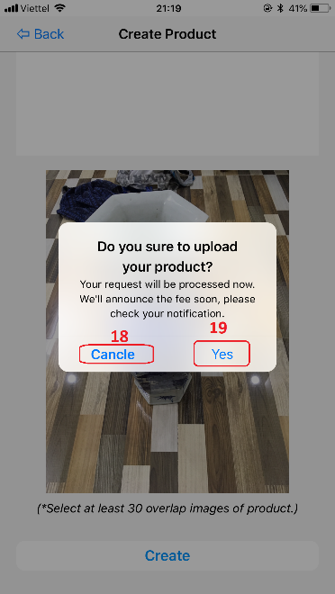

***Fields***

|  |  |  |  |  |  |  |  |
| --- | --- | --- | --- | --- | --- | --- | --- |
| ***No*** | ***Field Name*** | ***Description*** | ***Read only*** | ***Mandatory*** | ***Control Type*** | ***Data Type*** | ***Length*** |
| *2* | *Product name* | *Product name* | *No* | *Yes* | *Textfield* | *String* | *50* |
| *3* | *Quantiy* | *Quantiy of product* | *No* | *Yes* | *Textfield* | *Int* | *N/A* |
| *5* | *Price* | *Price of product* | *No* | *Yes* | *Textfield* | *Double* | *N/A* |
| *6* | *Origin* | *Origin of product* | *No* | *Yes* | *Textfield* | *String* | *50* |
| *9* | *Material* | *Material of product* | *No* | *Yes* | *Textfield* | *String* | *50* |
| *10* | *Color* | *Color of product* | *No* | *Yes* | *Textfield* | *String* | *50* |
| *11* | *Width* | *Width of product* | *No* | *Yes* | *Textfield* | *Int* | *N/A* |
| *12* | *Length* | *Length of product* | *No* | *Yes* | *Textfield* | *Int* | *N/A* |
| *13* | *Height* | *Height of product* | *No* | *Yes* | *Textfield* | *Int* | *N/A* |
| *14* | *Weight* | *Weight of product* | *No* | *Yes* | *Textfield* | *Double* | *N/A* |
| *15* | *Description* | *Description of product* | *No* | *Yes* | *Textarea* | *String* | *2000* |

***Buttons/Hyperlinks***

|  |  |  |  |  |
| --- | --- | --- | --- | --- |
| ***No*** | ***Function*** | ***Description*** | ***Validation*** | ***Outcome*** |
| *1* | *Back* | *Back* | *No* | *Back to previous view* |
| *4* | *Change quantiy* | *Change quantiy of product* | *No* | *Inscrease/descrease quantity* |
| *7* | *Select Style* | *Select Style of product* | *No* | *Radio button is checked* |
| *8* | *Select Category* | *Select Category of product* | *No* | *Show selected category* |
| *16* | *Select images* | *Select images of product* | *No* | *Display first image of list images* |
| *17* | *Create request* | *Create request* | *Yes* | *Show confirmation pop-up* |
| *18* | *Cancel request* | *Cancel request* | *No* | *Close pop-up* |
| *19* | *Confirm request* | *Confirm request* | *No* | *Request is sent to system* |

##### 5.3.2 Notification

##### 

***Buttons/Hyperlinks***

|  |  |  |  |  |
| --- | --- | --- | --- | --- |
| ***No*** | ***Function*** | ***Description*** | ***Validation*** | ***Outcome*** |
| *1* | *Back* | *Back* | *No* | *Back to previous view* |
| *2* | *Confirm notification* | *Confirm notification* | *No* | *Show pop-up with service pricing* |
| *3* | *Cancel* | *Close pop-up* | *No* | *Close pop-up* |
| *4* | *Pay* | *Execute payment for notification* | *No* | *Finish payment* |

## 6. Database Design

### 6.1 Entity relationship diagram (ERD)

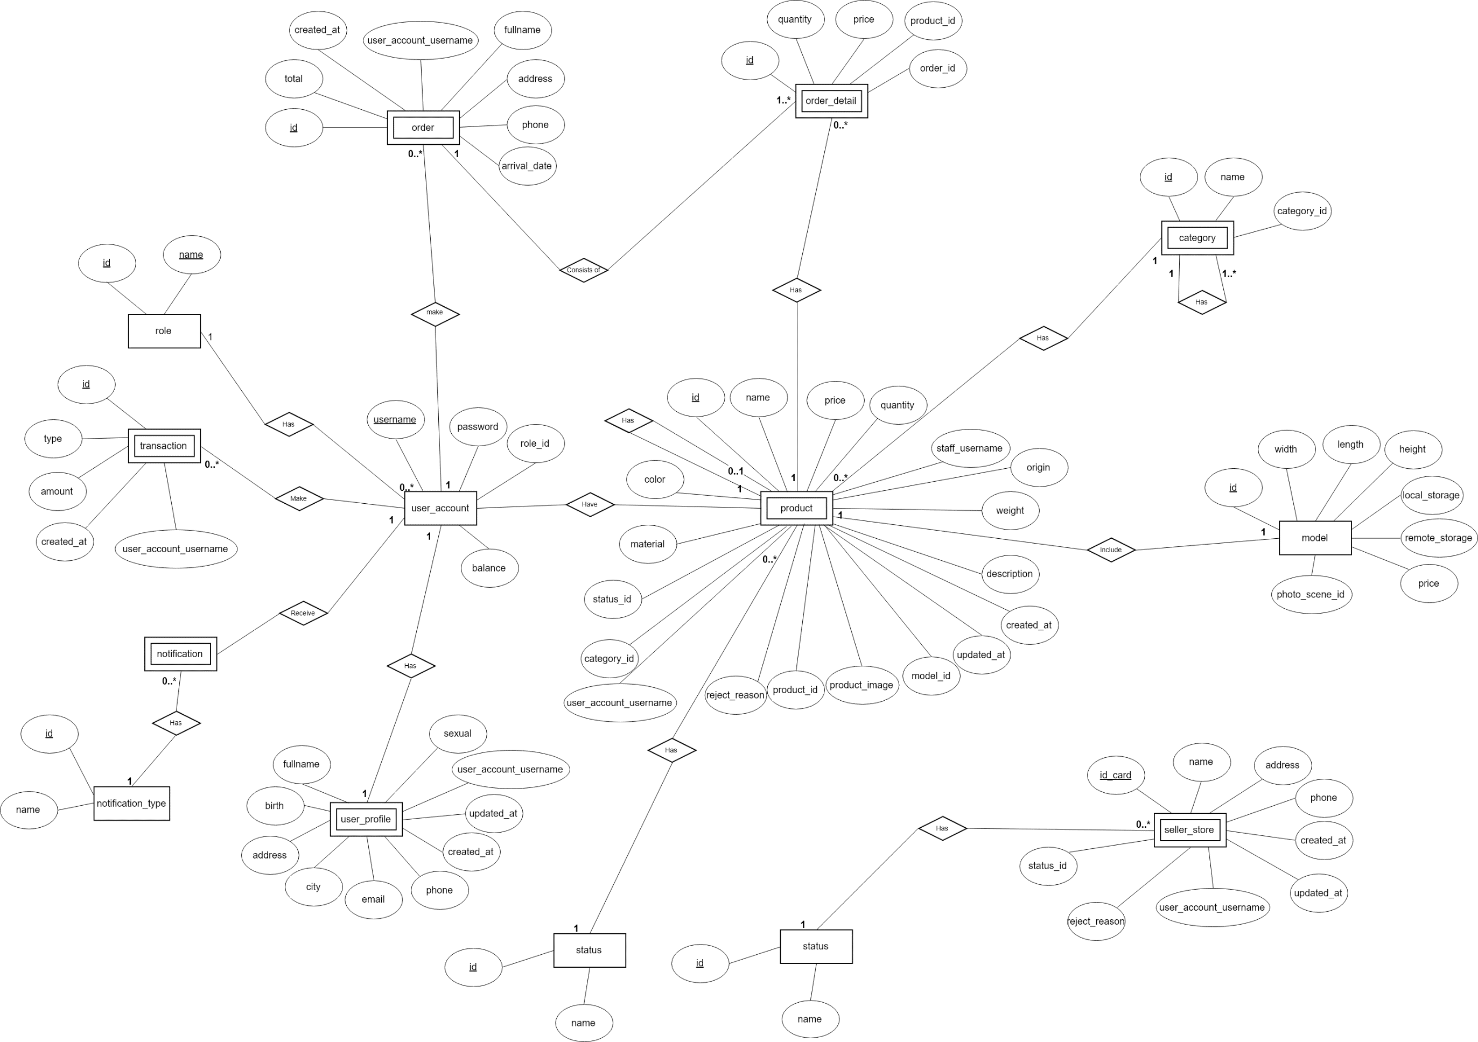

Figure 59 Entity relationship diagram

### 6.2 Data Dictionary

|  |  |
| --- | --- |
|  | Entity Data Dictionary |
| **Entity name** | **Description** |
| role | Contain the role information |
| order | Contain customer’s order information. |
| order\_detail | Contain order detail information. |
| transaction | Contain the transaction information. |
| user\_account | Contain the user account information of user profile. |
| product | Contain the product information. |
| category | Contain the category information of product. |
| model | Contain the model information of product. |
| notification | Contain the notification information. |
| notification\_type | Contain the notification type of notification. |
| user\_profile | Contain the user profile information. |
| seller\_store | Contain the seller’s store information |
| status | Contain the status information. |

## 7. Algorithms

### 7.1 Augmented Reality – Plane Detection

##### 7.1.1 Definition

The plane detection algorithm of Augmented Reality automatically detects multiple planes based on the proposed constrained sampling strategy.

##### 7.1.2 Define Problem

The whole concept behind Augmented Reality is blending together the reality around us with virtual objects that exist only within our App. In order to be able to do that successfully, we need to be aware of the geometry of our surroundings.

In other words, we need to be able to identify the ceilings, walls, tables and other physical objects.

Each plane has many specific point on it which will help us to build an algorithm to recognize plane. But we get some problems:

* Need a lot of time for building a good identification algorithm.
* Solution need to be stable to ensure reliability of system.

##### 7.1.3 Solution

Then we decide to use ARKit to detect plane with following concept:

* **Plane detection:** Plane detection is the ability to determine surfaces or planes in the physical environment. This is thing like the ground floor or may be a table.
* **Hit-testing:** Getting an intersection with the real-world topology so that you can place your virtual object in the physical world.
* **Light estimation:** Use to render or correctly light your virtual geometry to match that of the physical world.

##### 7.1.4 Work flow

Acquisition

Tracking

Camera

Rendering

Augmented Image

Plane Detection

Display

Figure 60 Augmented Reality - Plance detection work flow

#### 7.1.5 Reference

##### Augmented Reality with ARKit: Detecting Planes: <https://digitalleaves.com/blog/2017/10/augmented-reality-with-arkit-detecting-planes/>

### 7.2 Augmented Reality – Placing Object

##### 7.2.1 Definition

The placing object algorithm of Augmented Reality used for place object on existing surface in Augmented Reality.It determines the surface existing in Augmented Reality and place the object on that surface.

##### 7.2.2 Define Problem

After the system detected surface, we need an algorithm to help the system place object on existing surface in Augmented Reality.

To implement the algorithm, we use Hit-testing concept of ARKit to solve the algorithm of placing object on existing surface in Augmented Reality.

##### 7.2.3 Solution

To solve this problem, we should use Hit-testing concept of ARKit. Hit testing searches for real-world objects or surfaces detected through the AR session's processing of the camera image. A 2D point in the image coordinates can refer to any point along a 3D line that starts at the device camera and extends in a direction determined by the device orientation and camera projection. This method searches along that line, returning all objects that intersect it in order of distance from the camera. After surface detected, hit-testing will support to place the object on that surface.

##### 7.2.4 Work flow

Acquisition

Tracking

Camera

Rendering

Augmented Image

Plane Detection

Placing Object

Display

Figure 61: Augmented Reality – Placing Object work flow

##### 7.2.6 References

Apple Developer Documentation: Hit-test method:

<https://developer.apple.com/documentation/arkit/arframe/2875718-hittest>

##### 7.2.7 Example

Place 3D model of Ancient vase on table:

***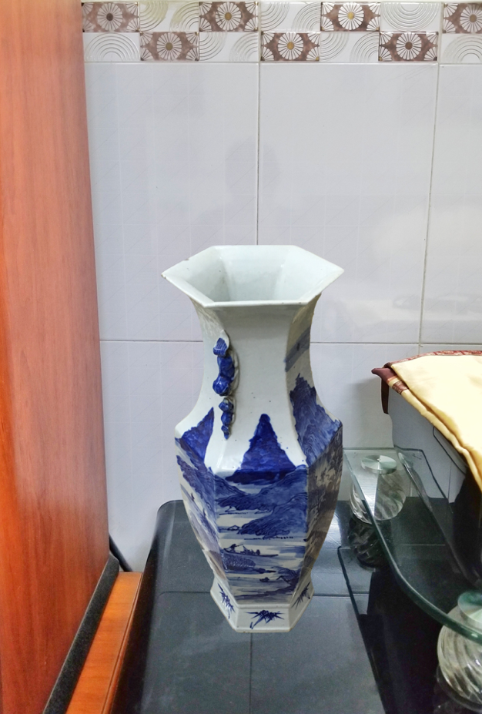***

Figure 62: Augmented Reality – Placing Object example

### 7.2 Reality Capture

#### 7.2.1 Definition

Reality capture is the process of scanning an object, building, or site and producing a digital model representation—allows today’s builders to capture site data quickly and more accurately than ever before and connect it directly to the digital design process. The result is a comprehensive 3D model based on millions of data points mapping the entire site, whether it’s a building renovation or an infrastructure project, often including a look at the systems that function below the surface. Reality Capture uses object recognition - a process for identifying a specific object in a digital image or video. Object recognition algorithms rely on matching, learning, or pattern recognition algorithms using appearance-based or feature-based techniques, to detect the object inside series of input images.

Thanks to Reality Capture, even user who doesn’t have experience in design is able to create 3D model, it also saves huge time and effort comparing to traditional way. The objects have small or medium size and average complexity are created in short time with almost exactly exteriority. Even smartphone’s camera can be used for Reality Capture.

#### 7.2.2 Define Problem

In normally, interior furniture is usually represented by list of images or in advance with 360o videos which can’t satisfy customer. Customers feel hard to determine the actual size and shape of furniture when they put them to their house.

To solve this problem, some online store applied 3D model to their website to give customer a better view. However, creating 3D model costs much time and money which makes product’s price more expensive.

#### 7.2.3 Solution

To solve this problem, we use Reality Capture to generate 3D model with Semi-auto processing that saves a lot of time and money. User only need to provide series of overlap pictures capturing the product with all aspects.

#### 7.2.4 Work flow

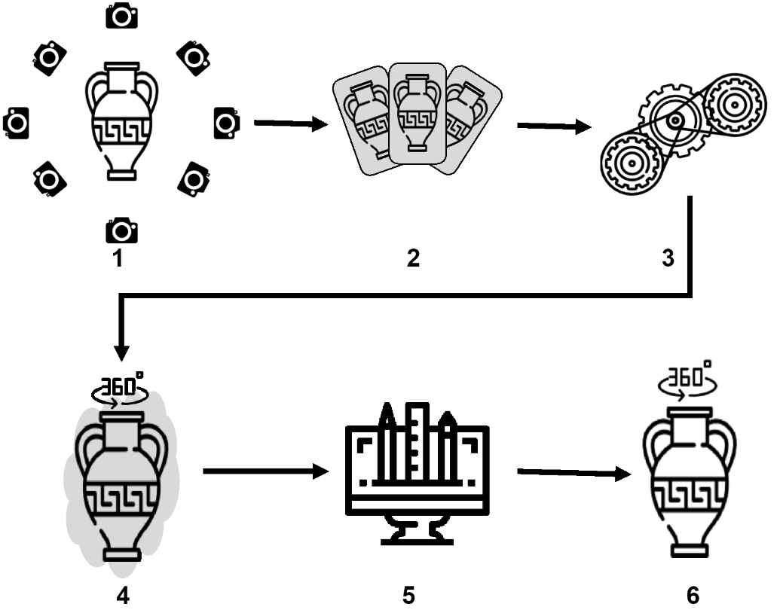

Figure 63: Reality Capture work flow

1. Capture series of overlap pictures of object with same distance at least 30 images.
2. Send these pictures to system with information about object: width, length, heigh and color.
3. Scheduler is going to generate 3D model from pictures provided by user.
4. Result model contains redundant textures (raw model) and need to upgrade quality.
5. Designer has responsibility to edit raw model, the raw model is removed unnecessary texture and fixed size, detail.
6. After being edited, the model is ready to represent the object. This model can be used in both AR view or 3D view.

#### 7.2.5 References

Kylee Swenson (2017). What is Reality Capture?: Redshift by Autodesk. <https://www.autodesk.com/redshift/what-is-reality-capture/>

#### 7.2.7 Example

***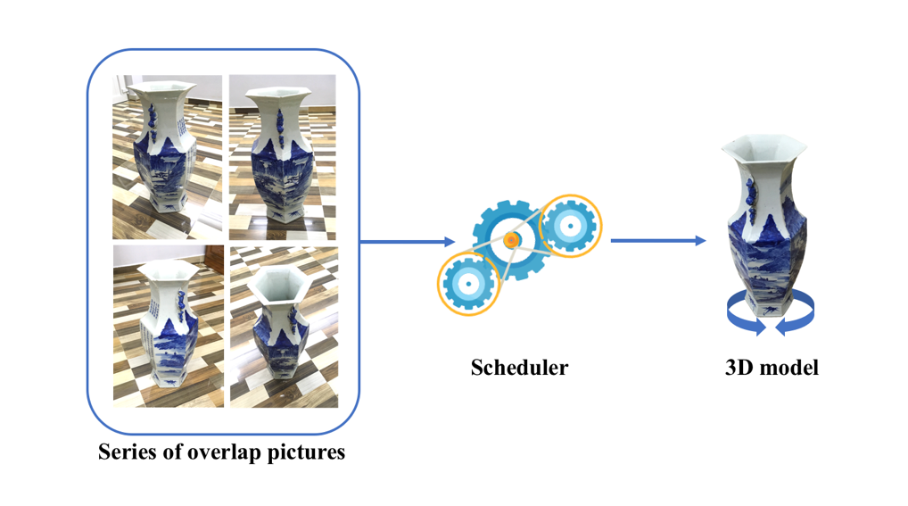***The example below is our Ancient Ceramic Vase:

Figure 64: Reality Capture example

# E. System Implementation & Test

## 1. Introduction

### 1.1 Overview

This section provides in detail all necessary information about implementation information of VASH which includes physical database design, system state machine diagram and testing procedure which includes test plans, test cases and test result.

### 1.2 Test Approach

We use black box test approach because to estimate our virtual assistant quality, tester need to aware of what VA should do but does not have the knowledge of how it does it. If tester had knowledge about the technical inside it, testing process won’t be objectivity.

## 2. Database Relationship Diagram

### 2.1 Physical Diagram

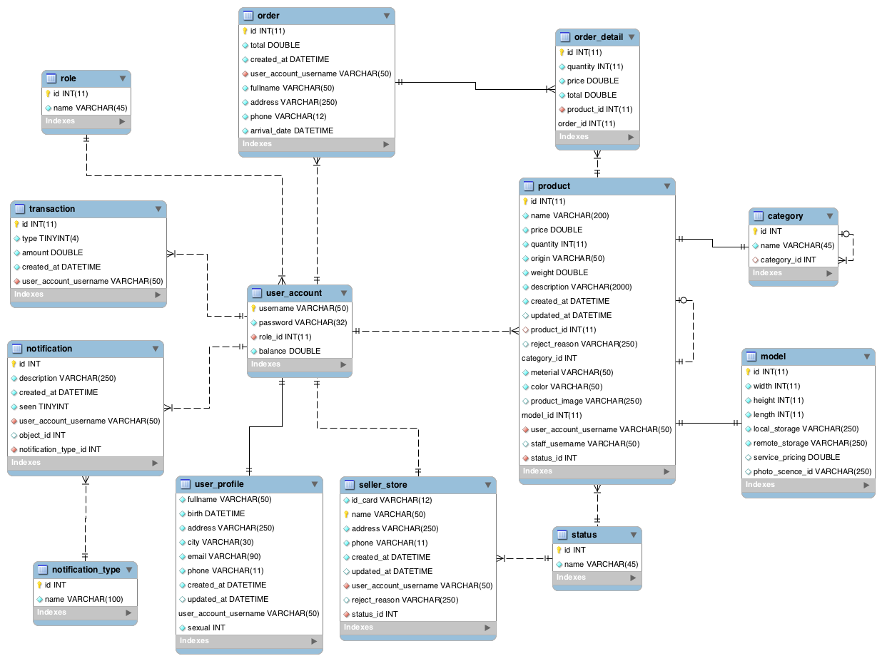  
Figure 65: Extend Entity Relation Diagram

2.2 Data Dictionary

|  |  |
| --- | --- |
| Data dictionary: describe content of all tables | |
| **Table Name** | **Description** |
| role | Table which contains the role information |
| order | Table which contains customer’s order information. |
| order\_detail | Table which contains order detail information. |
| transaction | Table which contains the transaction information. |
| user\_account | Table which contains the user account information of user profile. |
| product | Table which contains the product information. |
| category | Table which contains the category information of product. |
| model | Table which contains the model information of product. |
| notification | Table which contains the notification information. |
| notification\_type | Table which contains the notification type of notification. |
| user\_profile | Table which contains the user profile information. |
| seller\_store | Table which contains the seller’s store information |
| status | Table which contains the status information. |

|  |  |  |  |
| --- | --- | --- | --- |
| **Entity name** | **Attributes** | **Description** | **Null** |
| role | id {pk} | Unique identifier | No |
| name | Role name | No |
| order | id {pk} | Unique identifier | No |
| total | Total of order | No |
| created\_at | Create date | No |
| user\_account\_username{fk} | Username of user | No |
| fullname | Full name of user | No |
| address | Delivery address | No |
| phone | Phone number of user | No |
| arrival\_date | Expected arrival date | No |
| order\_detail | id {pk} | Unique identifier | No |
| quantity | Quantity of product | No |
| price | Price of product | No |
| total | Total of order tail | No |
| product\_id  {fk} | Identifier of product | No |
| order\_id {fk} | Identifier of order | No |
| transaction | id {pk} | Unique identifier | No |
| type | Transaction type | No |
| amount | Amount of money in transaction | No |
| created\_at | Create date | No |
| user\_account\_username{fk} | Username of user | No |
| user\_account | username{pk} | Username of user | No |
| password | Password of account | No |
| role\_int | Unique identifier of role | No |
| balance | Balance in account | No |
| product | id {pk} | Unique identifier | No |
| name | Name of product | No |
| price | Price of product | No |
| quantity | Quantity of product | No |
| origin | Origin of product | No |
| weight | Weight of product | No |
| description | Description of product | No |
| created\_at | Create date | No |
| updated\_at | Update date | Yes |
| product\_id {fk} | Identifier of parent of product | Yes |
| reject\_reason | Reason why product is rejected | Yes |
| category\_id {fk} | Identifier of category | No |
| material | Material of product | No |
| color | Color of product | No |
| product\_image | Image of product on marketplace | Yes |
| model\_id {fk} | Identifier of model | No |
| user\_account\_username {fk} | Username of user | No |
| staff\_username | Username of staff who reviews product | Yes |
| status\_id | Unique identifier of status | No |
| category | id {pk} | Unique identifier | No |
| name | Name of category | No |
| category\_id {fk} | Identifier of parent caterory | Yes |
| model | id {pk} | Unique identifier | No |
| width | Width of model | No |
| height | Height of model | No |
| length | Length of model | No |
| local\_storage | Reference link of local storage which stores model data | No |
| remote\_storage | Reference link of remote storage which stores model data | No |
| service\_pricing | Service pricing of approving product | Yes |
| photo\_scence\_id | Identifier of model in Reality Capture | Yes |
| notification | id {pk} | Unique identifier | No |
| description | Description of notification | No |
| created\_at | Create date | No |
| seen | Check if notification is seen or not | No |
| user\_account\_username {fk} | Username of user | No |
| object\_id | Identifier of object that relates the notification | Yes |
| notification\_type\_id {fk} | Notification type | No |
| notification\_type | id {pk} | Unique identifier | No |
| name | Name of notification type | No |
| user\_profile | fullname | Full name of user | No |
| birth | Date of birth of user | No |
| address | Address of user | No |
| city | City of user | No |
| email | Email of user | No |
| phone | Phone of user | No |
| created\_at | Create date | No |
| updated\_at | Update date | Yes |
| user\_account\_username {fk} | Username of user | No |
| sexual | Sexual of user | No |
| seller\_store | id\_card {unique} | Identity card of seller | No |
| name | Store name | No |
| address | Store address | No |
| phone | Phone number of store | No |
| created\_at | Create date | No |
| updated\_at | Update date | Yes |
| user\_account\_username {pk} | Username of user | No |
| reject\_reason | Reason why store is rejected | Yes |
| status\_id {fk} | Identifier of status | No |
| status | id {pk} | Unique identifier | No |
| name | Name of status | No |

**Table 13: EERD Data Dictionary**

## 3. Performance Measures

### 3.1 Augmented Reality Plane Detection Performance

The speed of plane detection will depend on light intensity, camera quality and camera steady. In worst case, the camera cannot detect plane if not enough light or too much light with shiny specular highlights, lack of texture, and fast movement. In happy case, time to detect plane is under 1 second.

### 3.2 Reality Capture Performance

The quality of 3D model generated from Reality Capture will depend on number of images and quality of images. Time to generate a 3D model is about 60 – 70 minutes and accuracy is about 80%. In worst case, the 3D model will generate fail if amount of number of images not enough (recommended at least 30 images).

## 4.Test Plan

The purpose of this section is to verify and ensure that VASH meets its design specification and other requirements from user. The following part will describe which features to be tested and which will not.

### 4.1 Features to be tested

4.1.1 Web application

* Approve sale product request
* Reject sale product request

4.1.2 Mobile application

* Seller requests to sell product
* Simulate products via AR view.
* Execute payment via Paypal.

### 4.2 Features not to be tested

* Functions are not listed aboves and user management functions won’t be test.

## 5. System Testing Test Case

5.1 Communication Diagram

##### 5.1.1 Manipulate sale product request

Figure 66: Manipulate sale product request test flow

##### 5.1.2 Simulate product via AR view

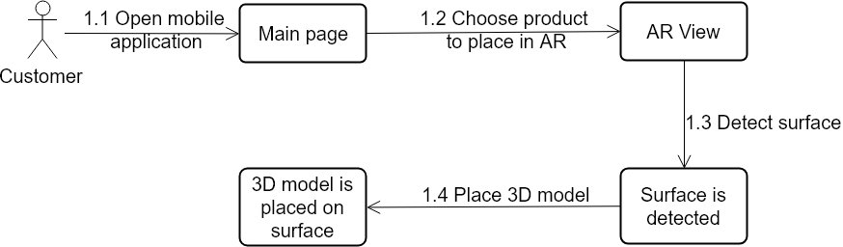

Figure 67: Simulate product via AR view test flow

##### 5.1.3 Checkout via Paypal

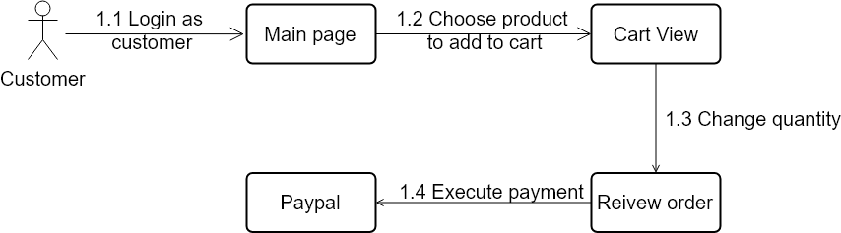

Figure 68: Checkout via Paypal test flow

##### 5.1.4 Seller requests to sell product

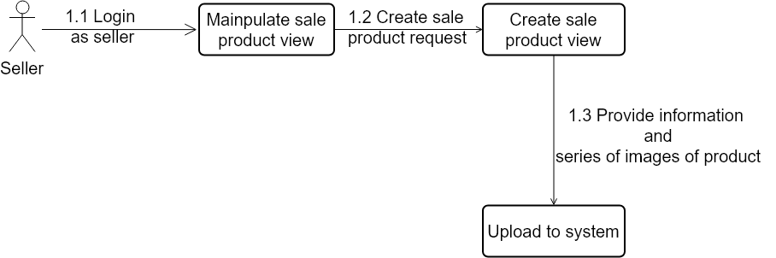

Figure 69: Seller requests to sell product test flow

5.1 Web Application Test case

5.1.1 Approve sale product request

|  |  |  |  |  |  |
| --- | --- | --- | --- | --- | --- |
| **ID** | **Test Case Description** | **Test Case Procedure** | **Expected output** | **Result** | **Test Date** |
| ASP1 | Approve sale product | 1. Login with role “Staff” 2. Go to “Manipulate request product” view. 3. Click “detail” button in record row from table contain list of request product. 4. Click “Approve” button in “Sale product request detail” view. 5. Input field “Service pricing”. 6. Click “Submit” button. | Product status change to processing. | Passed | 16/04/2018 |

5.1.2 Reject sale product request

|  |  |  |  |  |  |
| --- | --- | --- | --- | --- | --- |
| **ID** | **Test Case Description** | **Test Case Procedure** | **Expected output** | **Result** | **Test Date** |
| RSP1 | Reject sale product | 1. Login with role “Staff” 2. Go to “Manipulate request product” view. 3. Click “detail” button in record row from table contain list of request product. 4. Click “Reject” button in “Sale product request detail” view. 5. Input field “Reject reason”. 6. Click “Submit” button. | Product status change to rejected. | Passed | 16/04/2018 |

5.2 Mobile Application Test case

5.2.1 Simulate product via AR view

|  |  |  |  |  |  |
| --- | --- | --- | --- | --- | --- |
| **ID** | **Test Case Description** | **Test Case Procedure** | **Expected output** | **Result** | **Test Date** |
| SPC1 | Place product’s 3D model in flast surface or plane through camera. | 1. Go to “Main Page” View. 2. Select product from “Main Page” view to place in AR. 3. Move the phone to detect surface. 4. Tap to place 3D model on surface. | Product’s 3D model is placed in flast surface or plane through camera. | Passed | 16/04/2018 |

5.2.2 Request sale product

|  |  |  |  |  |  |
| --- | --- | --- | --- | --- | --- |
| **ID** | **Test Case Description** | **Test Case Procedure** | **Expected output** | **Result** | **Test Date** |
| RSP1 | Create a new product request. | 1. Login with role “Seller” 2. Go to “Manipulate sale product” view. 3. Click “+” button in “Manipulate sale product” view 4. Fill information of product. 5. Choose images of the product. 6. Click “Create” button. 7. Click “Yes” at confirm dialog. | New product request will be created | Passed | 16/04/2018 |

5.2.3 Checkout via Paypal

|  |  |  |  |  |  |
| --- | --- | --- | --- | --- | --- |
| **ID** | **Test Case Description** | **Test Case Procedure** | **Expected output** | **Result** | **Test Date** |
| CHK1 | Add products to cart and checkout | 1. Login with role “Customer” 2. Go to “Main Page” View. 3. Click “Add to cart” button from “Main Page” view to add product to cart. 4. Go to “Cart” view. 5. Click “Checkout” button in “Cart” view. 6. Review order in “Reivew order” view. 7. Click “Pay with Paypal” in “Select payment method” view. 8. Login with Paypal account. 9. Click “Continue” button to proceed checkout. | New customer order will be created | Passed | 16/04/2018 |

# F. Software User’s Manual

## 1. Installation Guide

1.1 Setting up environment

There are some recommend about specifications after testing performance according to recommend development environment from previous section of this document.

#### Hardware requirements

**For server**

|  |  |
| --- | --- |
| **Hardware** | **Description** |
| Internet Connection | Wi-Fi (15 Mbps) |
| Computer Processor | Intel® Core ® i7 2.4GHz |
| Computer Memory | 8GB RAM |

**For smartphone**

|  |  |
| --- | --- |
| **Hardware** | **Description** |
| Internet Connection | Wi-Fi (10 Mbps) or LTE (10 Mbps) |
| Operating System | iOS 11.3 |
| Device Version | iPhone 6S, iPhone 7 Plus |

#### Software requirements

|  |  |
| --- | --- |
| **Software** | **Name / Version** |
| Environment | Java EE 7  Swift 4 |
| Modeling tool | Star UML |
| IDE | Eclipse Neon.3 Release (4.6.3)  Xcode 9.3  MySQL Workbench 6.3.9 |
| DBMS | MySQL 5.6.30 |
| Source control | GitKraken Pro (3.5.1) |
| Web browser | Chrome 42 or later |
| Mobile OS | iOS 11.3 or later |

### Web Server Deployment Process

Open Eclipse application. Right click on project web server “IFAR”, choose “Run As” -> “Java Application”. Connect to Web server via host address: <http://localhost:62231/IFAR> with port 62231

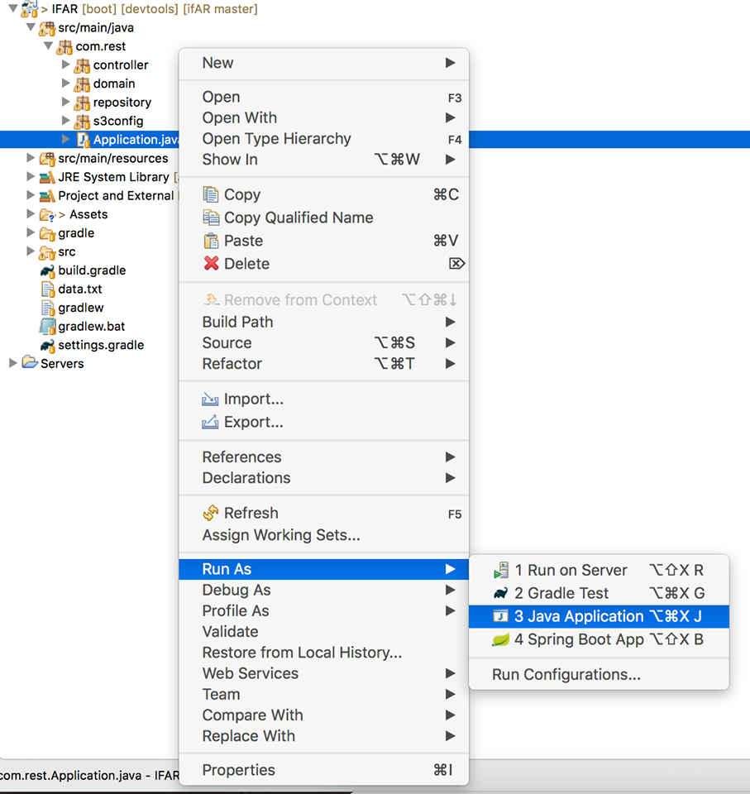

### Web Application Deployment Process

Open Eclipse application. Right click on web application project “AdminWeb”, choose “Run as” -> “Run on Server”. Connect to Web Application via host address:<http://localhost:8080/AdminWeb/> with port:8080

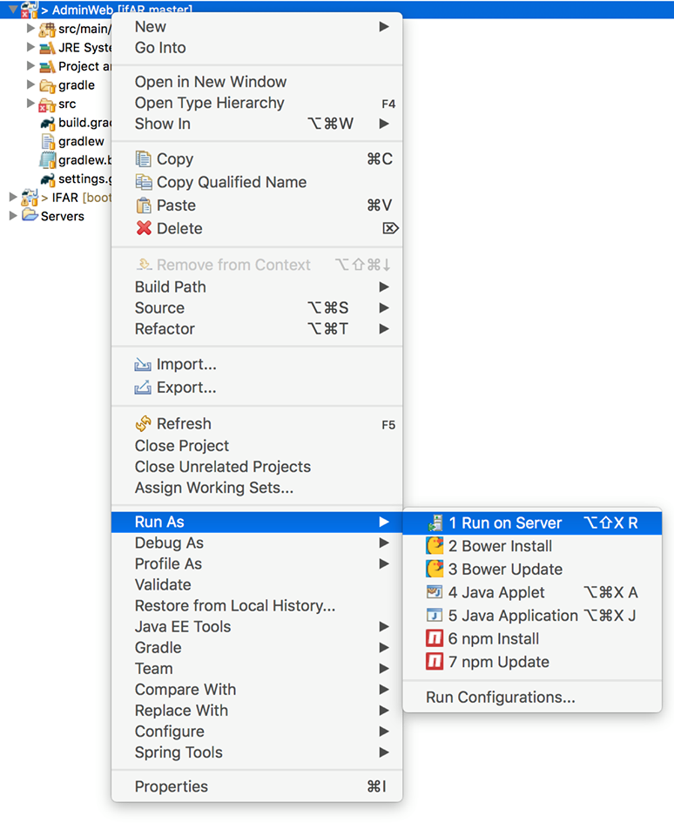

### Mobile Application Deployment Process

*Open “Cài đặt” to go to setting*

*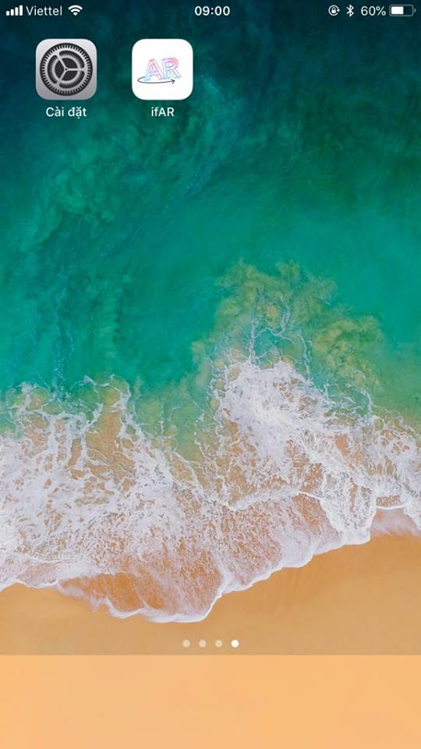*

*Choose “Cài đặt chung”*

*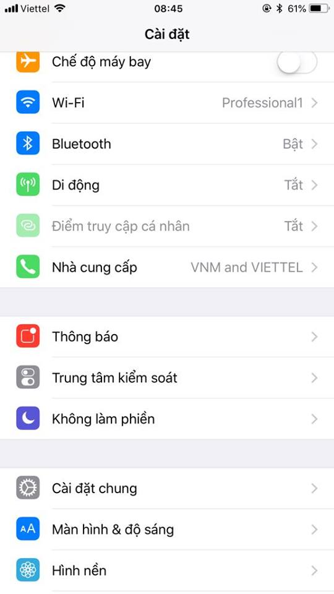Choose “Quản lý thiết bị”*

*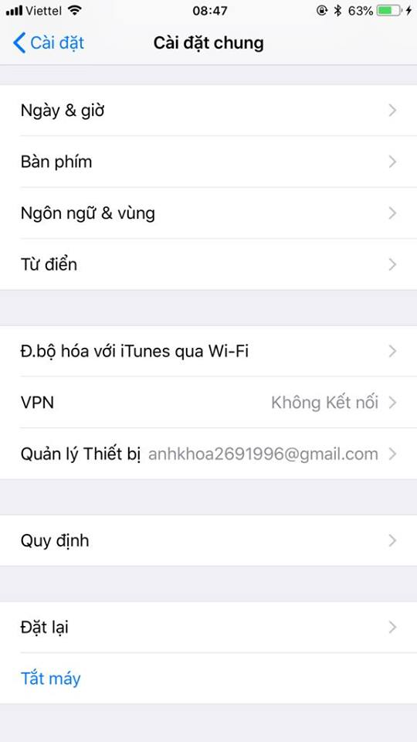*

*Choose your Apple Developer ID, mine is “anhkhoa2691996@gmail.com”*

*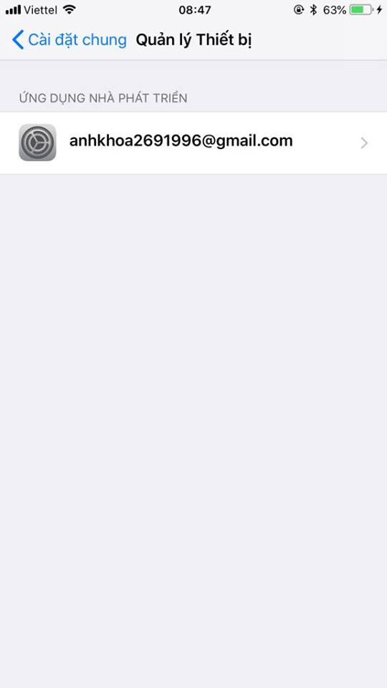*

*Then tap “Trust” to grant permission to this application.*

*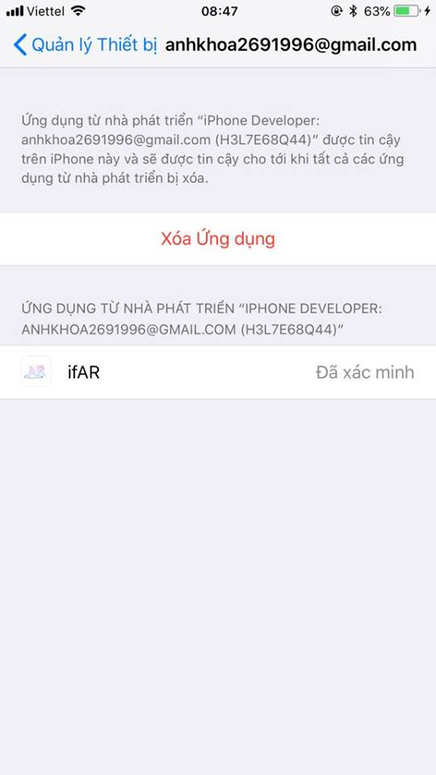*

## 2. User Guide

2.1 Web Application

2.1.1 Staff & Designer

2.1.1.1 Manipulate Seller

###### Login to Web Application via http://localhost:8080/IFAR, then choose menu “Manipulate Seller” on left edge. Seller’s information is listed in table below.

###### This page has 4 tabs: All, Approved, Pending and Rejected which display corresponding status of the seller.

###### Choose “Store Detail” at the end of each record to see full information of seller and his/her store.

###### This pop-up will show all information of seller’s store, staff can “Reject” or “Approve” this store.

###### If “Reject” button is chosen, there’s a new pop-up which reject reason is filled in and send to seller.

###### This is rejected store.

*This is approved store which is able to sell product on ifAR marketplace.*

*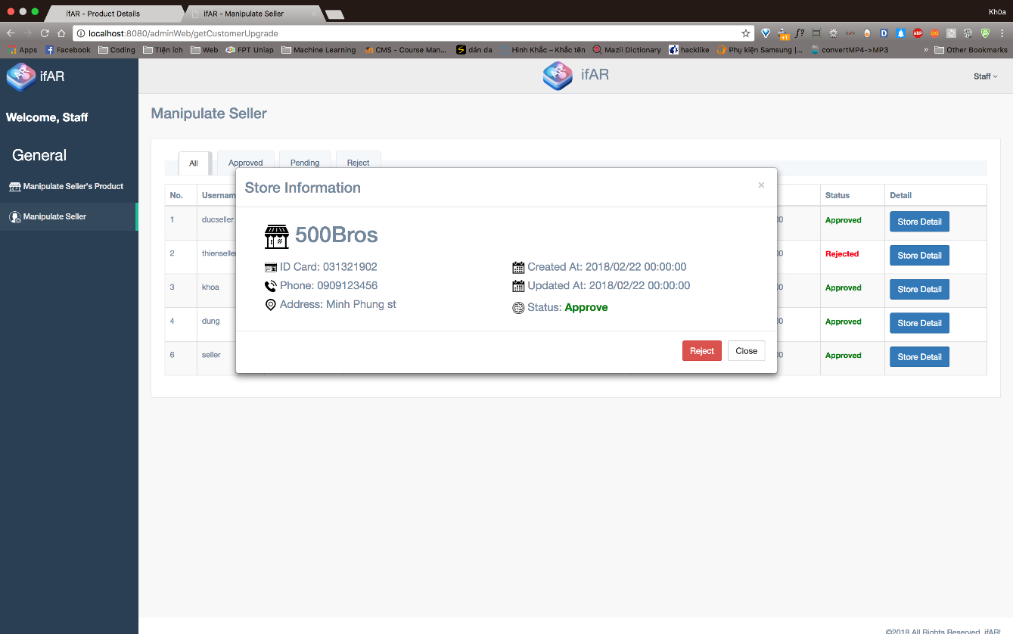*

2.1.1.2 Manipulate Sale Request

###### Login to Web Application via http://localhost:8080/IFAR, then choose menu “Manipulate Sale Product” on left edge. Product’s information is listed in table below.

###### This page has 4 tabs: All, Approved, Processing, Waiting, Pending and Rejected which display corresponding status of the product.

###### Choose “Detail” at the end of each record to see full information of product.

###### Product’s detail is shown below

###### If product’s status is “Pending”, Staff can “Approve” or “Reject” this product.

###### If product is approved, Staff will announce pricing service of this product (pricing is depended on complexity of product).

###### After being approved, this product change status from “Pending” to “Waiting for Seller’s confirmation” that means seller will approve the pricing service or not. If seller approves the pricing, product will be started processes (generate 3D model from images and upload to ifAR marketplace).

###### If product is rejected, Staff will announce the reason for seller.

**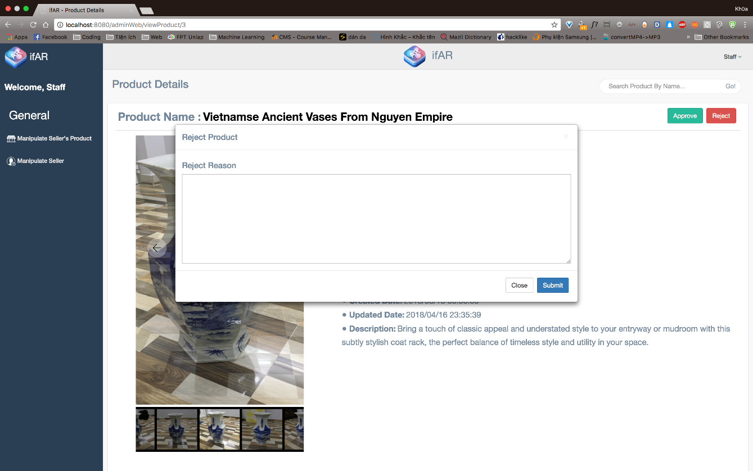**

2.2 Mobile Application

2.2.1 Customer

2.2.1.1 Simulate Product in AR view and 3D view

###### Choose product “Goddess Bastest”

###### 

###### Here’s information of product. Choose “View product” to view product in 3D view.

###### 

###### Wait for download 3D model process finish.

###### 

###### 3D model is loaded. You can rotate it in any direction.

###### You can also view this product in AR view by choose “View AR” in top right corner.

###### 

###### Here’s AR view, move camera near to surface to detect the surface. When yellow square appears, you can tap on it to place product.

###### 

###### Wait for downloading model from server

###### .

###### By tap the icon of product on right edge, you can perform some action such as: “Add to cart”, “Clone this model”.

###### 

###### 

###### Choose suitable action, “Add to cart”: add this product to cart, “Clone this model”: add one more 3D model to AR View.

###### 

2.2.1.2 Go Online Shopping

###### Add some products to cart, by tap the icon “add” on bottom left corner of product cell.

###### Then click Cart icon on top right corner of screen to or on tab bar at bottom to view cart.

###### 

###### Choose “Checkout” to check out your cart

###### 

###### Here’s delivery address in your profile, you can also change address by choose “Or use other address”. Choose “Continue” to move to next section.

###### 

###### We provide 2 methods of payment: “Cash on Delivery” and “PayPal”. In this example, we’ll use PayPal

###### .

###### Login to your Paypal Account and checkout by choose “Continue”

###### Check out successfully.

###### 

##### 2.2.1.3 Track Orders

###### Move to User tab on Tab bar at bottom. Then choose “My Orders” to view all your orders.

###### 

###### By choose any order cell, you can view order details of order.

###### Review order details’ information

###### 

2.2.2 Seller

2.2.2.1 Request to sell product

###### Choose “Seller Zone” tab on tab bar at bottom. Then choose “Requset Product” to request new sale product.

###### 

###### Tap “+” icon to create new request

###### 

###### Fill information of your product

###### 

###### And choose images of the product

###### 

###### Choose “Create” to send the request

###### 

###### By choose “Yes” option, your request will be sent to our system.

###### Wait for uploading process finish.

###### 

###### Choose “Notification” to get notification from system

###### Confirm the notification from system and pay service pricing to start create sale product on marketplace by choose “Pay” option.

###### 

2.2.2.2 Manipulate products

###### Choose “Seller Zone” on tab bar at bottom, then choosing “Sale product” to manipulate your products which is sold on marketplace.

###### 

###### Here’s all products are now selling on marketplace. By choose any product, you can view product’s detail.

###### 

###### Swipe left on product to remove it from marketplace.

###### C:\Users\KHOANPASE61742\Desktop\docs\docs capstone\iphone\product\30849817_1368200343325755_970375611_o.jpg

2.2.2.3 Manipulate orders

###### Choose “Seller Zone” on tab bar at bottom, then choosing “Sale product” to manipulate your products which is sold on marketplace.

###### 

###### Here’s all products are now selling on marketplace. By choose any product, you can view product’s detail.

###### 

###### By moving to last tab on tab bar, you can manipulate orders on this product.

###### 

# G. Appendix

The reference components of the reference material refer to the way of writing at: <http://www.khoahocviet.info/meresci/vi/meresci03d4.html>